Courtesy Translation Disclaimer
This English version is provided for courtesy and reference purposes only and was generated through machine translation. The original version of this document is in Romanian. In the event of any discrepancy, inconsistency, ambiguity, or terminological misunderstanding between the English translation and the Romanian original, the Romanian version shall prevail.

terms of reference
intended for the development of the integrated information system
"e-ANSA Import control and alert dissemination"
(SIMIDA)

Chisinau 2026

content
1. General 6
1.1. Context of the development of the information system 6
1.2. Institutional and ICT environment of ANSA 7
2. The scope and implementation objectives of the information system 10
2.1. Project scope 10
2.2. Purpose, objectives and tasks of the information system 11
2.3. Principles for information system development 13
3. The parties involved and the registrars of the information system 15
3.1. Parties involved in the development and implementation of the information system 15
3.2. Computer system registrars 15
4. The functional model of the information system 17
4.1. Information system architecture 17
4.2. Users and their roles within the information system 21
4.3. Functionalities provided by the information system 25
4.3.1 Functionalities related to import monitoring and control processes 26
4.3.2 Functionalities related to alert registration and dissemination processes 28
4.3.3 Functionalities related to data management on food chain operators 30
4.3.4 Common functionalities for all users, administration and system functionalities 31
4.4. Generic IT system workflows 33
4.4.1 Workflow for submitting and examining the notification regarding the import of products subject to sanitary-veterinary, phytosanitary and food safety supervision and control 33
4.4.2 Workflow for submitting and reviewing the notification regarding the import of plant protection products/fertilizer products 34
4.4.3 Workflow for recording, reviewing and disseminating non-conformities and notifications 35
4.4.4 Workflow for the registration of food chain operators and agri-food holdings 36
4.4.5 Workflow for data management on food chain operators/agri-food holdings 37
4.4.6 Workflow for automatic dissemination of public interest data 37
4.5. Information system data flows 37
4.6. The data model of the information system 43
5. Functional requirements of the information system 50
5.1. Functional requirements for SSI "Import monitoring and control" 50
5.1.1 CU01: Request to register as an importer representative 50
5.1.2 CU02: Sending import notification 52
5.1.3 CU03: Perform documentary control 54
5.1.4 CU04: Document identity and physical control 55
5.1.5 CU05: Manage import notifications 58
5.1.6 CU06: Manage data on producers, importers and products subject to control 60
5.1.7 CU07: Manage import control rules 61
5.1.8 CU08: Monitor notifications and import control 62
5.2. Functional requirements for SSI "Alert registration and dissemination" 63
5.2.1 CU09: Register non-compliance or initial notification 63
5.2.2 CU10: I report measures taken 66
5.2.3 CU11: I send requests related to notifications 67
5.2.4 CU12: Monitor alert notifications 68
5.2.5 CU13: Manage data on non-conformities or notifications 68
5.2.6 CU14: Check and classify non-conformity or notification 71
5.2.7 CU15: Distribute notification 72
5.2.8 CU16: Manage contact network data 73
5.3. Functional requirements for the SSI "Register of food chain operators" 74
5.3.1 CU17: Register food chain operators and agri-food holdings 74
5.3.2 CU18: I manage data on food chain operators and agri-food holdings 75
5.4. Functional requirements for implementing administration and system functionalities 79
5.4.1 CU19: Search/view data 79
5.4.2 CU20: I use dashboard 82
5.4.3 CU21: Download documents and extract reports 83
5.4.4 CU22: Approve/reject 86
5.4.5 CU23: Configure monitoring and control service upon import 86
5.4.6 CU24: Configure alert recording and dissemination service 87
5.4.7 CU25: Manage metadata and document templates 87
5.4.8 CU26: Manage users and access control 90
5.4.9 CU27: Configure data sets for export 91
5.4.10 CU28: Generate reports and documents 92
5.4.11 CU29: Execute automatic procedures 93
5.4.12 CU30: User notification 95
5.4.13 CU31: Journaling events 95
5.4.14 CU32: Data exchange with external systems 97
5.5. Functional requirements for the component that implements functionalities related to the Public Interface 100
5.5.1 CU33: Explore public interface content 100
6. Non-functional requirements of the information system 103
6.1. Information system architecture requirements 103
6.2. Information system interoperability requirements 105
6.3. Requirements for the technological stack of the information system 106
6.4. Requirements for the deployment of the information system 107
6.5. Requirements for the user interface of the information system 108
6.6. Performance and scalability requirements of the information system 109
6.7. Information system security and protection requirements 110
6.8. Requirements for IT system maintenance facilities 114
6.9. Licensing and Intellectual Property Requirements 115
7. Information system implementation requirements 116
7.1. General plan for implementing the information system 116
7.2. Project management requirements for the implementation of the information system 120
7.3. Requirements for the IT system implementation team 122
7.4. Requirements for the information system development process 125
7.5. Requirements for the deployment of the information system 126
7.6. Requirements for migration and data population of the information system 127
7.7. Requirements for training of computer system users 128
7.8. Requirements for IT system acceptance testing 130
7.9. Requirements for putting the information system into production 131
7.10. Requirements for stabilizing the information system 132
7.11. Requirements for information system project deliverables 132
7.12. Requirements for maintenance services and technical support of the information system 134
8. Annexes 137
8.1. Annex 1. Work processes related to public services provided by ANSA 137
8.1.1 A 1.1. Notification regarding the import of products subject to sanitary-veterinary, phytosanitary and food safety supervision and control 137
8.1.2 A 1.2. Notification regarding the import of phytosanitary products 148
8.1.3 A 1.3. Notification regarding the import of fertilizer products 155
8.1.4 A 1.4. Recording and reviewing non-compliance/alert notification 164
8.2. Annex 2. Reports 173
8.2.1 Reports related to SSI "Import monitoring and control" 173
8.2.2 Reports related to SSI "Alert Registration and Dissemination" 176
8.2.3 Reports related to the SSI "Register of food chain operators" 179
8.3. Annex 3. Information objects of the information system 188
8.4. Annex 4. Abbreviations, acronyms and concepts used in the document 197
8.5. Annex 5. References and legal aspects for the development of the information system 200
8.6. Annex 6. ANSA Organizational Chart 204
8.7. Annex 7. Technical annex regarding the exchange of data between SIMIDA and the IS of the Customs Service 205
8.7.1 A7.1. Interpellations 206
8.7.2 A7. 2 . Data Structures 208
8.7.3 A7. 3 . Classifiers 213
8.7.4 A7. 4 . General Service Level Agreement (SLA) 213
8.8. Annex 8. Example of response with queried data from RSPUFF 215

Overview

The context of the development of the information system
The National Food Safety Agency (hereinafter referred to as "ANSA") is committed to ensuring full compliance with the requirements of the European Union in the field of animal health and food safety, including with the aim of ensuring a transparent process for the import of products subject to ANSA control and supervision and the communication of incidents in the food sector. In continuing ANSA's efforts to modernize the processes of supervision and control of products introduced on the market of the Republic of Moldova, as well as to ensure effective risk management in the field of food safety, it is necessary to develop and implement the necessary IT support.
Thus, according to Government Decision No. 791/2022 on the establishment and approval of the Concept of the Integrated Information System "e-ANSA", the National Food Safety Agency will develop and implement several information subsystems to digitize and standardize business processes and documents in its areas of competence.
Therefore, all monitoring activities of the import of products subject to sanitary-veterinary, phytosanitary, food safety supervision and control, as well as phytosanitary and fertilizer products will be carried out through the Information Subsystem "Monitoring and control at import". Another indispensable component for ANSA is the Information Subsystem "Registration and dissemination of alerts", which will contribute to establishing faster control over food safety risks through the dissemination of alert notifications for feed and food products.
The basis for digitizing processes and ensuring data support both in the field of import monitoring and control and for communicating incidents in the food sector are the official registers of ANSA through which the record of food chain operators and the holdings used by them is ensured. According to the Concept of the Integrated Information System "e-ANSA", in order to ensure the efficient management of data on food chain operators and the holdings used by them, including the record of documents required in the registration/update process, it is imperative to develop the Information Subsystem "Register of Food Chain Operators".
All these three IT subsystems, which interact with each other through specialized services, represent component parts of the "e-ANSA" Integrated Information System (hereinafter "SII "e-ANSA"").
At the same time, the public data and documents produced as a result of the implemented digital workflows must be published and disseminated through the "ANSA Public Portal" Information Subsystem, which will be expanded with new functionalities for publishing data on food chain operators and their holdings, alert notifications, public statistics and other data and documents produced within the workflows.
The necessary IT support for the digitalization of processes in order to perform the basic functions of ANSA will be ensured through the implementation of the IT system development project "e-ANSA Import Monitoring and Alert Dissemination", (hereinafter "SIMIDA" ).
SIMIDA will provide an interoperable solution with other information subsystems of the SII "e-ANSA" and state information resources. All IT components in this project must be designed based on a multi-level architecture, oriented towards services with "Back Office" components to which authorized users within ANSA and other public institutions have access, as well as with a "Front Office" component, which will be achieved through internal means and other existing tools such as the Electronic Services Development Platform.
SIMIDA is a Government to Government (G2G), Government to Business (G2B) and Government to Citizens (G2C) solution, aimed at streamlining the collaboration of information resources in the field of food safety, increasing transparency and ensuring access to data and online services for farmers and businesses operating in the food sector.
This document describes the basic terms of reference that must be taken into account when implementing SIMIDA , including architectures, information objects, processes, functional and non-functional constraints, management approaches, implementation and maintenance of the information system.

ANSA's institutional and ICT environment
In accordance with Article 24 of Law No. 306/2018 on food safety, the National Food Safety Agency is the central public authority subordinate to the Government that implements state policy in the areas assigned to its competence by law.
ANSA performs its functions through the central apparatus, its territorial subdivisions, border inspection posts, as well as in cooperation with public institutions in which ANSA exercises the capacity of founder. ANSA outsources some of its functions to private laboratories and veterinarians. The organizational structure of ANSA is established in accordance with Government Decision no. 14/2023 on the organization and functioning of the National Food Safety Agency. The organizational chart of ANSA is presented in Annex 6 .
The high-level application architecture of ANSA is implemented in accordance with Government Decision No. 791/2022 on the establishment and approval of the Concept of the Integrated Information System "e-ANSA". The subsystems of the "e-ANSA" IIS and the interaction between them are presented in Figure 1.1.
Through the information subsystems that are components of the SII "e-ANSA", which represent distinct information applications, all of the ANSA functions within the computerized perimeter are performed. In this sense, the SII "e-ANSA" represents an information solution interconnected with all relevant external data sources, which is to automatically provide the data necessary to support workflows. The SII "e-ANSA" is also to ensure public access to data sets, to be consumed automatically by external applications in order to process them and provide added value.
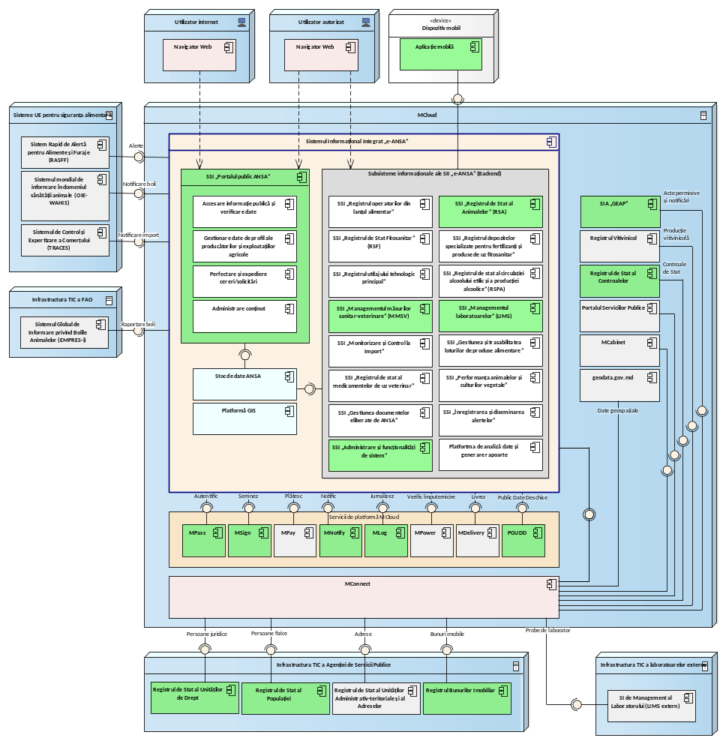
Figure 1. 1. Components of the "e-ANSA" SII and the interaction between them.
The following information subsystems are currently implemented in the ICT infrastructure of ANSA, which interact with each other through specialized services:
- The information subsystem "ANSA Public Portal" - which ensures access to public data related to ANSA activity or provides electronic services to citizens, food chain operators, laboratories and private veterinarians.
- Information subsystem "State Register of Animals" - which provides functionalities for the systematized registration and management of data on animals identified in livestock holdings, events occurring in relation to animals (including export and import), animal keepers, as well as documents and means of animal identification.
- The information subsystem "State Phytosanitary Register" - which provides functionalities for managing data on operators in the phytosanitary field, for recording documents used in the processes of cultivation, export and import of plant products, as well as for identifying and registering products subject to phytosanitary control, phytosanitary products and fertilizers.
- The information subsystem "Management of sanitary and veterinary measures" - which provides tools for the development, recording and monitoring of the execution of the Annual Program of strategic actions for the surveillance, prevention and control of animal diseases, prevention of the transmission of diseases from animals to humans and environmental protection, developed and approved by ANSA, in order to generate the data necessary for the management of sanitary and veterinary surveillance.
- The "Laboratory Management" information subsystem - which provides functionalities for registering requests for laboratory investigations and test reports following laboratory investigations on products of animal and plant origin to ensure consultation and obtaining information from it by ANSA and other public authorities implementing food safety policies in the Republic of Moldova.
- Mobile application – intended to facilitate the performance of critical SII "e-ANSA" functions remotely, and in some situations, without an Internet connection.
- The information subsystem "Administration and system functionalities" - which provides the key system functionalities of the "e-ANSA" SII for the centralized administration of all functional components of the "e-ANSA" SII and provides the authorized user, depending on the rights and roles held, with the user interface for accessing the relevant "e-ANSA" SII functionalities.
These components are hosted in the production environment on the common government technology platform (MCloud) and interoperability with information resources or external information systems is ensured through the interoperability platform (MConnect), as follows:
- Automated information system "State Register of Legal Entities" - for accessing official registration and identification data of legal entities.
- Automated information system "State Population Register" - for accessing official registration and identification data of individuals.
- The "Real Estate Register" information system – for accessing cadastral data of registered properties, including geospatial data.
- The automated information system "Management and issuance of permissive documents" - for accessing data on permissive documents issued by ANSA.
- Automated information system "State Register of Controls" - for accessing data on state controls over entrepreneurial activity.
For the information subsystems that are the subject of these terms of reference, interoperability interfaces will be developed both between them and the existing subsystems of ANSA, as well as external information systems.

The perimeter and implementation objectives of the information system

Project perimeter
SIMIDA project is initiated in the context of the implementation of the provisions of Government Decision no. 791/2022 on the establishment and approval of the Concept of the Integrated Information System "e-ANSA" according to which ANSA is to implement the necessary IT support for the digitalization of work processes in the computerized field. The following IT components are to be developed, modernized or configured to achieve this objective:
- The information subsystem "Monitoring and control at import" (hereinafter "MCI") - which is part of the SII "e-ANSA" and will provide Front Office and Back Office functionalities for the preparation and transmission of import notifications by economic agents with the right to import products under the supervision of ANSA. MCI will provide workflow management functionalities related to the processing of import notifications and documentation of control at the ANSA inspection post at the border, the preparation of documents related to import decisions and other categories of documents produced within the workflows.
This IT component will provide the following basic functionalities, as follows:
  - registration and transmission of import notifications;
  - examining import notifications and carrying out documentary control;
  - documentation of identity and physical checks at ANSA border inspection posts and at the place of destination of the imported goods;
  - monitoring of the carrier and the cargo in case of transit through the territory of the Republic of Moldova;
  - systematized management of data on producers, importers and products subject to control;
  - record of data on imported products;
  - issuing border crossing decisions and admitting the import of goods;
  - achieving automated data exchange with other external IT systems to ensure a smoother process for importing goods.
- The information subsystem "Registration and dissemination of alerts" (hereinafter "IDA") - which is part of the SII "e-ANSA" and will provide functionalities for the rapid registration and dissemination of alert notifications for food and feed products. The MCI will serve as a collaboration environment between different institutions and contact points to assess risks and coordinate the necessary measures to guarantee food safety and mitigate the consequences for the population.
This IT component will provide the following basic functionalities, as follows:
  - recording non-conformities and alert notifications for food and feed;
  - managing collaboration between state institutions and contact points to identify risks and necessary measures to guarantee food safety;
  - effective monitoring of alert notifications to provide a faster response to food incidents ;
  - rapid distribution of alerts to the network of contact points, partner institutions abroad and citizens;
  - management of data about the network of contact points for distributing alerts;
  - achieving automated data exchange with other external IT systems that participate in the analysis and control flow of food non-conformities.
- The information subsystem "Register of food chain operators" (hereinafter "ROLA") - which is part of the SII "e-ANSA" and will provide the necessary functionalities for the management of data on food chain operators and holdings used by them. At least the following data categories are to be managed through ROLA:
  - operators and veterinary-authorized holdings;
  - operators and holdings registered with the veterinary health authority;
  - operators and holdings in the field of food safety of non-animal origin;
  - operators and farms in the phytosanitary field;
  - operators and holdings registered for the production and/or processing, and/or marketing of seeds;
  - operators and specialized warehouses for fertilizers and phytosanitary products;
  - operators and main technological equipment used in the manufacture of distillates of agricultural origin or in the production of strong alcoholic beverages.
- The information subsystem "ANSA Public Portal" - which is part of the SII "e-ANSA" and provides functionalities with external access to anonymous users. The information subsystem "ANSA Public Portal" is to be expanded with the following functionalities:
  - search and visualization of data about food chain operators and the agri-food holdings managed by them;
  - dissemination of data on food and feed alert notifications;
  - publication of statistical data related to processes managed through SIMIDA components .
- The information subsystem "Administration and System Functionalities" - which is a component of the "e-ANSA" SII, provides the key system functionalities of the "e-ANSA" SII for the administration and configuration of the functional components of the "e-ANSA" SII. The information subsystem "Administration and System Functionalities" is to be expanded with new functionalities in order to unify the principles of authentication, authorization, logging, notification and centralized metadata management, etc.
- Data analysis and report generation platform – which represents a software platform jointly exploited by all ANSA IT applications for generating documents and reports specific to each individual IT application. This platform exposes an API interface, specialized to all functional components of the SII "e-ANSA" for generating and providing all reports and documents specific to them. Through the Data analysis and report generation platform, all reports and documents specific to the business processes implemented by the functional components of SIMIDA are to be configured .

The purpose, objectives and tasks of the information system
The implementation of SIMIDA will bring immediate benefits and impact for ANSA, food chain operators and citizens by ensuring centralized access to data and electronic services necessary for the conduct of business processes specific to their activity. Thus, the development of all IT components within the SIMIDA perimeter will allow for increased transparency in ANSA's areas of competence, standardize business processes and related documents, eliminate inconsistencies and redundancies in data and reduce interaction time with potential data users.
Based on the existing regulatory framework and the objective needs of the subjects involved, the following objectives are defined to be achieved following the implementation of the SIMIDA project :
- digitalization of the processes of transmitting and processing import notifications, of the processes of recording and disseminating alert notifications, of the processes of recording and updating data on food chain operators, as well as of the processes of issuing extracts and other categories of documents;
- implementing workflows based on the electronic circulation of documents and decisions in the activity process of all parties involved in the exploitation of SIMIDA components ;
- ensuring data traceability, increasing transparency and ensuring access to data and electronic services for all subjects involved in business processes related to SIMIDA components ;
- eliminating data redundancy and reducing operational costs by standardizing work processes and documents; implementing a digital working environment for all subjects involved in the operation of SIMIDA components ;
- reducing response time and providing the information necessary for the decision-making process related to increasing productivity, streamlining economic activity in the areas supervised by ANSA;
- achieving interoperability between the information subsystems of ANSA and the external information systems of public authorities and institutions that hold and manage data necessary for the implementation of workflows related to ANSA activity;
- guaranteeing access to data related to electronic services provided by ANSA, depersonalized data from registers managed by ANSA, as well as public reports/statistics;
- ensuring the implementation of data protection and information security policies;
- legalizing SIMIDA components and making them operational by defining clear roles and responsibilities for maintenance and sustainable operation.
The implementation of SIMIDA is to provide ANSA with efficient tools for the provision of electronic services and the implementation of the regulatory, supervisory and control function in its areas of competence. The main tasks assigned to SIMIDA are the following:
- providing electronic services for registering and sending import notifications for products subject to ANSA supervision and control;
- implementing workflows for processing import notifications and documenting physical checks at border inspection posts or at the place of destination of the goods;
- achieving automated data exchange between the ANSA information subsystems and the Customs Service information systems to ensure access to data necessary for the decision-making process and optimizing border crossing and customs clearance processes;
- providing functionalities for monitoring control activities at ANSA border inspection posts and ensuring traceability of data on imported goods;
- providing functionalities for recording non-compliances and alert notifications for food and feed;
- implementing workflows related to collaboration between state institutions and contact points to identify risks and necessary measures to guarantee food safety;
- providing functionalities for managing data about the network of contact points and rapid distribution of alerts to the network of contact points, partner institutions abroad and citizens;
- providing functionalities for efficient monitoring of alert notifications to provide a faster response to food incidents;
- providing functionalities for managing the processes of registration and updating data on food chain operators and the holdings owned by them;
- implementing mechanisms designed to ensure centralized access to information resources of SIMIDA components , management of common metadata, configuration of SIMIDA components , mutual data exchange between SIMIDA functional components and with external information systems, and access to shared information systems;
- implementation of a data analysis and report generation platform jointly operated by all SIMIDA component subsystems for the generation of documents and reports specific to each individual IT application;
- carrying out electronic data exchange with third parties for the automated reception of data necessary for the business processes of SIMIDA components through the MConnect interoperability platform (for the information systems of the Republic of Moldova) or APIs exposed by the information subsystems in the integrated information space of ANSA;
- facilitating public access to data produced through SIMIDA components and data related to work processes implemented by SIMIDA components .

Principles for information system development
the following principles must be taken into account when designing, developing and implementing SIMIDA :
- The principle of legality , which requires the creation and operation of the information system in accordance with national legislation and recognized international norms and standards in the field.
- The principle of single address , which consists of optimizing the processes related to the provision of services in the public sector in such a way that citizens and businesses provide data only once to a public administration for the purpose of obtaining public services. In this regard, the role of public administrations is to share internally the data necessary for the provision of public services to citizens and businesses.
- The principle of dividing the architecture into levels , which consists in the independent design of the functional components of SIMIDA in accordance with the interface standards between levels.
- The principle of alignment with the large-scale ICT architecture of the Food Safety Agency , which assumes that the place of the information subsystems of SIMIDA components in the large-scale ICT architecture is explicitly delimited in relation to other information subsystems of the integrated information space "e-ANSA". SIMIDA will be implemented with the application of the principles of ICT architecture based on microservices established by ANSA and will be able to interact with other components of the ICT architecture.
- The principle of service-oriented architecture (SOA) , which consists of distributing application functionality into smaller, distinct units, called services, which can be distributed across a network and used together to create applications designed to implement the business functions of the information system.
- The principle of reusing existing capabilities , which assumes that SIMIDA will be implemented by reusing at the level of its components the current ICT capabilities to which ANSA has access. The development of new specific capabilities will be done only in case of their lack in the current ICT architecture of ANSA.
- The principle of security by design , which involves designing SIMIDA components with due knowledge of the information security risks that may affect the proper functioning of the information system. The applicable regulatory requirements for the implementation of information security mechanisms must be considered at the design stage and implemented at the development stage. SIMIDA will ensure controlled, transparent and responsible access to data.
- The principle of data integrity, completeness and veracity , which involves the implementation of mechanisms that allow the preservation of the content and unambiguous interpretation of data under the conditions of accidental influences and the elimination of the phenomena of their accidental distortion or liquidation, providing a sufficient volume of data to perform the business functions of the information system and ensuring a high degree of correspondence of the data with the real state of the objects they represent and which are part of the computerized space.
- The principle of progressive development , which stipulates the possibility of expanding and supplementing the information system with new functions or improving existing ones in accordance with the advancement of information technologies.
- The principle of the first person/single center , which assumes the existence of a high-ranking responsible person, with sufficient rights to make decisions and coordinate activities in order to create and operate the information system.
- The principle of scalability , which involves ensuring constant performance of the IT solution as data volume and user demand increase.
- The principle of simplicity and ease of use , which involves the design and development of all applications, technical and program means accessible to users based on exclusively visual, ergonomic and logical design principles.
- The principle of technological independence and neutrality , which assumes that the information system must be implemented based on functional requirements independent of specific technologies or software products.
- The principle of compatibility of SIMIDA components with state information systems in the country or information subsystems from the integrated technological space of ANSA.
- The principle of unity of information space , which provides for the use of a single system of classifiers, data formats, information interaction protocols, standards, interdependent normative and methodological documents.
- The principle of control , which provides for the totality of organizational and technical program measures that ensure the high quality of the formed information resource, the reliability of its preservation and the correctness of its use in accordance with the legislation.
- The principle of computer auditing , which involves recording data about user actions and business events, to make it possible to reconstruct the history of an object or its state at a previous stage.
- The principle of accessibility of public information , which involves the implementation of procedures to ensure applicants' access to public information.

The parties involved and the registrars of the information system

Parties involved in the development and implementation of the information system
In accordance with the legislation in force, the following entities are interested or must be involved in the process of developing or operating the component subsystems of SIMIDA :
- The Ministry of Agriculture and Food Industry , as a central specialized body of public administration, which ensures the implementation of government policy in areas relevant to the SII "e-ANSA".
- The National Food Safety Agency , as the owner of the SII "e-ANSA" and a central public authority subordinate to the Government that implements state policy in the areas assigned to its competence by law.
- The public institution "Electronic Governance Agency" , as the owner of the Electronic Services Development Platform (PDSE) and the Automated Information System "Management and Issuance of Permissive Acts" (SIA GEAP), which will ensure through the interoperability platform (MConnect) access to data on the processing of public service requests that are subject to registration in ROLA. Likewise, AGE will facilitate integration with shared information systems (MPass, MSign, MPower, MLog, MNotify and the Government Data Portal).
- The Customs Service of the Republic of Moldova , which will ensure, through the interoperability platform (MConnect), data exchange with the "Frontiera" Information System and the "ASYCUDA World" Information System.
- The Public Services Agency , which will ensure, through the interoperability platform (MConnect), the exchange of data with the State Register of Legal Entities (RSUD), the State Population Register (RSP) and the State Register of Vehicles (RSV).
- The Agency for Geodesy, Cartography and Cadastre , as a data provider, which will ensure data exchange with the Real Estate Registry (RBI) through the interoperability platform (MConnect).
- The State Chancellery of the Republic of Moldova , which will ensure data exchange with the State Register of Controls (RSC) through the interoperability platform (MConnect).
- The public institution "Information Technology and Cybersecurity Service" , which exercises its duties in accordance with the regulatory framework in the field of technical administration and maintenance of state information systems.
The role of owner and holder of the information system reflects the administrative aspects and skills necessary for the operation, administration and continuous development of the information system.
Thus, ANSA, as the central authority for state supervision and control in the field of veterinary and zootechnics, phytosanitary and plant protection, food safety, production and circulation of wine and alcoholic products, consumer protection in the food sector and compliance with licensing conditions, according to the relevant field, holds the roles of owner and holder for the following IT subsystems that are the subject of the terms of reference:
- Information subsystem "Import monitoring and control" ;
- Information subsystem "Alert registration and dissemination" ;
- Information subsystem "Register of food chain operators" ;
- The information subsystem "ANSA public portal" ;
- Information subsystem "System administration and functionalities" .

Computer system registrars
As registrars for the component subsystems of SIMIDA, there will be authorized users, natural persons and legal entities of public or private law, who have the appropriate powers, in accordance with the regulatory framework, such as: powers of registration, updating, modification of data, as well as ensuring security, protection and integrity of data. Users of the component information subsystems of SIMIDA are divided into the following categories:
- National Food Safety Agency – through the profile directorates within the central apparatus, as well as through the territorial subdivisions, ANSA holds the role of main registrar. ANSA exercises its duties in relation to the work processes implemented by the SIMIDA components through the following component structures:
  - Border Inspection Directorate – responsible for ensuring the quality control of imported products by coordinating and managing the activity of border inspection posts. The Border Inspection Directorate is the main beneficiary and will manage, including through the ANSA border inspection posts, the work processes implemented through the SSI "Import Monitoring and Control" .
  - Directorate for the control of the use and placing on the market of phytosanitary products and fertilizers – responsible for coordinating and exercising control over the admission of the import of phytosanitary products and fertilizers. The Directorate is also responsible for ensuring the record-keeping and supervision of the traceability of phytosanitary products and fertilizers for each imported batch.
  - Planning, Risk Assessment and Quality Management Directorate – responsible for exercising the duties of the national contact point within the ISS "Registration and Dissemination of Alerts" , and ensures the rapid exchange of information between network members regarding products with increased risk to the health of consumers in the Republic of Moldova.
  - Border inspection posts – responsible for carrying out control of sanitary, veterinary and phytosanitary products, food and plants, feed, pesticides for the purpose of protecting animal and plant health, protecting public health, preventing the introduction of epizootic diseases into the country.
  - Territorial subdivisions of ANSA – responsible for surveillance and control activities in the territory to ensure food safety, animal health and plant protection. The territorial subdivisions, in particular, are responsible for the registration and record-keeping processes of food chain operators and the agri-food holdings through which they carry out their activity.
- Importers/operators in the food chain – depending on the field of activity, prepare and send import notifications through the SSI "Monitoring and control at import" for all products subject to supervision and control by ANSA.
- Members of the national network of contact points – representing public authorities and state institutions and cooperating in the process of registering, analysing and disseminating alerts. The contact points request, report and provide relevant details about non-compliances and alert notifications, to allow clear identification of the product, risks, cases of non-compliance and suspicions of fraud, provide traceability information, where possible, and identify the contact points responsible for any action taken on the notification or response to a request.

The functional model of the information system

Information system architecture
The information subsystems within the SIMIDA perimeter will be implemented based on a service-oriented architecture, based on reusable modular components and abstract interfaces that will allow the implementation of a multi-level architecture with a clear delimitation of architectural levels. The system components will be relatively independent, with possibilities for interaction between them through dedicated interfaces.
By implementing several information subsystems within the SII "e-ANSA" perimeter, the architecture of the SIMIDA components must be compatible with the SII "e-ANSA" architecture. All functional components within the SIMIDA perimeter will be part of the large-scale ICT architecture of the SII "e-ANSA" and will be explicitly delimited in relation to other information subsystems of the SII "e-ANSA". SIMIDA will be implemented by applying the principles of ICT architecture based on microservices established by ANSA and will be able to interact with other components of the ICT architecture.
SIMIDA components must be interoperable because they represent IT solutions that are to exchange data with both information systems within ANSA and external information systems.
The Web user interface provided by SIMIDA must be accessible through a widely used Internet explorer. From a functional point of view, a reliable and scalable solution will be developed both in the event of an increase in the number of users and in the event of an increase in the volume of data managed by it.
The choice is made to use technologies widely used on the market in the Republic of Moldova and in the region, compatible with technologies already implemented within ANSA, interoperable with external systems and ensuring independence from a single supplier.
In order to ensure an adequate level of information security, the delivered IT solution must allow for secure connections between client stations and the application server to ensure the security of the data sent. All user connections to SIMIDA components will be made via secure connections using the TLS/SSL cryptographic protocols that ensure secure communication and data transfer between 2 computer network nodes.
The information subsystems within the SIMIDA perimeter are to be hosted on the common government technological platform (MCloud), in the technical infrastructure of ANSA, alongside the other information subsystems in production within the SII "e-ANSA". The high-level architecture of SIMIDA is presented in Figure 4.1 and the cooperation solution between SIMIDA resources consists of the interaction between several external information resources and subsystems of the SII "e-ANSA".
SIMIDA architecture consists of the following distinct outlines:
- The ICT infrastructure of the National Food Safety Agency , which includes SIMIDA components and the other information subsystems of the "e-ANSA" SII.
- The ICT infrastructure of the Electronic Government Agency , which includes the Platform for the Development of Electronic Public Services and the Automated Information System "Management and Issuance of Permissive Acts".
- The ICT infrastructure of the Customs Service , which includes the "Frontiera" Information System and the "ASYCUDA World" Information System.
- The ICT infrastructure of the State Chancellery , which includes the State Register of Controls.
- The ICT infrastructure of the Public Services Agency , which hosts the State Register of Legal Entities, the State Register of Population and the State Register of Vehicles.
- The ICT infrastructure of the Geodesy, Cartography and Cadastre Agency , which hosts the Real Estate Registry.
- The ICT infrastructure of the National Center for Animal, Plant Health and Food Safety , which hosts the State Register of phytosanitary products and fertilizers.
- Shared information systems , as follows: MPass, MSign, MPower, MNotify, MLog, PGD.
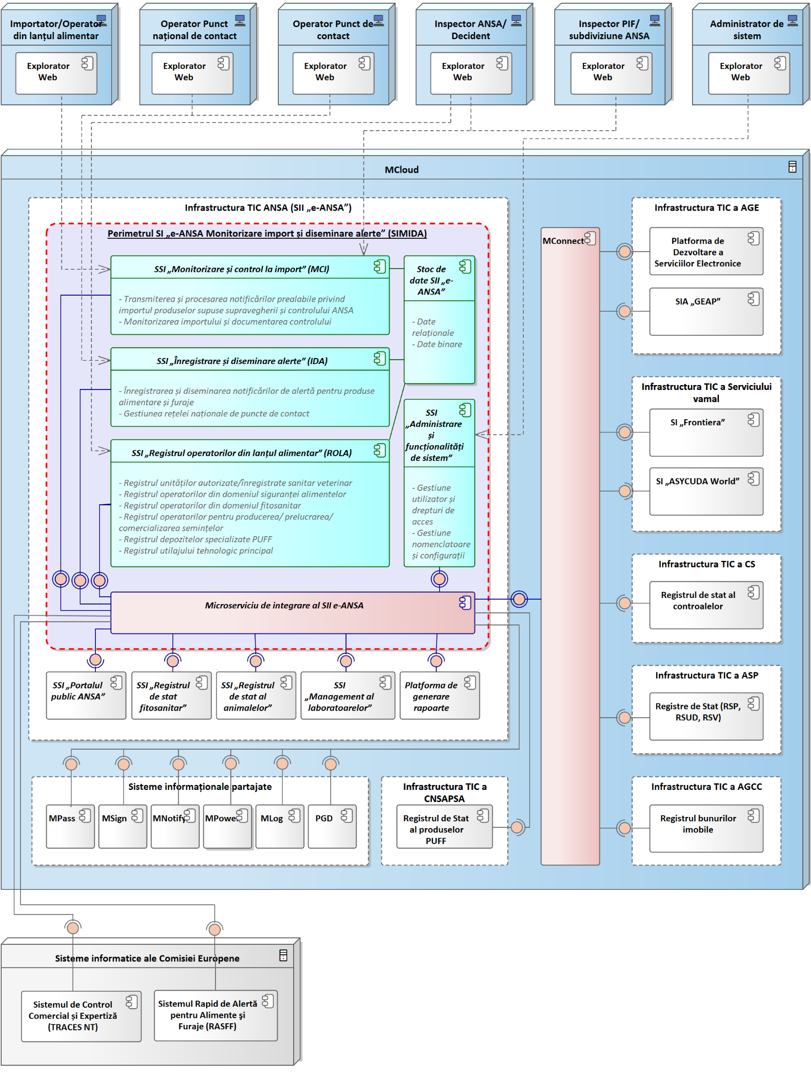
Figure 4. . 1SIMIDA components and interaction with external systems.
According to the component and deployment diagram illustrated in Figure 4.1, the SIMIDA perimeter consists of the following basic components:
- The information subsystem "Monitoring and control at import" , which represents a key subsystem within the SIMIDA perimeter and implements Front Office and Back Office functionalities intended for authorized users representing importers of goods subject to ANSA supervision and authorized users with specific roles within ANSA for processing import notifications, documenting control at border inspection posts and completing the necessary decisions and other types of documents in the areas of competence of ANSA.
- The information subsystem "Registration and dissemination of alerts" , which represents a key subsystem within the SIMIDA perimeter and implements Back Office functionalities intended for authorized users in the national network of contact points for the registration and dissemination of alert notifications, as well as for collaboration in order to assess risks and coordinate the necessary measures to guarantee food safety and mitigate the consequences for the population.
- Information subsystem "Register of food chain operators" . The digitalization of the services provided by ANSA can only be achieved by ensuring the necessary information support for the management of data on food chain operators and holdings used by them. ROLA will be made up of the official registers of ANSA for recording data related to ANSA activity, as follows:
  - Register of authorized sanitary and veterinary units;
  - Register of registered veterinary units;
  - Register of operators in the field of food safety of non-animal origin;
  - Register of operators in the phytosanitary field;
  - Register of economic agents registered for the production and/or processing, and/or marketing of seeds;
  - Register of specialized warehouses for phytosanitary products and fertilizers;
  - State register of the main technological equipment used in the manufacture of distillates of agricultural origin or in the production of strong alcoholic beverages.
- The information subsystem "System Administration and Functionalities" , which is to be expanded with new functionalities, to unify the principles of access management to ANSA subsystems, authentication, authorization, logging, notification, centralized administration of metadata and system configurations.
- The integration microservice of the SII "e-ANSA" , intended to achieve interoperability between the information subsystems of the SII "e-ANSA" and the implementation of APIs intended for data exchange with external information systems through MConnect. Likewise, this component will unify access to shared information systems.
- SII data warehouse "e-ANSA" , which includes relational data and binary data.
To implement the work processes related to SIMIDA components , data exchange must be carried out with the following information subsystems from the integrated information perimeter of ANSA:
- SSI "State Register of Animals" – for access to data on animal operators and holdings, events occurring in connection with animals (including export and import), animal keepers, as well as documents and means of identification of animals;
- SSI "State Phytosanitary Register" - for access to data on operators in the phytosanitary field (agricultural producers, exporters, importers, producers of seed and planting material, shipping centers, warehouses, users of phytosanitary products and fertilizers, producers of wooden packaging, etc.);
- SSI "Laboratory Management" – for access to data on laboratory investigations and test reports following laboratory investigations;
- SSI "ANSA Public Portal" - to ensure access to public data related to ANSA activity or provide electronic services to citizens and operators in the food chain;
- Data analysis and report generation platform – for generating, based on the data stock of the "e-ANSA" SII, reports, statistics and performance indicators necessary for monitoring and decision-making processes;
- State Register of phytosanitary products and fertilizers.
In order to perform the ANSA functions of registration and management of data on food chain operators and their holdings, according to the architecture described in Figure 4.1, the SSI IT component "Register of food chain operators" , which is located within the SIMIDA perimeter , must be interoperable with the following external information systems in the AGE ICT infrastructure through the interoperability platform (MConnect) and which will implement Front Office functionalities in order to request public services by economic agents:
- The electronic services development platform , which implements workflows for submitting requests for public services provided by ANSA. Likewise, PDSE will provide functionalities for viewing electronic service requests and their traceability events, sending additional documents or correcting data, generating electronic documents issued by ANSA using standard templates, downloading documents issued by ANSA in digital format, verifying the authenticity of electronic documents issued by ANSA via QR code. Integration with PDSE aims at bidirectional data exchange for taking over requests for registration/modification of the registration of food chain operators in ROLA and transmitting to PDSE data regarding documents issued by ANSA and information from ROLA.
- The automated information system for "Management and issuance of permissive acts" , which, in its interaction with the SSI "Register of food chain operators" , will provide data on permissive acts issued by ANSA, data on newly registered food chain operators or updated data on existing food chain operators and the holdings managed by them. In turn, SIA GEAP will consume data from ROLA to ensure the digitalization of public service provision processes in accordance with Law no. 160/2011 on the regulation of entrepreneurial activity by authorization.
In order to optimally carry out business processes, the IT components within the SIMIDA perimeter will consume data through the interoperability platform (MConnect) from the following state information resources:
- The automated information system "State Register of Controls" - for accessing data, documents and traceability events related to state controls carried out or still ongoing.
- The "Real Estate Register" information system – for accessing cadastral data of registered properties, including geospatial data.
- Automated information system "State Register of Legal Entities" - for accessing data on legal entities.
- The automated information system "State Population Register" - for accessing data on individuals.
- The automated information system "State Register of Vehicles" - for accessing data on sanitary-veterinary registered vehicles.
To implement key functionalities, SIMIDA must be integrated with the following shared information systems:
- The government's electronic authentication and access control service (MPass) , with the aim of authenticating users via electronic signature or mobile signature.
- The integrated electronic government electronic signature service (MSign) , intended for the application and validation of electronic signatures.
- The automated information system "Register of powers of representation based on electronic signature" (MPower) , for extracting data on powers of representation of individuals.
- Government electronic notification service (MNotify) , intended for notifying actors involved in business processes regarding certain events related to workflows.
- The electronic government logging service (MLog) , intended for logging business events produced.
- Government data portal , for publishing relevant datasets from ANSA's official registers, key performance indicators, statistics and public reports.
Likewise, to ensure future interoperability with the European Commission's information systems, SIMIDA must be able to consume data from the following foreign information systems through the "e-ANSA" SII Integration Microservice :
- Trade Control and Expertise System (TRACES NT) – which is an online platform of the European Commission for the electronic certification, notification and monitoring of trade in animals, animal products, feed, plants and other goods in the EU.
- Rapid Alert System for Food and Feed (RASFF) – a European system that allows authorities in EU member states (including EFTA associated countries) to quickly exchange information about serious risks detected related to food or feed, in order to take rapid and coordinated action, such as withdrawing products from the market.

Users and their roles within the information system
The human roles that interact with SIMIDA are presented in Figure 4.2. It should be noted that these roles are generic ones that determine access rights of authorized users to the user interface and the functionalities delivered by SIMIDA components . At the data and document level, the access configuration will be supplemented by user group configurations, explicitly granted rights and workflow configurations.
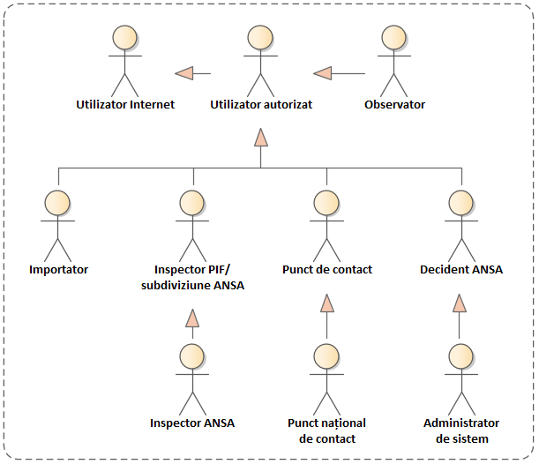
Figure 4. 2. Human users interacting with SIMIDA components.
The access level of internal SIMIDA users is differentiated depending on the roles and access rights, duties and responsibilities in the implemented processes. The following categories of users interact within SIMIDA 's IT subsystems:
- Internet user – human actor, with access to the public interface provided by the SSI "ANSA Public Portal" with access to the following functionalities:
  - exploring the content of the public interface of the SSI "ANSA Public Portal" ;
  - exploring public data from the official ANSA registers;
  - verification of data on documents issued by ANSA (certificates, extracts, etc.);
  - exploring statistical reports, performance indicators.
- Authorized user – human actor, which represented a role with generic access to the functionalities of SIMIDA components common to all categories of authorized users. This category of human actors will have access to the following functionalities:
  - access to functionalities for users with the Internet User role ;
  - access to the dashboard to access notifications and trigger actions/forms related to the exercise of job duties;
  - searching and viewing data in accordance with access rights;
  - executing tasks within workflows ;
  - generating documents and reports specific to job duties .
- Observer – human actor with a role related to authorized users who have access rights only to view data, documents and reports within SIMIDA . These actors have access to the following functionalities:
  - access to data on import notifications;
  - access to traceability events related to import notifications, physical control carried out at border inspection posts and imported products;
  - access to traceability events related to non-conformities and alert notifications, information requests and measures taken in relation to food safety incidents;
  - access to data on food chain operators and their holdings;
  - access to data on notifications (alert, information, rejection at the border);
  - access to documents produced within workflows;
  - other access rights to data and documents in accordance with the access permissions configured in SIMIDA .
- Importer – economic operator, who, in accordance with the legislation in force, holds the rights to import products subject to sanitary-veterinary, phytosanitary and food safety supervision and control, control of the use and placing on the market of phytosanitary products and fertilizers. It is a category of key users of the S SI "Monitoring and control at import" , who are involved in the workflow of sending the import notification. These actors must have access to the following functionalities:
  - access to functionalities for users with the Authorized User role ;
  - submits requests for enrollment in the S SI "Monitoring and control at import" of the representatives of the economic agent as importer;
  - sends import notifications related to products subject to ANSA supervision and control;
  - viewing traceability events related to the processing of import notifications;
  - view data on non-conformities and alert notifications related to types of imported products;
  - access to relevant decisions and documents produced within workflows.
- BIP Inspector/ANSA Subdivision – ANSA employee from the border inspection posts or within the territorial subdivisions of ANSA, who uses IT components from the SIMIDA perimeter for the purpose of exercising their duties. This is a category of key users, who are involved in all workflows implemented in the information system. These actors can be divided into several distinct roles and must have access to the following functionalities:
  - access to functionalities for users with the Authorized User role ;
  - processing requests for enrollment in the SSI "Import monitoring and control" of representatives of the importing economic agent;
  - processing import notifications and carrying out documentary control;
  - documentation, identity control and physical control of notified goods;
  - management of tasks related to workflows implemented within the "Import Monitoring and Control" SSI ;
  - preparation of documents produced within the SSI workflows "Import monitoring and control" ;
  - data management related to food chain operators;
  - data management related to agri-food holdings;
  - generation/download of documents and reports related to job duties.
- ANSA Inspector – ANSA employee, who uses IT components within the SIMIDA perimeter for the purpose of exercising his/her duties. This is a category of key users of SIMIDA , who are involved in all workflows implemented in the information system. These actors can be divided into several distinct roles and must have access to the following functionalities:
  - access to functionalities for users with the Authorized User role ;
  - access to the functionalities of users with the role of PIF Inspector/ANSA subdivision ;
  - data management on import notifications;
  - data management on producers, importers and products subject to control;
  - import control rules management;
  - monitoring import notifications and carrying out controls at border inspection posts;
  - access to traceability events related to import notifications, physical control carried out at border inspection posts and imported products;
  - management of data related to the importer's profile (data about representatives, contact details, etc.);
  - task management and completion of documents produced within workflows;
  - registration of agri-food operators and holdings;
  - data management related to food chain operators;
  - data management related to agri-food holdings;
  - management of documents issued by ANSA;
  - generation/download of documents and reports related to job duties.
- Contact point – a member of the national network of the rapid alert system for food and feed, which, in accordance with the legislation in force, uses the functionalities of the S SI "Registration and dissemination of alerts" and cooperates in reporting food safety incidents and taking measures to reduce the risk to the population and the rapid distribution of non-conformities and alert notifications. This category of users is involved in the workflow of registration and dissemination of alert notifications and must have access to the following functionalities:
  - access to functionalities for users with the Authorized User role ;
  - non-compliance registration or initial notification and formation of the list of contact points for distribution;
  - participation and cooperation in the risk assessment process and analysis of the impact of non-conformities or incidents in the field of food safety;
  - reporting measures taken to reduce food safety risks to the population;
  - monitoring alert notifications and distributing them to the entire national network of contact points;
  - management of tasks related to workflows implemented within the "Import Monitoring and Control" SSI ;
  - preparation of documents produced within the SSI workflows "Registration and dissemination of alerts" ;
  - access data about operators in the food chain and agri-food holdings;
  - generation/download of documents and reports related to job duties.
- National contact point – member of the national network of the rapid alert system for food and feed, which, in accordance with the legislation in force, uses the functionalities of the S SI "Registration and dissemination of alerts" and cooperates in reporting food safety incidents and taking measures to reduce the risk to the population and the rapid distribution of non-conformities and alert notifications. This category of users is involved in the workflow of registration and dissemination of alert notifications and must have access to the following functionalities:
  - access to functionalities for users with the Authorized User role ;
  - access to functionalities for users with the Point of Contact role ;
  - verification and classification of non-conformities or alert notifications;
  - monitoring data on external alert notifications where the Republic of Moldova is indicated as the country of origin or destination of the notified products;
  - management of data on non-compliances and alert notifications;
  - data management on measures taken to reduce food safety risks to the population;
  - data management about the national network of contact points;
  - monitoring alert notifications and distributing them to the entire national network of contact points and abroad;
  - generation/download of documents and reports related to job duties.
- ANSA Decision Maker – ANSA employee, who uses the components within SIMIDA and has a decision maker role in the workflows. The actors in question will have access to the following functionalities:
  - access to functionalities for users with the Authorized User role ;
  - supervision of user activity within work processes;
  - approval / rejection of draft documents;
  - approve /reject tasks within workflows (decide on the workflow evolution strategy ) ;
  - generation/download of documents and reports related to job duties.
- System Administrator – human actor, with the highest level of access to the information system resources and empowered with the administration and configuration of the IT components within the SIMIDA perimeter . It is a role with supervisory access that must ensure the proper functioning of the IT system. These actors have access to the following functionalities:
  - access to all functionalities available to all categories of authorized users;
  - administration of authorized user profiles, roles and access rights;
  - classification, nomenclature and metadata management;
  - configuration of operating parameters of the IT components within the SIMIDA perimeter ;
  - configuration of workflows and electronic forms;
  - configuration of reports and document templates;
  - configure data sets for export;
  - monitoring , diagnosing and troubleshooting problems with the functioning of IT components within the SIMIDA perimeter ;
  - generating reports related to the audit of the information system and the information content of the information system database;
  - backups and actions to restore functionality in the event of a disaster.

Functionalities provided by the information system
SIMIDA component architecture and the business needs of ANSA, the functionalities offered to users are divided into 5 groups:
- Functionalities for sending and processing import notifications , implemented through the "Import Monitoring and Control" SSI which provides all use cases to economic agents importing products subject to ANSA supervision and control and various categories of authorized users within ANSA for the performance of their duties.
- Functionalities for recording and disseminating alert notifications , implemented through the "Alert Recording and Dissemination" SSI that provides all use cases to all members of the national network of contact points to collaborate in the process of analyzing, distributing and monitoring non-conformities and incidents in the field of food safety.
- Functionalities related to the management of data about food chain operators , implemented through the SSI "Register of Food Chain Operators" which provides the use cases necessary for the registration and management of data and documents related to food chain operators and their holdings.
- Public data access and visualization functionalities , implemented through the SSI " ANSA Public Portal" and which provide functionalities to anonymous users for public exploration of data from ANSA's official registers and their export in editable format.
- Common functionalities for all users, administration and system functionalities , which implement all use cases common to all categories of authorized users, as well as use cases necessary for the administration and configuration of components within the SIMIDA perimeter .
The diagrams presented in sections 4.3.1-4.3.4 illustrate the main categories of actors and use cases related to the functionalities implemented within the SIMIDA perimeter . The purpose of these diagrams is to present high-level business functions for understanding the purpose of the information system needed to be developed and what is expected to be achieved by implementing or modernizing the information components of the SII "e-ANSA" .

Functionalities related to import monitoring and control processes
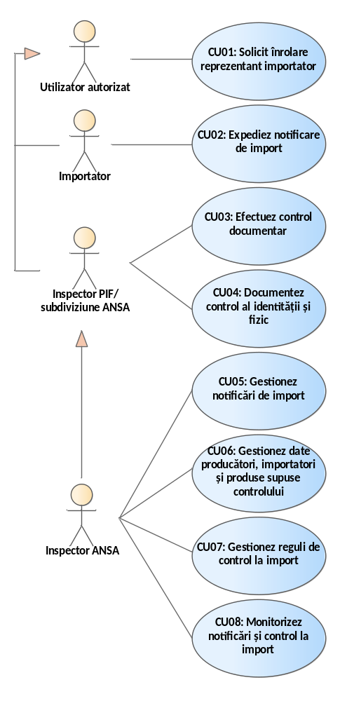
Figure 4. 3. Use cases for the functionalities provided by the SSI component "Import Monitoring and Control".

CU01: Request to register as an importer representative
This use case includes functionalities for requesting access to the SSI "Import Monitoring and Control" and obtaining the right to use the information system for the preparation and transmission of import notifications by economic agents for products subject to ANSA supervision and control . Thus, the MCI must allow the submission of an access request from entities that do not yet have an active account or are seeking to add a new representative.

CU02: Sending import notification
Through this use case, MCI will provide functionalities for authorized users with the role of Importer to prepare and send prior notifications regarding the import of products subject to ANSA supervision and control . Import notifications will be prepared and sent by authorized users who have been previously registered as representatives of companies with the right to import.
An indicative description of the workflow for the preparation and submission of the import notification is included in Annex A1.1. , Annex A1.2. and Annex A1.3.

CU0 3: I perform documentary control
Use case through which MCI will provide functionalities intended for PIF Inspectors or ANSA Inspectors from the central office to perform documentary control of import notifications.
The MCI must allow for documentary control to be carried out both preventively, before the arrival of the goods at the border, and at the time of presentation of the transport unit at the checkpoint.

CU04: Document identity and physical control
Use case through which MCI will provide functionalities intended for PIF Inspectors or ANSA Inspectors from territorial subdivisions to document the identity and physical control of the lots indicated in the import notifications.
Identity and physical checks can be carried out either upon arrival of the transport unit at the control post or at the place of destination, if requested by the Importer .

CU05: Manage import notifications
Use case that provides functionalities necessary for ANSA to keep track of import notifications according to each field of activity and category of products subject to import control.

CU06: I manage data on producers, importers and products subject to control
Use case that implements functionalities necessary for authorized users within ANSA to keep records of data about:
- producers and exporting countries from which the import of products subject to ANSA control at border inspection posts is permitted;
- non-resident economic agents who can submit prior notifications for the transit of products on the territory of the Republic of Moldova;
- the combined nomenclature of goods and the configuration of products (categories/subcategories) that are subject to control based on prior notifications for each area.

CU07: Manage import control rules
It represents a use case intended for IT System Administrators who will have access to modify the configuration data of the import supervision and control mechanism such as nomenclatures, classifiers, configuration variables, specification parameters and control requirements. This data will only be able to be modified by the MCI system administrator or another role with appropriate responsibilities in the event of changes to the regulatory framework.

Functionalities related to alert registration and dissemination processes
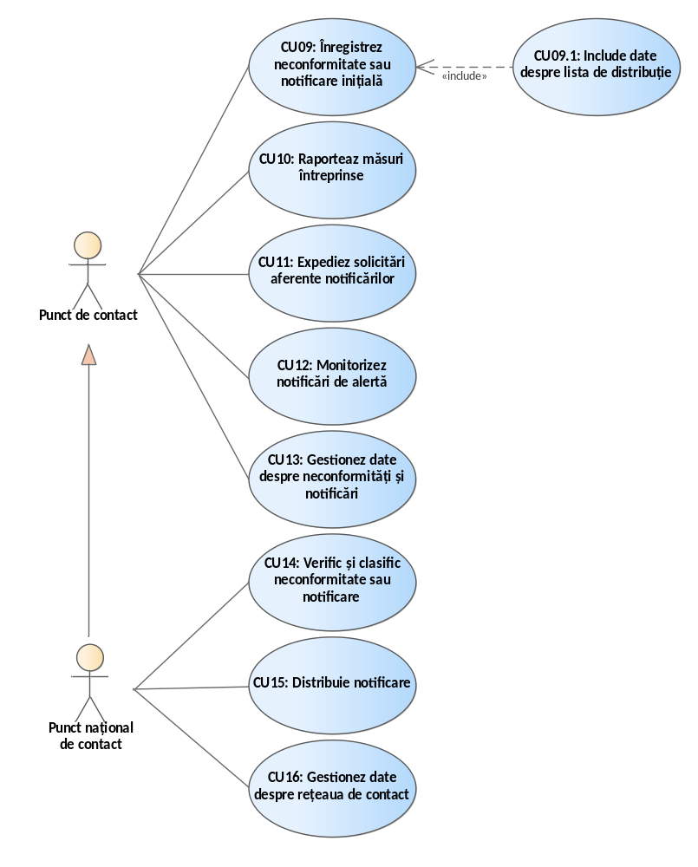
Figure 4. 4. Use cases for the functionalities provided by the SSI component "Alert Recording and Dissemination".

CU09: I register non-compliance or initial notification
Key use case of IDA that provides the functionality required to record data about non-compliances or initial notifications. The functionality to record non-compliances is only available to users with the National Contact Point (NCP ) role. Initial notifications can be created by any registrar designated as a Contact Point of the contact network.
The categories of data that are saved when registering a notification are detailed in Appendix 3 .

CU10: I report measures taken
Use case through which Contact Points report the measures taken in the management of a notification, ensuring documentation and traceability of the actions applied.

CU 11: I send requests related to notifications
Use case that provides authorized users, acting as PNC or Point of Contact , with functionalities for submitting requests related to notifications, in order to complete or ensure the quality of the data provided up to that point.

CU12: I monitor alert notifications
Use case provided by IDA and available to users with the role of PNC or Point of Contact intended for implementing the functionalities for monitoring performance indicators obtained as a result of registering notifications.
Every user will only view the indicators related to their level of competence and the data to which they have access rights.

CU13: I manage data about non-conformities or notifications
Use case that provides authorized users with the role of PNC or Point of Contact with the functionalities necessary for the management of data regarding non-conformities and notifications such as:
- requests for expertise;
- decisions on the classification of non-compliance/notification;
- notification validation;
- validation of requests for modification/withdrawal/closing notification;
- provision of additional information;
- other relevant functionalities.

CU14: Check and classify non-compliance or notification
Use case that implements functionalities required by PNC for verification, classification of non-conformities and notifications, ensuring the accuracy of recorded data.
All classification decisions will be recorded in the IDA , including the related justifications and any contributions from the profile departments in the form of follow-up records.

CU15: Distribute notification
Use case that provides authorized users with the role of PNC or Point of Contact with functionalities necessary for distributing notifications to other points of contact. Notification distribution rights are established according to the structure of the alert network and the ANSA organizational chart , so that the attributions reflect institutional responsibilities and operational hierarchy.

CU16: I manage data about the contact network
This use case includes dedicated PNC functionalities for managing contact network data. The network will be managed through a hierarchical nomenclature of contact points, organized by levels and areas of competence.

Functionalities related to data management about food chain operators
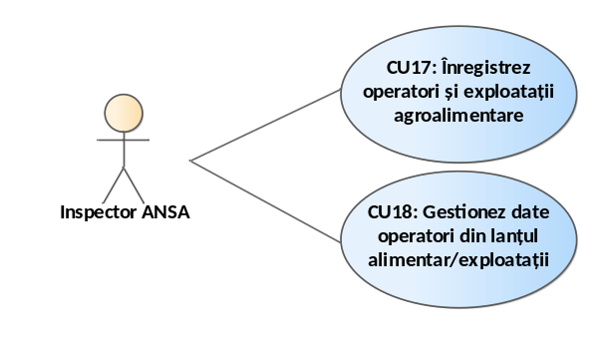
Figure 4. 5. Use cases for the functionalities provided by the SSI component "Register of food chain operators".

CU17: I register agri-food operators and holdings
This represents a key use case implemented through the SSI "Register of Food Chain Operators" and will provide comprehensive functionalities for users with authorized access to register food chain operators and the agri-food holdings they manage.

CU18: I manage data of food chain operators/farms
The SSI "Register of food chain operators" will provide functionalities intended for authorized users with specific roles within ANSA for the management of data on food chain operators and agri-food holdings under their management. The ROLA will be made up of the official registers of ANSA for the recording of data related to ANSA activity and the management of the records will be carried out following the request from economic agents or at the decision of ANSA .
All data categories that must be taken into account when designing the ROLA described and illustrated in the Information Objects section of the SSI "Register of food chain operators" .

functionalities for all users, administration and system functionalities
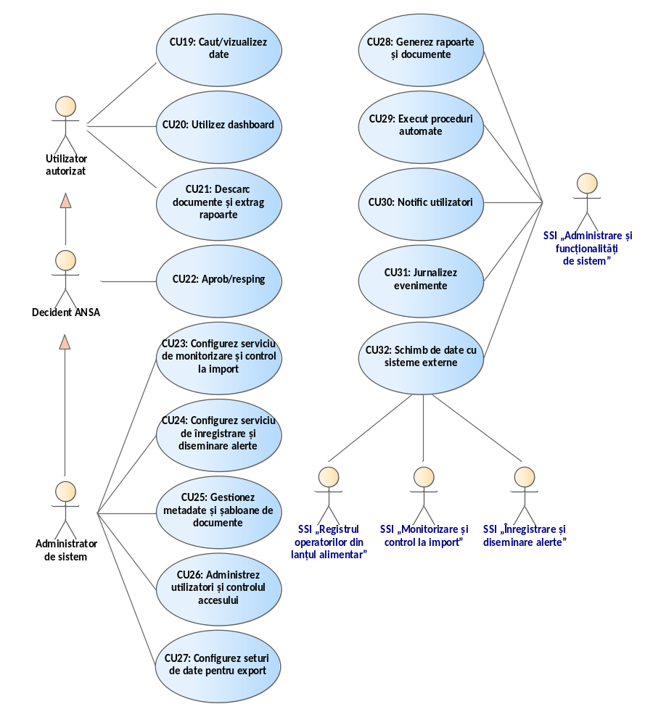
Figure 4. 6. Use cases for administration and system functionalities.

CU19: Search/view data
Complex use case that provides all the functionalities for formulating information search criteria in the database. The information system will provide global or advanced search facilities in the information content of the data collection so that SIMIDA system users can use different search strategies to explore desired results.

CU20: I use dashboard
It represents a tool through which authorized users of SIMIDA will be alerted and will be able to quickly view and access all business events related to their interaction with the IT system and service tasks ( for example: system notifications, workflow events, etc. ). The dashboard will also provide direct access to the functionalities related to notified business events (for example: direct access to the electronic import notification form, direct access to follow-up records added to a notification or non-compliance, etc. ).

CU21: Download documents and extract reports
Functionality accessible to all authorized users, who, depending on their role in SIMIDA, will have access to generate, view and download standard and ad-hoc documents and reports regarding the information content of the IT system.
An indicative list of document templates and description of filtering parameters is included in Annex 2 .

CU22: Approve/reject
SIMIDA business processes ( for example: ANSA Inspector , National Contact Point, ANSA Decision Maker, etc. ) through which they will be able to approve or reject draft documents or other types of records depending on the stages of the work process they are at. The decision-making functionality categories could include the workflow evolution decision (choosing the workflow evolution alternative or making changes to the workflow evolution).

CU23: Configure import monitoring and control service
The system administrator will have access to modify the configuration data of the import monitoring and control service. The service must ensure the management of operational parameters, notification flows and rules for performing documentary and physical control.

CU24: Configure alert recording and dissemination service
administrator will have access to modify the configuration data of the alert registration and dissemination service. The service must ensure the management of operational parameters, notification flows and alert transmission rules within the national network.

CU25: I manage metadata and document templates
Use case that provides users with the System Administrator role access to functionalities intended for managing nomenclatures, classifiers and metadata whose identifiers are used to complete electronic forms used in business processes implemented by SIMIDA .

CU26: I manage users and access control
This use case describes the functionalities intended for the System Administrator through which he manages the profiles and roles of authorized users of the information system. Also, this use case must provide the functionalities necessary to define the access rights of users to the user interface components and the data necessary to specify the behavioral characteristics of the user interface components in the interaction with authorized users.

CU27: Configuring datasets for export
This represents a use case through which authorized users with business administration roles of the information system use a mechanism that provides functionality for configuring and exporting data sets from the common data warehouse of the components within the SIMIDA perimeter .

CU28: I generate reports and documents
It is a use case that provides all the functionalities for generating reports and electronic documents so that the relevant roles of the IT system can carry out the modeled business processes under optimal conditions. All reports and documents produced within the workflows implemented in SIMIDA must be generated in accordance with the standard forms approved by ANSA .
The developer will configure and integrate into the user interface of SIMIDA components at least the following reports according to Annex 2 .

CU 29: Execute automatic procedures
Technical and indispensable use case for the proper functioning of the information system that provides the functionalities for triggering and automatically operating a series of automatic procedures specific to the components within the SIMIDA perimeter in order to rationally use server resources, launch specific services and provide data to authorized users at the appropriate time ( for example: sending notifications; event logging; automatic generation and assignment of tasks; generating reports in the background; performing backups; other automatic procedures ).
All automatic procedures necessary for operating SIMIDA components under optimal conditions will be implemented, configured and triggered through the "System Administration and Functionalities" SSI .

CU30: Notify users
Use case that provides user notification functionalities in accordance with the business roles configured for the components in the SIMIDA perimeter . The IT subsystems in this perimeter will access, through the available APIs, the service for generating and sending notifications to authorized users based on business events that require their involvement. Depending on the user's role (their profile configuration data), the following notification strategies will be used: notification through the MNotify government platform; notification in the authorized user's dashboard.

CU31: I journal events
It represents a use case through which the logging of business events generated by the functional components of SIMIDA will be performed . Any event generated within the business processes implemented within SIMIDA will be logged and saved in the corresponding tables of the Database. The information subsystems within the SIMIDA perimeter will access the relevant business event logging service through the available APIs.

CU32: Data exchange with external systems
Use case that will provide the functionalities to exchange data with external information systems by achieving interoperability with them and achieving integration with shared information systems. This data exchange refers to the exposure or consumption of data through interfaces intended for mutual data exchange ( for example: receiving data from external sources, sending data to external information systems and bidirectional data exchange ).
The "Integration Microservice" component will provide the functionalities necessary to unify access to shared information systems for all subsystems that are part of SIMIDA .

Generic IT system workflows
Workflows within SIMIDA refers to the specific processes for processing import notifications sent by Importers, recording and disseminating non-conformities and notifications, recording and managing data on food chain operators and agri-food holdings, as well as disseminating public data.
SIMIDA must be implemented on a transactional basis, when any addition, update or deletion of data is carried out through specific electronic forms to be processed based on specialized workflows. In this regard, it is necessary to implement the following basic information flows, available to different categories of users of the SIMIDA IT project:

Workflow for submitting and examining the notification regarding the import of products subject to sanitary-veterinary, phytosanitary and food safety supervision and control
It represents the flow in which Importers, ANSA representatives and external information systems are involved for receiving data from official sources, validating the content of import notifications by ANSA representatives. This workflow includes the interaction of several MCI users with clear responsibilities within the process of transmitting and examining the notification regarding the import of products subject to sanitary-veterinary, phytosanitary and food safety supervision and control.
The following indicative scenario and tools are to be implemented in the MCI:
- The importer authenticates in the system using MPass. MCI will implement the mechanism for verifying the powers of representation granted through MPower for requesting and collecting permissive acts/documents from ANSA, on behalf of the holder.
- The importer selects the type of import notification and completes the form proposed by the system.
- MCI warns the Importer , during the completion of the notification, if there are alerts associated with the information entered.
- The MCI notifies the BIP inspectors at the border inspection post specified in the notification regarding the registration of a new import notification.
- Upon arrival of the transport unit at the border, based on the registration number, SI "Frontiera" queries the MCI for import notification data. If there is an active notification, SI "Frontiera" sends to the MCI confirmation of the arrival of the transport unit at the border.
- The PIF inspector performs the documentary control of the import notification and decides on: permitted border crossing; promotion for physical control; return for completion; detention at the border, rejection of the notification.
- The importer will be notified of the PIF Inspector's decisions . If necessary, he will complete/correct the import notification data.
- Notifications promoted for identity and physical control will be analyzed and documented by the responsible PIF Inspector . In case of request for physical control at destination, these activities will be carried out by the ANSA Inspector from the respective territorial subdivision.
- The PIF inspector will record in the MCI all decisions regarding the admission or rejection of the import of the goods specified in the notification.
- All decisions related to the import notification will be submitted to customs authorities through interoperability with the "ASYCUDA World" SI.
- The MCI will notify the PIF Inspector of the existence of an import notification for transit purposes that must be closed at his inspection post.
- The PIF inspector at the point of exit from the country will document the closure of the import notification for transit purposes.
- In the case of sampling during physical control, the results of laboratory investigations will be transmitted to the MCI through interoperability with LIMS .
- MCI , throughout the notification review flow, will record all traceability events (data changes, status changes, approval/rejection events) and will send relevant notifications to all actors involved in the import notification review process.
The detailed description of the workflow for the submission and examination of the notification regarding the import of products subject to sanitary-veterinary, phytosanitary and food safety supervision and control is presented in Annex A1.1.

Workflow for submitting and reviewing the notification regarding the import of plant protection products/fertilizer products
It represents the flow in which Importers, ANSA representatives and external information systems are involved for receiving data from official sources, validating the content of import notifications by ANSA representatives. This workflow includes the interaction of several MCI users with clear responsibilities within the process of transmitting and examining the notification regarding the import of phytosanitary products or fertilizer products.
The following indicative scenario and tools are to be implemented in the MCI:
- The importer authenticates in the system using MPass. MCI will implement the mechanism for verifying the powers of representation granted through MPower for requesting and collecting permissive acts/documents from ANSA, on behalf of the holder.
- The importer selects the type of import notification and completes the form proposed by the system.
- MCI warns the Importer , during the completion of the notification, if there are alerts associated with the information entered.
- The MCI notifies the Inspector in the ANSA central office regarding the registration of a new import notification.
- The ANSA inspector performs the documentary control of the import notification and decides on the admission/rejection of the import, or return for completion if necessary.
- In the event of returning the notification for completion/correction, the Importer applies the changes and resends the notification to the ANSA Inspector for repeated control.
- Upon arrival of the transport unit at the border, based on the registration number, SI "Frontiera" will query the MCI for import notification data. If there is an active notification, SI "Frontiera" will send to the MCI confirmation of the arrival of the transport unit at the border.
- The PIF Inspector performs the identity and physical checks, then documents the results and decisions in the MCI. In case of a request for physical checks at destination, these activities will be carried out by the ANSA Inspector from the respective territorial subdivision.
- The PIF inspector will record in the MCI all decisions regarding the admission or rejection of the entry of the goods specified in the notification into the country.
- The importer will be notified by the system regarding the completion of the import and the decisions made by ANSA representatives regarding the submitted import notification.
- All decisions related to the import notification will be submitted to customs authorities through interoperability with the "ASYCUDA World" SI.
- MCI , throughout the notification review flow, will record all traceability events (data changes such as registration number, notification status; approval/rejection events) and will send relevant notifications to all actors involved in the import notification review process.
The detailed description of the workflow for the submission and examination of the notification on the import of plant protection products is presented in Annex A1.2. , and for fertilizer products see Annex A1.3.

Workflow for recording, reviewing and disseminating non-conformities and notifications
It represents the flow involving contact points, members of the rapid alert network and external information systems for receiving data from official sources. This workflow includes the interaction of several IDA users with clear responsibilities within the process of recording and disseminating non-conformities/notifications.
The following indicative scenario and tools are to be implemented in the IDA :
- The National Contact Point (NCP) authenticates in IDA using MPass.
- The PNC accesses the non-conformity registration form and completes the available data.
- IDA automatically receives, through the interoperability ensured with LIMS, all non-conformities found following laboratory investigations.
- IDA sends notifications to the PNC regarding newly registered non-conformities available for review.
- The PNC examines new non-conformities and classifies them either as simple non-conformities or as notifications that need to be initiated. If necessary, the PNC distributes the non-conformity for further analysis and expertise to the relevant technical department.
- The PNC updates the classification of the respective non-conformity and the status of revised/classified non-conformity in the Non-conformity Register.
- In the event of non-compliance being included in the initial notification, the PNC assigns the Contact Point responsible for initiating and subsequently completing the notification.
- The initiating contact point, designated by the PNC , accesses the form for registering a new notification or opens, for completion, the notification generated following the decision to classify a simple non-compliance. In this situation, certain fields are automatically pre-filled with information taken from the non-compliance that was the basis for the notification. The initial notification is sent to the PNC for approval and coding.
- The PNC approves the classification assigned by the contact point, or reclassifies it as appropriate. If necessary, the PNC requests the expertise of the technical department in the field.
- The notification approved by the PNC is automatically encoded by the IDA by applying a unique notification code.
- The PNC distributes the notification to all contact points it considers relevant.
- Contact points can complete the notification, using IDA facilities , with additional information, change requests, measures taken, etc. Change requests are sent to the PNC for approval.
- IDA sends notifications to the PNC when notification modification requests are registered that require approval.
- The PNC decides on the approval or rejection of a change request.
- Changes approved by the PNC are applied to the notification by the Initiating contact point.
- Contact Point requests the closure of the notification when all parties involved have fulfilled their responsibilities. The closure request is forwarded to the PNC for approval.
- The PNC decides whether to approve or reject the closure of the notification. In case of rejection, the PNC adds the justification and sends the notification to the contact point for review.
The detailed description of the workflow for recording and reviewing non-conformities/notifications is presented in Annex A 1.4.

Workflow for the registration of food chain operators and agri-food holdings
It represents the flow in which ANSA Inspectors and external information systems are involved in receiving data from official sources. This workflow includes the interaction of several ROLA users with clear responsibilities within the process of registering food chain operators and agri-food holdings.
The following indicative scenario and tools are to be implemented in ROLA :
- The ANSA Inspector authenticates in the system via MPass and accesses the form for registering the food chain operator or agri-food holding if the Inspector makes a fully manual registration, or selects an existing registration request in the register to complete it with additional data.
- The ANSA inspector completes all available data (as a result of the unannounced control) about the food chain operator or agri-food holding and attaches the necessary documents.
- ROLA consumes data on food chain operators and agri-food holdings through interoperability services exposed by external systems SIA GEAP, eServicii.gov.md (FOD) and SSI "State Phytosanitary Register" (RSF). The received data will be automatically registered in ROLA .
- GEAP SIA transmits to ROLA data relating to authorized operators and holdings, resulting from the approval and issuance processes of permissive acts.
- The SSI "State Phytosanitary Register" provides data on the registration of operators in the phytosanitary field, as well as economic agents registered for the production and/or processing and/or marketing of seeds.
- eServicii.gov.md (FOD) transmits data on requests for registration of food chain operators and/or holdings, as well as the documents attached by Applicants when submitting the request.
- The ANSA Inspector reviews and completes, as appropriate, the data consumed from external systems . In the case of registration requests originating from the FOD, the ANSA Inspector digitizes the attached documents and enters the related data into ROLA .
- The ANSA inspector, upon request, extracts from the ROLA the registration extract of the food chain operator and/or the agri-food holding.
- ROLA, during the notification examination process, fully records traceability events (data changes, status changes, events transmitted by external systems, etc.) and sends the corresponding notifications to all actors involved in the registration of the operator and/or agri-food holding.

Workflow for data management on food chain operators/agri-food holdings
They represent workflows in which ANSA Inspectors are involved who have a role in managing the data recorded in ROLA . At least the following workflows are to be implemented in ROLA to ensure the necessary tools to carry out ANSA's activity in optimal conditions:
- modification of data about food chain operators/agri-food holdings;
- issuance of the registration extract in ROLA;
- suspension of the registration of the food chain operator/agri-food holding;
- deregistration of the food chain operator/agri-food business;
- other workflows, as appropriate.

Workflow for automated dissemination of public interest data
It represents a workflow through which open data created within SIMIDA's business processes are disclosed. The dissemination of open data related to SIMIDA is to be carried out through the SSI "ANSA Public Portal" and the Government Data Portal.

Information system data flows
The data flows related to the cooperation mechanism of information resources within the SIMIDA perimeter are described in the data flow diagrams in Figures 4.7 - 4.9. It includes the main data flows that are carried out between human actors with access rights to functionalities and work processes that are digitized through the information subsystems within the SIMIDA perimeter . Likewise, these diagrams describe the data flows carried out in an automated manner by ensuring interoperability between information systems and external information resources and information subsystems within the SIMIDA perimeter .
According to the data flow diagrams, all information subsystems within the SIMIDA perimeter will allow access to data related to its business processes through the following methods:
- through the MConnect interoperability platform according to the provisions of Law no. 142/2018 on data exchange and interoperability;
- through the "e-ANSA" SII Integration Microservice component intended both for achieving interoperability with external information systems and for data exchange between the component subsystems of the "e-ANSA" SII. Thus, external information resources will be able to be accessed jointly and similarly by all "e-ANSA" SII subsystems ;
- through the facilities offered by the user interface of SIMIDA components .
It is advisable to design and implement and jointly use a relational and binary data store for all information subsystems within the SII "e-ANSA". Thus, the developer will design and develop all the data structures necessary for the implementation of SIMIDA using the existing instance of MS SQL Server that is configured on the technological infrastructure of ANSA in MCloud. Likewise, SIMIDA must support an integrated data model for reference data (nomenclatures, classifiers, configuration parameters, etc.) that will be common for all subsystems within the perimeter of the SII "e-ANSA".
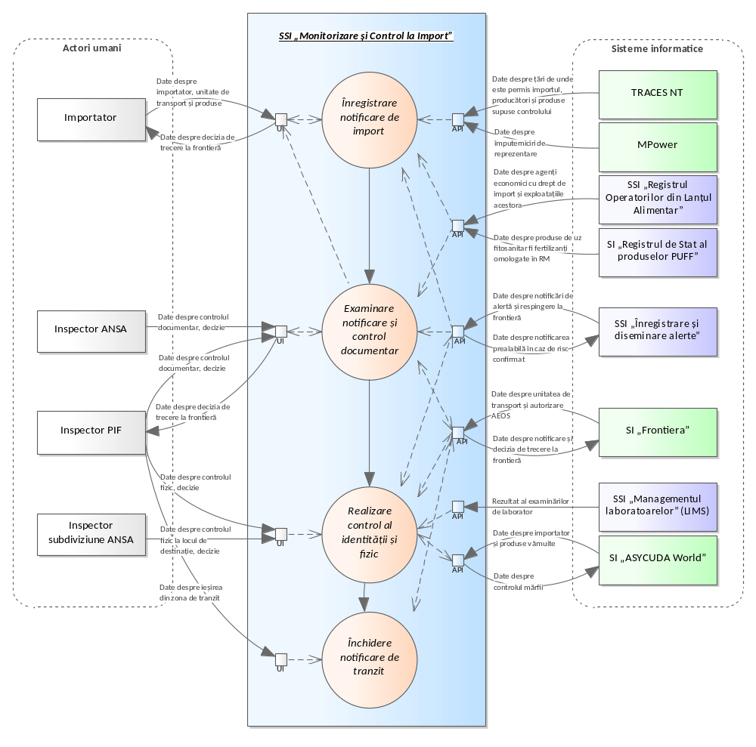
Figure 4. 7. Data flows within the information space of the SSI "Import Monitoring and Control".
As shown in Figure 4.7, the SSI "Monitoring and control at import" will exchange data necessary for its business processes both with external IT systems and with other information subsystems of the SII "e-ANSA". Thus, the SSI "Monitoring and control at import" will be able to query and receive the following categories of data:
- data on economic agents with the right to import and their holdings from the SSI "Register of food chain operators";
- data on phytosanitary products and fertilizers approved in the Republic of Moldova from the SI "State Register of Phytosanitary Products and Fertilizers";
- data on alert and border rejection notifications from the SSI "Alert Registration and Dissemination" ;
- data on laboratory investigations and results of laboratory examinations from the SSI "Laboratory Management" ;
- data about the transport unit and AEOS authorization from SI "Frontiera";
- data about the importer and customs-cleared products from SI "ASYCUDA World";
- data on countries from which imports are permitted, producers and products subject to control from TRACES NT;
- data on powers of representation registered through MPower.
At the same time, the "Import Monitoring and Control" SSI will provide the following categories of data to external information systems and resources, such as:
- data on prior notification in case of confirmed risk;
- data on the notification and the decision to cross the border;
- data on the control of goods at border inspection posts or at the place of destination of the goods;
- data on the decision to admit the import of goods subject to ANSA control ;
- data related to the traceability of imported products.
The "Import Monitoring and Control" SSI will implement the necessary functionalities and user interface facilities for authorized users to provide all data and documents within the workflows. The following categories of input data could be entered by human actors of the information system:
- data on requests for registration of representatives of economic agents with import rights;
- data about the importer, transport unit and products subject to ANSA supervision and control ;
- data on import notifications;
- data on documentary control of import notifications and border crossing decisions;
- data on the physical inspection and the decision to admit the import;
- data on exit from the transit zone;
- data about decisions related to workflows.

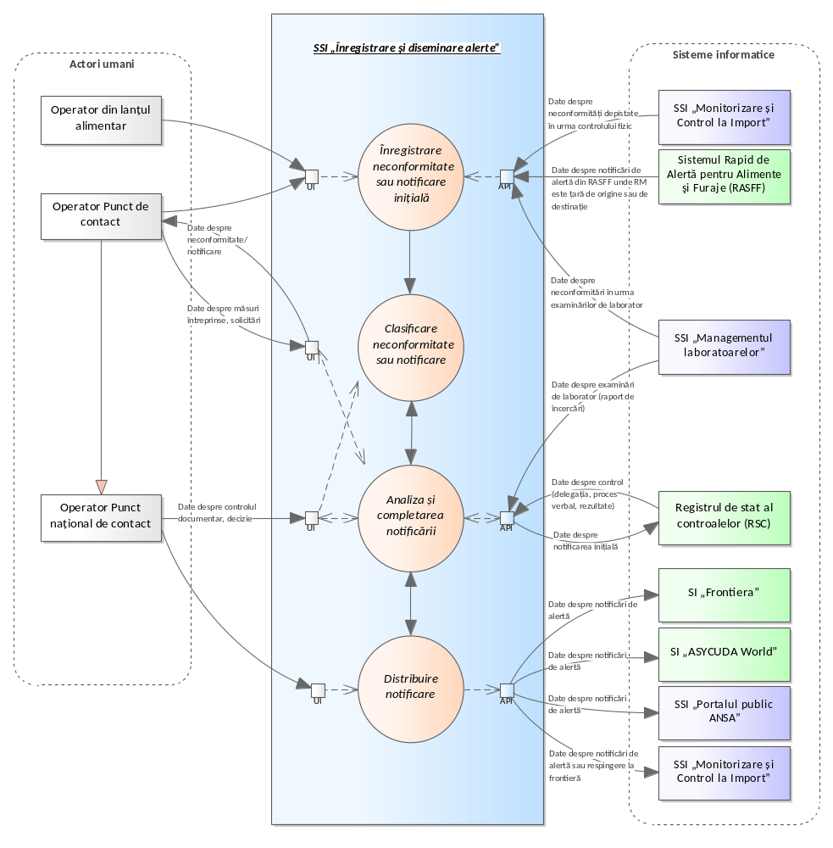
Figure 4. 8. Data flows within the information space of the ISS "Alert registration and dissemination".
As seen in Figure 4.8, the SSI " Registration and dissemination of alerts " will exchange data necessary for its business processes both with external IT systems and with other information subsystems of the SII "e-ANSA". Thus, the SSI "Registration and dissemination of alerts" will be able to query and receive the following categories of data:
- data on non-conformities detected following physical control from the SSI "Import Monitoring and Control";
- data on non-conformities following laboratory examinations from the SSI "Laboratory Management" ;
- data on state control (delegation, minutes, results) from the State Register of Controls;
- data on alert notifications where RM is the country of origin or destination from RASFF.
At the same time, the "Alert Registration and Dissemination" SSI will provide the following categories of data to external information systems and resources, such as:
- data on non-compliances and alert notifications;
- data on alert or rejection notifications at the border;
- data on contact points and measures taken to mitigate risks in relation to alert notifications;
- data related to the traceability of alert notifications.
The "Alert Registration and Dissemination" ISS will implement the necessary functionalities and facilities offered by the user interface for authorized users to provide all data and documents within the workflows. The following categories of input data will be able to be entered by human actors of the information system:
- data on non-conformities or initial notifications;
- data on measures taken by members of the national contact point network;
- data on documentary control and classification of non-conformities or notifications;
- data on members of the national contact point network;
- data related to the distribution of the alert notification to the national network of contact points and the public;
- data about decisions related to workflows.

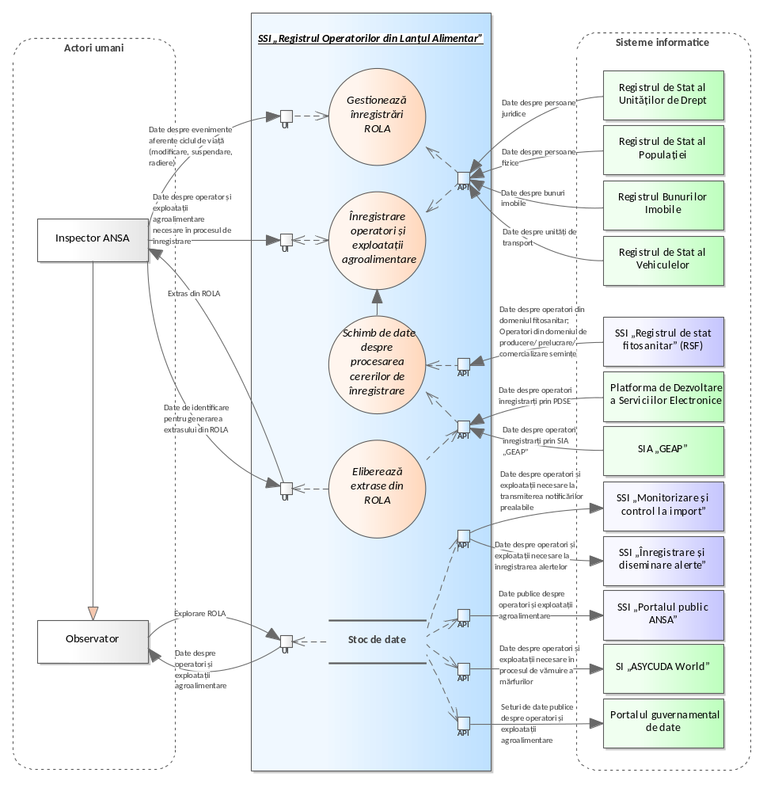
Figure 4. 9. Data flows within the information space of the SSI "Register of food chain operators".
As shown in Figure 4.9, the SSI "Register of food chain operators" will exchange data necessary for its business processes with both external IT systems and other information subsystems of the SII "e-ANSA". Thus, the SSI "Register of food chain operators" will be able to query and receive the following categories of data:
- data about operators in the field of phytosanitary products, operators in the field of production, processing, and marketing of seeds from the SSI "State Phytosanitary Register" ;
- data related to agricultural crops and cultivated agricultural varieties, products subject to phytosanitary control and phytosanitary products and fertilizers from the SSI "State Phytosanitary Register" ;
- data on food chain operators, agri-food holdings and permissive documents issued through SIA "GEAP";
- data on requests for registration of food chain operators from the Electronic Services Development Platform;
- data on legal entities from the State Register of Legal Entities;
- data about individuals from the State Population Register;
- data about real estate from the Real Estate Registry;
- data on vehicles registered with sanitary and veterinary authorities from the State Register of Vehicles.
At the same time, the SSI "Register of Food Chain Operators" will provide the following categories of data to external information systems and resources, such as:
- data on registered/authorized veterinary operators and agri-food holdings managed by them;
- data on officially registered food safety operators and their holdings;
- data about registered economic agents in the phytosanitary field and their holdings;
- data on economic agents registered for the production and/or processing and/or marketing of seeds and their holdings;
- data on specialized warehouses for fertilizers and phytosanitary products;
- data on the technological equipment used in the manufacture of rectified ethyl alcohol, distillates of agricultural origin and/or in the production of strong alcoholic beverages.
- public data about food chain operators and agri-food holdings for publication on the SSI "ANSA Public Portal";
- extracts from ROLA;
- data about food chain operators and their holdings necessary in the customs clearance process of goods that will be accessed by the "ASYCUDA World" SI;
- public data sets about agri-food operators and holdings for publication on the Government Data Portal.
The SSI "Register of food chain operators" will implement the necessary functionalities and facilities offered by the user interface for authorized users to provide all data and documents within the workflows. The following categories of input data could be introduced by human actors of the information system:
- data and documents related to food chain operators and agri-food holdings necessary in the registration or modification process;
- data about various events related to the life cycle of the ROLA registration (modification, suspension, deletion);
- other data necessary in the ROLA records management process.

The data model of the computer system
Figures 4.10, 4.11 and 4.12 present a high-level view of the data model for each information subsystem included in the SIMIDA perimeter . It should be noted that the data models illustrated in these figures are generic, in order to understand the specifics of the data with which the actors involved are to operate. These models do not describe the structure of the database , but provide an understanding of the categories of key information objects used within the business processes digitized through these information subsystems. Nomenclatures, classifiers, and other data categories that are secondary to the data model are not reflected in the given diagrams. The developer is to modify the data model to ensure the implementation of the development requirements for each subsystem in particular.
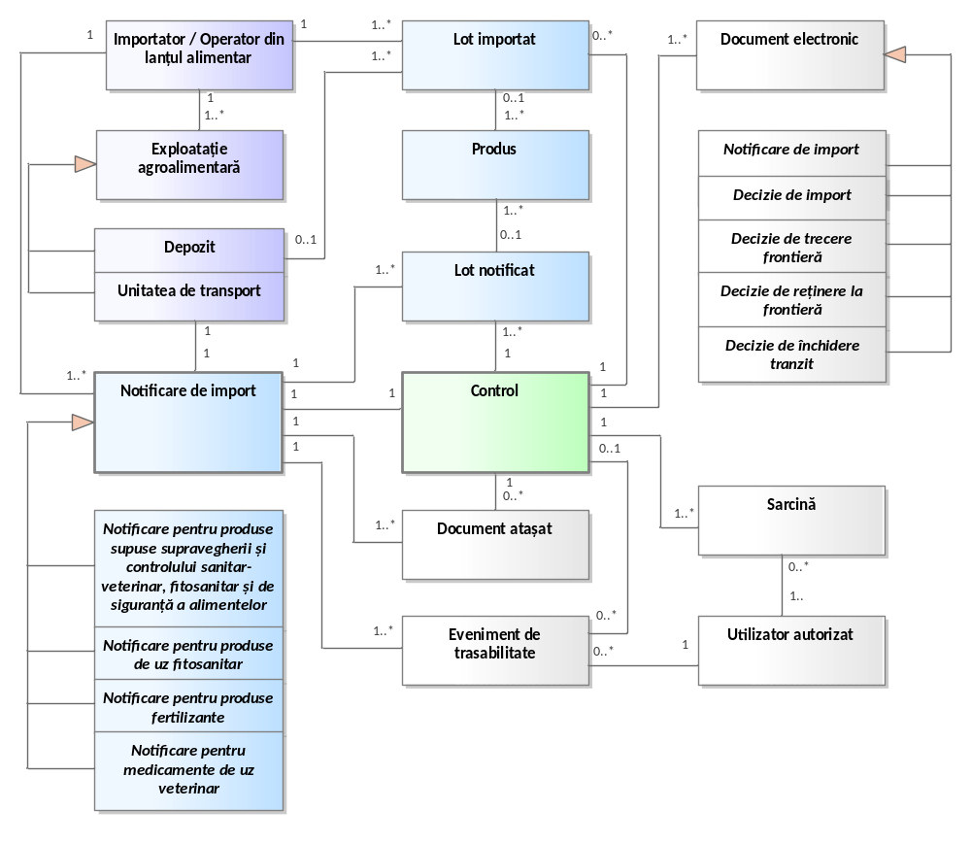
Figure 4. 10. Information objects of the SSI "Import monitoring and control".
Figure 4.10 presents the IT solution consisting of the following categories of information objects of different complexity that must be taken into account in the development process of the " Import Monitoring and Control " ISS:
- Import notification – represents a complex information object that contains all the data regarding import notifications sent in advance by importers . We distinguish the following types of import notifications that must be submitted before the import operation:
  - Prior notification for the import of products subject to sanitary-veterinary, phytosanitary and food safety supervision and control;
  - Prior notification for the import of phytosanitary products;
  - Prior notification for the import of fertilizer products.
- Notified batch – represents an information object that contains all the data about the product batch that is notified for import or transit.
- Imported batch – represents an information object that contains all the data about the batch of product that has been approved for border crossing.
- Product – represents an information object that contains all the data about the product that is notified for import or transit.
- Importer – represents the economic agent carrying out activities of importing goods. For the most part, these economic agents are operators registered in ROLA. Foreign importers are manually registered in the system after submitting the transit notification and validating their data.
- Control – represents an information object that contains all data related to official checks carried out by inspectors on goods previously notified for import, with the aim of deciding on the admission/rejection of import, as well as their entry into the country.
- Agri-food holding – represents the units registered/authorized by ANSA within or with the help of which food chain operators with an importer profile carry out their activities, namely: warehouse; transport unit.
- Traceability event – represents an information object that contains data related to all traceability events of files for examining prior notifications through the information system (addition, modification, cancellation, approval/rejection, workflow, etc.).
- Authorized user – represents the authorized user profile with access to the user interface of the SSI "Import Monitoring and Control ".
- Task – represents the information object that describes the tasks assigned to authorized users of the " Import Monitoring and Control " SSI created and managed according to the workflows operated with and the service duties of the users.
- Electronic document – represents a complex information object that includes all documents developed or inserted within the workflows of the SSI "Import Monitoring and Control" . We distinguish the following types of electronic documents managed by ANSA (for each of them a specific template will be implemented in the "Import Monitoring and Control" SSI ):
  - Import decision – document generated in the "Import Monitoring and Control" SSI as a result of the event of approval or rejection of the prior notification after the documentary control carried out by the central ANSA Inspector.
  - Border crossing decision – document generated in the "Import Monitoring and Control" ISS as a result of the event of admission or rejection of border crossing, by PIF inspectors, of the cargo lots specified in the import notification.
  - Border detention decision – document generated in the "Import Monitoring and Control" SSI as a result of the event of detention of goods at the border.
  - Transit closure – document generated in the "Import Monitoring and Control" SSI , in the case of notifications for transit purposes, as a result of the notification closure event by the PIF inspector at the point of exit from the country.

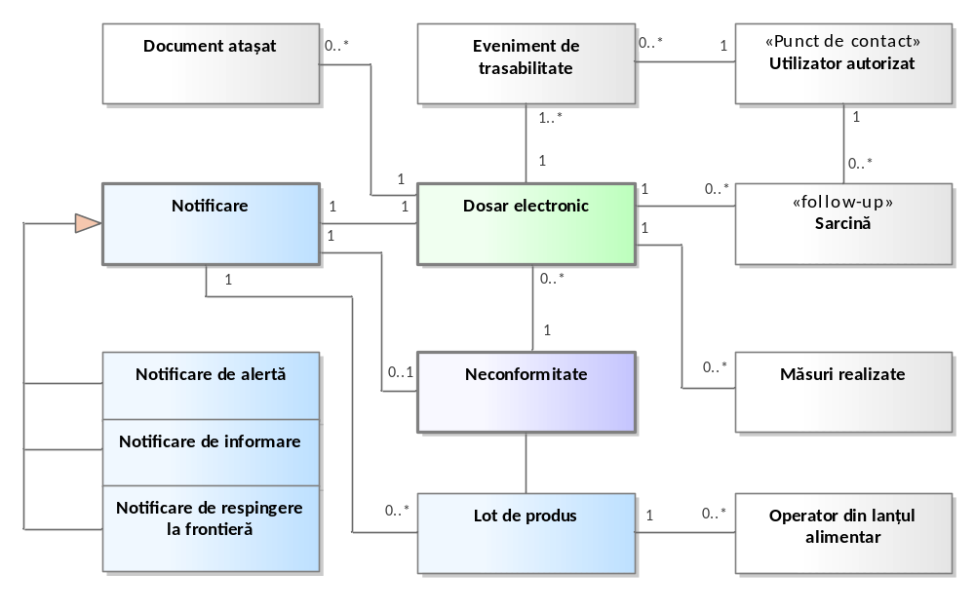
Figure 4. 11. Information objects of the SSI "Alert registration and dissemination".
Figure 4.11 presents the IT solution consisting of the following categories of information objects of different complexity that must be taken into account in the development process of the " Alert Registration and Dissemination " ISS:
- Notification – represents a complex information object that contains all the data regarding non-compliance notifications registered by the contact points of the national rapid alert system. We distinguish the following classification into which these notifications can be classified:
  - Initial notification, which can be classified into:
  - Alert notification;
  - Border rejection notification;
  - Information notification, from which derives:
    - Information notification for tracking;
    - Information notice for attention.
- Non-conformity – represents a complex information object that stores all unclassified non-conformities, taken through interoperability with LIMS, or added manually from other external sources (news, European notifications, border rejection decisions, etc.).
- Electronic file – which represents a complex information object that includes all the data for processing non-conformities or initial notifications. The file will be created as a consequence of the receipt of a new registration request from the external “e-Services” system, as well as upon the initiation of a registration directly in ROLA by ANSA. A file will consist of several categories of data and electronic documents such as:
  - data on non-compliance (if applicable);
  - data on the initial notification (if applicable);
  - distribution list;
  - data about the batch/product in question;
  - data on the food chain operators concerned;
  - test report results;
  - traceability events;
  - other relevant data and documents related to the business processes for processing the non-compliance or notification.
- Product batch – represents an information object that contains all the data about the product batch that is the subject of a non-conformity or notification registered by the point of contact.
- Measure taken – represents an information object that contains all the data regarding the measures taken to resolve a registered notification.
- Traceability event – represents an information object that contains data related to all traceability events of files for examining non-conformities and notifications managed through the SSI " Alert Registration and Dissemination " (addition, coding, modification, withdrawal, approval/rejection, workflow, etc.).
- Authorized user – represents the authorized user profile with access to the user interface of the SSI “ Registration and dissemination of alerts ”. These users are contact points within the national rapid alert network.
- Task – represents the information object that describes the tasks assigned to authorized users of the ISS " Alert Registration and Dissemination " created and managed according to the workflows used and the users' job duties.

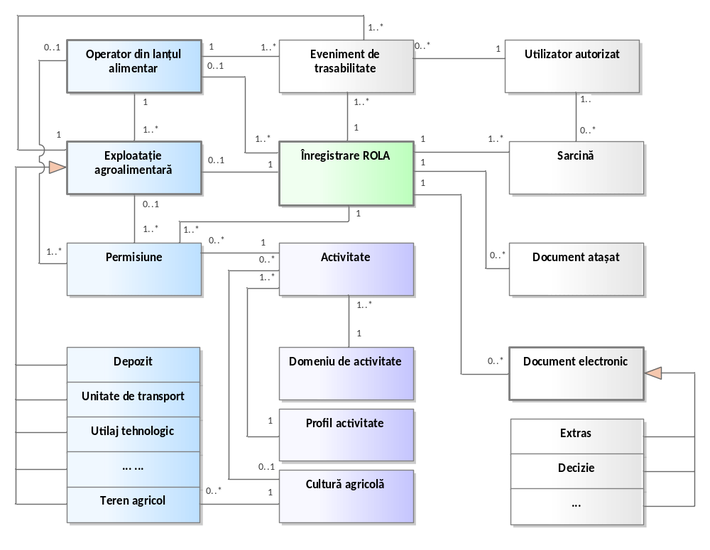
Figure 4. 12. Information objects of the SSI "Register of food chain operators".
Figure 4.12 presents the IT solution consisting of the following categories of information objects of different complexity that must be taken into account in the development process of the S SI "Register of food chain operators" :
- Food chain operator – represents the legal entity or natural person who is an animal owner, producer of products of plant origin, producer of seeds and planting material or any other activity subject to control and supervision by ANSA and who is subject to inclusion in the SSI "Register of food chain operators" .
- Agri-food holding – represents the units within which food chain operators carry out their activities and which are managed by them (slaughterhouses, livestock farms, agricultural land intended for plant crops, storage centers and collective warehouses, food processing units of non-animal or animal origin, etc.). Through the SSI "Register of food chain operators" , ANSA will be able to manage several types of agri-food holdings, each with a set of specific attributes. Among these, we distinguish the following types of agri-food holdings:
  - deposit;
  - agricultural land;
  - animal husbandry;
  - slaughterhouse;
  - apiary;
  - technological equipment;
  - transport unit;
  - others.
- ROLA Registration – represents a complex information object that includes all the data related to the registration of food chain operators and agri-food holdings. ROLA records can be entered manually or taken over automatically through integration with the "e-Services" electronic services portal. A ROLA record will consist of several categories of data and electronic documents such as:
  - data about the food chain operator;
  - data about the agri-food holding;
  - data about the permissive act;
  - traceability events;
  - other relevant data and documents related to the business processes for processing the request for public services.
- Electronic document – represents a complex information object that includes all documents developed or inserted within the workflow of the S SI "Register of food chain operators" . Based on the diagram presented in Figure 4.12, we distinguish the following types of electronic documents managed by ANSA (for each of them the system will implement a specific template):
  - Extract – document generated by the S SI "Register of food chain operators" and issued by ANSA based on existing data from official registers managed by ANSA.
  - Decision – document generated by S SI "Register of food chain operators" as a result of an event of modification or suspension of registration, deletion from ROLA;
- Permission – represents a key information object that is described by the totality of attributes that specify the rights of food chain operators to practice an activity that is under the supervision and control of ANSA according to the regulatory framework. Food chain operators may have one or more permissions depending on the registered agri-food holding, field of activity, activity profile, agricultural crop (as applicable) and other rights explicitly defined by ANSA.
- Activity – information object consisting of all attributes that describe the activities pursued by ANSA in order to ensure supervision and control in accordance with the regulatory framework. It is a key information object according to which the permissions of food chain operators to carry out one or another activity are configured. It is described primarily by the field of activity, the activity profile, the agricultural crop (as applicable), and other attributes necessary to constrain a specific activity in the legal norms.
- Field of activity – information object consisting of all attributes that describe the fields of activity of ANSA as the central authority for state supervision and control in the field of veterinary and zootechnics, phytosanitary and plant protection, food safety, production and circulation of wine and alcoholic products, consumer protection in the food sector and compliance with licensing conditions ( for example: veterinary, plant protection, seed control, etc. ).
- Activity profile – information object that represents the main activity profiles of operators in the food chain and that ANSA follows for supervision and control ( for example: purchase, storage, processing, manufacturing, distribution, transportation, import, export, etc. ).
- Agricultural crop – information object that is described by the totality of data about crop groups, crops, varieties and managed by ANSA in order to record data on surveillance activities in the field of phytosanitary, seed control and plant protection.
- Traceability event – represents an information object that contains data related to all traceability events of files for examining electronic service requests, food chain operators and holdings managed through the information system (addition, modification, cancellation, approval/rejection, workflow, etc.).
- Authorized user – represents the authorized user profile with access to the user interface of the information system.
- Task – represents the information object that describes the tasks assigned to authorized users of the S SI "Register of food chain operators" created and managed according to the workflows operated with and the service attributions of the users.
The identification of information objects within the SIMIDA components is carried out by using, for each of them, a unique identification code, including the one provided by the external data provider on the basis of which the information object is formed (example: IDNP, IDNO, Cadastral Number, etc.).
The detailed description of the information objects, including their attributes, is presented in Annex 3 .

Functional requirements of the information system
This section of the technical specifications reflects the functional aspects of the components within the SIMIDA perimeter . The requested software solution that is to automate the business processes related to the provision of public services by ANSA must satisfy all the functional requirements described below.
The functional requirements contained in this document are described according to the following principle:
- each functional requirement is indexed based on 2 values: X and Y , where X represents the category of the described functional requirement and Y – the ordinal number of the functional requirement;
- For each functional requirement, the mandatory implementation requirement is associated with it: M – mandatory requirement to be implemented, D – desired requirement to be implemented and I – informative requirement.

Functional requirements for SSI "Import monitoring and control"
The "Import Monitoring and Control" SSI will implement "Front Office" and "Back Office" functionalities in order to manage the workflows related to the provision of public services for prior notification of the import of products subject to ANSA supervision and control. The "Front Office" component will provide the necessary functionalities for importing economic agents to prepare and submit the import notification. The "Back Office" component will provide the functionalities with authorized access to authenticated users with specific roles within ANSA for processing import notifications, efficient coordination of control activities at border inspection posts and preparation of the documents necessary in the import supervision process.

CU01: Request to register as an importer representative
The functional requirements intended for implementing the functionalities for requesting the enrollment of an importer representative are presented in Table 5.1.
Table 51. Functional requirements of use case CU01.
ID | compulsoriness | Functional requirement description
CF 01.01. | M | MCI must offer functionalities dedicated to economic agents or their representatives, through which they can request registration and obtain the right to use the system, necessary for completing and submitting import notifications related to products subject to ANSA supervision and control.
CF 01.02. | M | MCI must allow the submission of an access request from the following categories of economic agents that do not have a user account:  - importing economic agents registered by ANSA as food chain operators, with the right to import goods intended for introduction on the domestic market of the Republic of Moldova;  - economic agents registered abroad who intend to transit the territory of the Republic of Moldova;  - representatives of economic agents who are to submit import notifications.
CF 01.03. | M | An importing economic agent will have functionalities to request registration and obtain access to the system for its legal administrator. He will authenticate via MPass, then complete the registration form.
CF 01.04. | M | MCI will automatically process enrollment requests submitted by the legal administrator of the economic agent registered in the Republic of Moldova, if the authentication for submitting the request was performed through the MPass shared information system. MCI will automatically activate the user account of the legal administrator.
CF 01.05. | M | Foreign economic agents intending to transit the territory of the Republic of Moldova will have functionalities to send the enrollment request without the need for authentication through MPass. These requests will be redirected for manual processing to the responsible ANSA Inspector .
CF 01.06. | M | Representatives of local or foreign economic agents will have functionalities to request enrollment as a company representative, responsible for submitting import notifications on its behalf.  If the representative authenticates via MPass, the request will be sent for approval to the legal administrator of the company mentioned in the form, otherwise, to the ANSA Inspector .
CF 01.07. | M | Requests will be submitted through the SSI " ANSA Public Portal" , by completing an electronic form in which the following data will be indicated :  - representative's profile (personal data, contact details);  - the importing company profile (telephone, work email address, etc.).
CF 01.08. | M | Data about the importing company or representative, which are available in external information resources, will be automatically retrieved based on the unique identification code. Thus, data about the importing company will be queried from RSUD based on the IDNO code, and data about the representative will be queried from RSP based on the IDNP code.
CF 01.09. | M | MCI will send notifications to the ANSA Inspector or to the importing company when there are requests that require review and approval, as well as in the event of changes to the data related to registered representatives.
CF 01.10. | M | MCI will provide functionalities for the ANSA Inspector to view the details of enrollment requests registered without authentication via MPass, respectively recording the decision to accept or reject enrollment requests.
CF 01.11. | M | MCI will provide functionalities intended for the company's legal administrator to:  - viewing enrollment requests sent on behalf of the company by representatives (individuals) who authenticated through MPass;  - recording the decision to accept or reject the request (if necessary, MCI will allow the approval of this category of representatives by the ANSA Inspector);  - viewing the list of user representatives of the company and other data related to their activity and access to the computer system.
CF 01.12. | M | MCI must provide functionalities for automatic updating of data about the importing company by querying from RSUD and updating data about representatives by querying from RSP.  MCI will not allow editing of official company/representative registration data that is automatically updated by taking it from external information resources.
CF 01.13. | M | The MCI must include functionalities for automatically notifying the Applicant regarding the decision to approve or reject the enrollment request.
CF 01.14. | M | MCI access request , the system automatically create and activate a user account, with appropriate permissions to the functionalities according to the assigned role.
CF 01.15. | M | MCI must log all events related to the representative enrollment request process.
CF 01.16. | M | MCI will ensure traceability functionalities of changes that occurred as a result of the representative enrollment request process. MCI will retain all versions of the records.

CU0 2: I am sending import notification
The functional requirements intended for implementing import notification sending functionalities are presented in Table 5.2.
Table 52. Functional requirements of use case CU02.
ID | compulsoriness | Functional requirement description
CF 02.01. | M | MCI will implement functionalities necessary for the preparation and dispatch of prior notifications regarding the import of products subject to ANSA supervision and control .  Import notifications will be prepared and submitted by authorized users who have been previously registered as representatives of companies with import rights.
CF 02.02. | M | Prior import notifications may be submitted exclusively for the following purposes:  - import of products for introduction into the domestic market of the Republic of Moldova;  - transit through the territory of the Republic of Moldova.
CF 02.03. | M | Depending on the purpose of the import (domestic market, transit), import notifications may be submitted by:  - companies resident in the Republic of Moldova that are also registered as food chain operators with import rights in areas supervised by ANSA;  - foreign companies that intend to transit goods through the territory of the Republic of Moldova.
CF 02.04. | M | When submitting the notification on behalf of a resident economic agent, MCI will verify data about its registration in ROLA , as well as the import right for the mentioned category of goods, based on the permitted import activities.  In the event that no record was identified in ROLA about the economic agent, the system will allow the notification to be sent, but will display a warning for the user sending the notification.
CF 02.05. | M | For importers registered in ROLA , MCI will facilitate the notification submission process by automatically suggesting notification types and products that can be imported based on the food chain operator's field of activity and their specific import rights.
CF 02.06. | M | For notifications submitted in the case of transit through the territory of the Republic of Moldova, the MCI will require the additional indication of the point of exit from the country.
CF 02.07. | M | MCI must provide functionalities for the preparation and transmission of the following types of import notifications:  - DCIA – notification regarding the import of products subject to sanitary-veterinary supervision and control (live animals);  - DCIP – notification regarding the import of products subject to sanitary-veterinary supervision and control (products of animal origin);  - DCID – notification regarding the import of products subject to food safety surveillance and control;  - DCIPP – notification regarding the import of products subject to phytosanitary supervision and control;  - DCIPUF – notification regarding the import of products subject to the supervision and control of phytosanitary products;  - DCIF – notification regarding the import of products subject to fertilizer supervision and control.
CF 0 2.08. | M | When completing data on the categories of imported products subject to sanitary-veterinary, phytosanitary and food safety control, MCI will allow the specification of products according to the combined nomenclature of goods (Law no. 172/2014) and the list of products indicated in Annexes 2-4 of Government Decision no. 938/2018.
CF 02.09. | M | For phytosanitary products, the MCI will allow their selection and verification according to the data in the State Register of Phytosanitary Products and Fertilizers (RSPUFF). The MCI will be interoperable with RSPUFF and will receive data on this category of products, including data on approval and the related period. The categories of data that can be queried from RSPUFF are described in Annex 8 .
CF 02.10. | M | RSPUFF will not be mandatory .
CF 02.11. | M | When submitting the notification, for products of the type "EC Fertilizers", the Importer will confirm the data on his own responsibility.
CF 02.12. | M | In the event that the fertilizer product does not fall into the "EC Fertilizers" category and cannot be identified by the importer in RSPUFF , the MCI system will allow the notification to be sent, requesting additional confirmation from the user submitting the notification.  In such cases, the ANSA Inspector from the competent department will be informed through a warning message, in order to further verify the product approval data.
CF 02.13. | M | MCI must be integrated with ROLA to automatically verify data on food chain operators with the right to import and their holdings (e.g. , for plant protection products, the importer must select the registered warehouse for storing plant protection products and fertilizers ) .
CF 02.14. | M | When submitting an import notification, depending on the type of notification, the importer will complete at least the following categories of data:  - data about the representative of the importing economic agent;  - data about the importer/operator in the food chain;  - data about the agri-food holding, as appropriate ( warehouse, etc. );  - data on imported products;  - data about the manufacturer of the imported goods and the exporting country;  - data about the border inspection post where the products will be introduced into the country;  - data about the transport unit with which the products will be introduced into the country;  - documents attached to the notification;  - other data depending on the type of notification.
CF 02.15. | M | MCI , through integration with ROLA, will implement automatic verification of data about the carrier and data about the sanitary-veterinary authorization for the transport unit. Some transport units are additionally certified for the right to import organic products. In ROLA , these will be specified separately with a mention that allows them to carry out such imports.
CF 02.16. | M | For certain product categories, the importer will be able to specify in the notification data about the place of physical control ( for example, to be carried out at the place of destination of the goods ). For this purpose, MCI will be interoperable with ROLA , to verify information regarding the place of destination of the goods subject to control ( for example: authorized/registered sanitary-veterinary warehouses, PUFF warehouses, etc. ).
CF 0 2.17. | M | MCI will provide the necessary functionalities for authorized users submitting the import notification to manually fill in data about the manufacturer.
CF 02.18. | M | The MCI must be interoperable with the IDA to exchange the necessary data to prevent the import of products for which there are active alert notifications. Thus, when completing a prior import notification, if the product selected by the importer is listed in a border rejection notification, the MCI will allow the notification to be sent, but will display an explicit warning message regarding the risk of rejection at customs.
CF 02.19. | M | MCI will facilitate the display of all alert notifications, received from IDA , in the process of preparing and submitting import notifications. These alert notifications will be displayed according to the type of imported product, country of origin, provenance, measures taken, etc.
CF 02.20. | M | MCI must implement functionalities for automatic verification and validation of data in the import notification. Thus, for example, the Importer will be informed in advance in the event of import suspension for certain product categories.
CF 02.21. | M | MCI will highlight import notifications that include information or warning mentions and will send information notifications to the ANSA Inspector from the competent department.
CF 02.22. | M | MCI should provide functionality to create pre-import notifications by copying data from an existing import notification. This functionality will facilitate the rapid completion of import notifications.
CF 02.23. | M | The MCI must provide the necessary functionalities for the Importer to be able to cancel the import notification in case he fails to complete the import within the legal deadline.
CF 02.24. | M | The MCI must provide contextual help functionality for users. For each compartment/field to be filled in the electronic form, the Authorized User will have the opportunity to access extended suggestions and help instructions.
CF 02.25. | M | MCI must display validation messages at each stage of completing the electronic import notification form, in an easy-to-understand manner, with suggestions and links to the user guide.
CF 02.26. | M | The MCI must provide functionality for automatically saving data from the electronic import notification submission form. Automatic saving will ensure that already completed parts of the form are not lost. In these cases, the notification will be saved with the status "draft".
CF 02.27. | M | The MCI must provide functionalities to the Authorized User to view, modify and delete the record that is in "draft" status.
CF 02.28. | M | MCI must provide relevant information about user support channels and Call Center/Help Desk phone numbers.
CF 02.29. | M | MCI must log all events related to the process of sending import notifications.
CF 02.30. | M | An indicative description of the workflow for the preparation and submission of the import notification is included in Annex A1.1 , Annex A1.2 and Annex A1.3 .

CU03: I perform documentary control
The functional requirements intended for implementing functionalities for performing documentary control of import notifications are presented in Table 5.3.
Table 53. Functional requirements of use case CU03.
ID | compulsoriness | Functional requirement description
CF 03.01. | M | MCI will implement functionalities necessary for performing documentary control of import notifications. This functionality will be accessible exclusively to PIF Inspectors or ANSA Inspectors at the central office, depending on the type of notification.
CF 03.02. | M | The MCI must allow for documentary control to be carried out both preventively, before the arrival of the goods at the border, and at the time of presentation of the transport unit at the checkpoint.
CF 03.03. | M | The system must provide mechanisms to facilitate communication between the Importer and ANSA , allowing the request and transmission of clarifications or additional documents.
CF 03.04. | M | If the import notification contains incomplete or erroneous data, the system must allow ANSA Inspectors to return it with an indication of the identified non-conformities.
CF 03.05. | M | MCI will provide functionalities intended for the Importer to correct non-conformities and re-send the import notification for repeated validation.
CF 03.06. | M | The ANSA inspector at the central office will have functionalities to complete the list of products included by the Importer in the import notification with some additional data, as well as the product category (herbicide, insecticide, etc.) or other data from the notification.
CF 03.07. | M | Inspectors responsible for documentary control must be able to access at least the following data sets in the system:  - alerts associated with the information declared in the import notification;  - information or warning statements, as a result of the automatic validation of the import notification;  - data about importers who have the right to import organic products;  - data on AEO economic operators;  - other relevant data.
CF 03.08. | M | The MCI must provide Inspectors performing documentary control with functionalities for recording the import approval/rejection decision or promotion for identity and physical control.
CF 03.09. | M | MCI will notify all participants involved in the process of verifying import notifications regarding the result of the documentary control ( PIF Inspectors, ANSA Inspectors from territorial subdivisions, etc. ).
CF 03.10. | M | ANSA decisions regarding import controls ( including approval/rejection of import after documentary control ) will be automatically transmitted, in electronic format, to the Customs Service systems through established interoperability mechanisms, without requiring manual intervention or paper confirmation from economic operators.
CF 03.11. | M | The MCI must log all events related to the documentary control process of import notifications.

CU04: Document identity and physical control
The functional requirements for implementing identity and physical control documentation functionalities for import notifications are presented in Table 5.4.
Table 54. Functional requirements of use case CU04.
ID | compulsoriness | Functional requirement description
CF 04.01. | M | MCI will implement functionalities necessary for documenting the identity and physical control of product lots indicated in import notifications. This functionality will be accessible exclusively to PIF Inspectors or ANSA Inspectors from territorial subdivisions, depending on the place of physical control mentioned in the notification.
CF 04.02. | M | The MCI must allow for the documentation of identity and physical checks for any of the following situations, as appropriate:  - upon arrival of the transport unit at the border inspection post;  - at the place of destination, if this has been requested by the Importer .
CF 04.03. | M | MCI will be integrated with the customs system SI "Frontiera" to benefit from operational data about the importer to facilitate the control of goods at the border, creating a predictive and coordinated process.
CF 04.04. | M | The MCI must automatically provide and the "Frontiera" SI will query data from the MCI about the notifications sent by the Importer to ANSA, based on the registration number of the transport unit .
CF 04.05. | M | By ensuring interoperability between MCI and SI "Frontiera" , PIF Inspectors will benefit from viewing data about transport units that have entered the border and are due to come for control based on prior notification.
CF 04.06. | and | By ensuring interoperability between MCI and AND "Border" , The Customs Service will ensure access to data on import notifications and the need to subject the goods to ANSA control . Thus, the Customs Service will direct the Importer to the ANSA inspection post for the necessary control.  Detailed description of the data exchange mechanism between MCI and The "Border" SI and possible scenarios is included in Annex 7 .
CF 04.07. | M | Inspectors responsible for identity and physical control must be able to access at least the following data sets in the system:  - the decision and conclusion of the previously carried out documentary check;  - alerts associated with the information declared in the import notification;  - information or warning statements, as a result of the automatic validation of the import notification;  - data about importers who have the right to import organic products;  - data on AEO economic operators;  - other relevant data.
CF 04.08. | M | The MCI must provide functionalities to the PIF Inspectors or the ANSA Inspector in the territory for documenting the identity and physical control for drafting a decision, as appropriate:  - decision to allow border crossing, for physical control at destination;  - border crossing decision with customs clearance allowed;  - detention decision;  - rejection decision at the border;  - transit closure decision;  - other relevant decisions.
CF 0 4.09. | M | MCI must provide access and the Customs Service will automatically query data through AND "Border" regarding the decisions taken by ANSA. Thus, the Customs Service will have all the necessary information with the result of the ANSA control to allow the Importer to cross the border .
CF 04.10. | M | For import notifications requesting physical control at the place of destination, the PIF Inspector will have to ensure that the documentary control has been passed, and will subsequently be able to record the decision for free border crossing provided that the control at the place of destination has been carried out.
CF 04.11. | M | Based on the information in the notification , the MCI will send a notice to the responsible Inspector in the territorial subdivision of loop regarding the need to carry out identity checks and physical checks at destination .
CF 04.12. | M | The MCI will provide the ANSA Inspector from the territorial subdivision with functionalities to complete the dedicated section of the import notification with data on the result of the physical control carried out in the territory. Subsequently, based on this information, the ANSA Inspector from the subdivision will draw up the act of passage, detention or rejection at the border.
CF 04.13. | M | The MCI must provide access and the Customs Service will receive the decision of the physical control carried out in the territory through interoperability with the Customs Service 's IT system "ASYCUDA World" . Based on this decision and other additional data received from the official ANSA registers, the Customs Service will be able to carry out customs clearance of the goods.
CF 04.14. | M | AND "ASYCUDA World" will receive data from MCI about at least the following events :  - permitted crossing – if the Importer has passed the ANSA control or if the ANSA has decided to carry out the control at the place of destination.  - permitted customs clearance – if the Importer has passed ANSA control either at the border inspection post or at the place of destination.
CF 04.15. | M | PIF inspectors must receive in advance, by achieving integration between MCI and AND "Border", data on trusted importers (AEOs) present at the border and identified based on the registration number of the transport unit that was included in the import notification .  The Customs Service manages, through the AEO information system, data on importing economic agents classified as Trusted Importers . In collaboration with the Customs Service , ANSA gives priority to this category of importers when carrying out controls at BIPs .
CF 04.16. | M | MCI will provide functionalities intended for the PIF Inspector at the point of exit from the country for closing the notification and completing the transit, for import notifications for transit purposes.
CF 04.17. | M | MCI will send information notifications regarding the result of the identity and physical control to all participants involved in the process of verifying import notifications ( PIF Inspectors, ANSA Inspectors from territorial subdivisions, Importer, etc. ).
CF 04.18. | M | ANSA decisions regarding identity and physical control of import notifications ( permitted crossing, permitted customs clearance, etc. ) will be automatically transmitted, in electronic format, to the Customs Service systems through established interoperability mechanisms, without requiring manual intervention or paper confirmation from economic operators.
CF 04.19. | M | MCI must log all events related to the identity and physical control process of import notifications.

CU 05: Manage import notifications
The functional requirements intended for the implementation of import notification management functionalities are presented in Table 5.5.
Table 5.5. Functional requirements of use case CU05.
ID | compulsoriness | Functional requirement description
CF 05.01. | M | MCI must provide functionalities for recording and processing import notifications. At least the following functionalities will be available to ANSA users:  - viewing import notifications;  - updating data on import notifications ( for example: data on the transport unit, notification status, etc. );  - validation of import notifications;  - blocking the Importer's access (if the registration or import right cannot be validated);  - closing transit notifications;  - other relevant functionalities.
CF 05.02. | M | MCI must provide Importers (including their representatives) with the ability to manage their own notifications. At a minimum, the following functionalities shall be available to Importers :  - viewing your own notifications;  - updating the data of submitted import notifications;  - cancellation of import notifications ( for example: import fails on time, etc.);  - other relevant actions.
CF 05.03. | M | MCI must apply automatic changes to import notifications, resulting from validations performed in the background, such as:  - validation of the import deadline;  - validation of the transit period;  - other relevant validations.
CF 05.04. | M | The MCI must allow notifications to be viewed and processed only by ANSA Inspectors (central office, territorial subdivisions and PIF) who have competence in the specific field of notification.
CF 05.05. | M | The system must ensure the restriction and granting of rights to view and process notifications registered in the MCI for ANSA Inspectors according to the following criteria:  - type of notification – access allowed only to Inspectors who have competence in the specific field of notification;  - border inspection post (BIP) – access allowed only for BIP Inspectors mentioned in the notification;  - specified place for physical control – extended access for the Inspector from the territorial subdivision where the destination place is located.
CF 05.06. | M | The MCI will provide the ANSA Inspector with functionalities for viewing and validating notifications containing information or alert mentions. If the ANSA does not have data about this economic operator, or the right to import is not proven, the ANSA Inspector will have functionalities for refusing the import and blocking the Importer's access to the MCI, if applicable.
CF 05.07. | M | The MCI must ensure the distinct and uniform highlighting of import notifications transmitted to PIF Inspectors or ANSA Inspectors , if they have associated alerts. The marking will be done through a standardized visual mechanism (e.g.: color, graphic symbol or textual label), so that inspectors can quickly identify critical notifications, regardless of the volume of data processed .
CF 05.08. | M | MCI will allow the Importer's legal administrator to manage all import notifications related to that economic agent.  Importer representative will only be able to manage their own submitted notifications.
CF 05.09. | M | The importer must have the possibility to change the registration number of the transport unit in the event that the importer changes the transport unit.  If necessary, this functionality can also be used by the ANSA Inspector .
CF 05.10. | M | The MCI must allow the Importer to cancel the submitted import notification, if impediments arise in completing the import on time.
CF 05.11. | M | The MCI must allow the simultaneous involvement of several ANSA Inspectors (central office, territorial subdivisions and PIF) in the import validation and approval process, in situations where the notification includes products subject to controls in different areas.
CF 05.12. | M | MCI will notify the Importer in advance of the expiry of the import deadline, as well as of the expiry of the transit deadline.
CF 05.13. | M | Import notifications whose import deadline has expired will be automatically canceled by MCI .
CF 05.14. | M | The MCI must automatically monitor the transit deadline ( 15 days from border crossing to entry into the country ) for import notifications for transit purposes and automatically update the notification status when the deadline is exceeded.
CF 05.15. | M | The MCI must automatically send alerts to the appropriate border inspection post and to the central apparatus of the ANSA if the transit deadline has expired and the import notification has not yet been closed.
CF 05.16. | M | The MCI must automatically notify ANSA Inspectors involved in processing an import notification of any changes applied to it, regardless of whether the change is made by a human user or automatically generated by the system .
CF 05.17. | M | The MCI must allow the generation of statistical reports on inspections carried out at the border, with the possibility of filtering and aggregating data by type of control, border inspection post, product category, exporting country, importer and other relevant parameters.
CF 05.18. | M | MCI must be able to export the entire import notification data set with all fields for analysis outside the system.
CF 05.19. | M | An import notification cannot be physically deleted if there is at least one record in the database that refers to it. In this case, it will only be possible to change the status of the record.
CF 05.20. | M | The MCI must log all events related to the import notification management process.
CF 05.20. | M | MCI will provide traceability functionalities for changes to import notification data. MCI will retain all versions of records.

CU 06: I manage data on producers, importers and products subject to control
The functional requirements intended for the implementation of data management functionalities on producers, importers and products subject to control are presented in Table 5.6.
Table 56. Functional requirements of use case CU06.
ID | compulsoriness | Functional requirement description
CF 06.01. | M | MCI must provide functionalities that allow ANSA users to keep records of producers, importers and products subject to control.
CF 06.02. | M | MCI will provide necessary functionalities to ANSA users to record data on producers and exporting countries from where the import of products subject to ANSA control is allowed. This information resource will be formed following the process of drafting and transmitting import notifications to the competent subdivisions of ANSA.
CF 06.03. | M | MCI will automatically save data about producers and exporting countries in a dedicated nomenclature as soon as the submitted import notification is accepted by ANSA.
CF 06.04. | M | At least the following data about producers will be stored in the created information resource:  - manufacturer name;  - address;  - country;  - other relevant data.
CF 06.05. | M | MCI will also provide data management functionalities for non-resident economic agents who can submit prior import notifications for the transit of products on the territory of the Republic of Moldova.
CF 06.06. | M | The MCI must automatically form an information resource with non-resident economic operators upon submission of their first import notification. At least the following identification and contact data will be stored about non-resident economic operators:  - name of economic agent;  - unique identification number (tax code);  - country of origin;  - legal form;  - mailing address;  - telephone, email;  - field of activity;  - other relevant data.
CF 06.07. | M | MCI will implement functionalities intended for ANSA users for the management of the combined nomenclature of goods and the configuration of products (categories/subcategories) that are subject to control based on prior notifications for each domain.  The Combined Nomenclature of Goods will be taken as the basis for identifying goods in the process of submitting import notifications.
CF 06.08. | M | MCI will provide functionalities for ANSA users responsible for updating the nomenclature with TRACES NT codes that are currently not found in Annexes 2-4 of Government Decision 938/2018.
CF 06.09. | M | The MCI must allow responsible ANSA users to update and, where appropriate, add notes to the records in the nomenclatures, regardless of whether they were created manually or automatically completed by taking over data from prior notifications.
CF 06.10. | M | MCI must be able to export the entire data set per each nomenclature, with all fields for analysis outside the system.
CF 06.11. | M | The MCI must log all events related to the data management process about manufacturers, importers and products subject to control.
CF 06.12. | M | MCI will ensure traceability functionalities of changes in data about manufacturers, importers and products subject to control. MCI will keep all versions of the records.

CU07: Manage import control rules
The functional requirements for managing import control rules are presented in Table 5.7.
Table 5.7. Functional requirements of use case CU07.
ID | compulsoriness | Functional requirement description
CF 07.01. | M | MCI will provide the necessary functionalities to properly manage and enforce import control rules for authorized users within the functionalities offered.
CF 07.02. | M | MCI will provide the functionalities for modifying the configuration data of the supervision and control mechanism upon import such as nomenclatures, classifiers, configuration variables, specification parameters and control requirements.
CF 07.03. | M | The MCI must provide functionality for configuring the minimum deadline for submitting pre-import notifications. The minimum submission deadline can be set depending on the type of notification ( for example: 24 hours for fertilizer notification, 3 days for phytosanitary product import notification, etc. ).
CF 07.04. | M | MCI will provide functionality for configuring mandatory verification criteria for controlling imported goods based on multiple characteristics. At least the following data categories must be taken into account when implementing these rules:  - importer/operator in the food chain;  - the exporting country;  - categories of imported products;  - producer;  - the place of destination of the products;  - border inspection post;  - others.
CF 07.05. | M | MCI will allow the configuration and management of data on the categories of products subject to ANSA control for which import into the Republic of Moldova, possibly transit through the territory of the Republic of Moldova, is permitted. The following particularities in the formation of these rules will be possible:  - managing data on countries from which the import of controlled products is permitted based on prior import notification;  - management of data on goods subject to ANSA control, depending on the field ( sanitary-veterinary, food safety, phytosanitary, etc. );  - managing data on products for which import is prohibited/suspended based on reinforced orders of ANSA;  - other rules.
CF 07.06. | M | MCI must provide functionalities for configuring filters that establish the frequency of control of imported products depending on several criteria. This automatic selectivity mechanism for carrying out physical control based on frequency can be established according to the following criteria:  - product category;  - types of products ( for example: organic products );  - border inspection post;  - importer's field of activity;  - risk level for product category;  - risk level depending on the country of origin of the products;  - registered alert notifications;  - importer's risk profile;  - others.
CF 07.07. | D | Based on pre-import notifications and rejection history, MCI will implement a risk profile formation mechanism for each of the above criteria. These risk profiles will be applied to the automated selection for physical control, by adjusting the frequency of controls or even excluding importers with a compliant history from control.  Also, based on these criteria, MCI will provide functionality to configure the minimum and maximum number of physical controls.
CF 07.08. | M | MCI , thanks to its interoperability with IDA and data on registered alert notifications, will offer manual and automatic configuration functionalities of the control frequency. For example, in case of registration of previous non-compliances, the control frequency will be changed to 100% for the next 10 batches of the importer mentioned in the alert notification .

CU08: I monitor notifications and import control
The functional requirements intended for the implementation of notification monitoring and import control functionalities are presented in Table 5.8.
Table 58. Functional requirements of use case CU08.
ID | compulsoriness | Functional requirement description
CF 08.01. | M | The MCI must provide functionalities for authorized users with specific rights to monitor the entire pre-notification process and import control, as well as the performance indicators obtained as a result of registering notifications.
CF 08.02. | M | MCI must provide authorized users with tools that will facilitate quick access to relevant data on the import of products according to the areas of activity supervised by ANSA.
CF 08.03. | M | Monitoring tools will be carried out through operational indicators, performance indicators and statistical reports generated by MCI .  Each relevant category of authorized users with access to import monitoring and control functionalities will have access to these tools depending on the roles and rights they have in the system.
CF 08.04. | M | The most frequently used monitoring tools will be available directly from the IT system dashboard.
CF 08.05. | M | At least the following categories of data must be generated and accessible to roles with monitoring rights:  - data on import notifications sent and not processed for each category of products subject to control;  - data on processed import notifications and with allowed import over a period of time;  - data on import notifications grouped by border inspection posts and calendar periods;  - data on import notifications grouped by import notification type and calendar periods;  - data on import notifications for which the import was not carried out within the allowed period;  - data on transit notifications and records at exit points from the country;  - data on rejected import notifications by product category, exporting country, importer, etc.;  - data on the busiest border inspection posts with control activities;  - other relevant categories of data for the purpose of carrying out import control monitoring activities.
CF 08.06. | M | MCI will ensure the monitoring and display, in each user's dashboard, of statistical reports and indicators resulting from the grouping and aggregation of relevant data, in accordance with the assigned access level and viewing rights.
CF 08.07. | M | Each user will only view the indicators related to their level of competence and the data to which they have access rights.

Functional requirements for SSI "Alert registration and dissemination"
The SSI " Registration and dissemination of alerts " will implement "Back Office" functionalities in order to manage workflows related to collaboration processes between members of the national network of contact points for the purpose of registering and disseminating alerts. This component will provide functionalities with authorized access to authenticated users with specific roles within ANSA and other public institutions for registering non-conformities and alert notifications, reporting measures taken to mitigate the risk to animals and the population, accessing and viewing data related to alerts where the Republic of Moldova is the country of destination or origin, completing the necessary documents in the process of examining and disseminating alerts.

CU09: I register non-compliance or initial notification
The functional requirements intended to implement the functionalities for recording non-conformities or initial notifications are presented in Table 5.9.
Table 5.9. Functional requirements of use case CU09.
ID | compulsoriness | Functional requirement description
CF 09.01. | M | IDA will implement functionalities necessary for recording non-conformities and initial notifications. This functionality will be accessible depending on user roles and rights.  An indicative description of this work process is included in Annex 1.
CF 09.02. | M | The non-conformity registration functionality is available to users with the Point of Contact and PNC roles.  Users with the PNC role will benefit from functionalities that allow the manual entry of non-conformities from the following sources:  - notifications from European Union information systems;  - media sources;  - consumer complaints;  - notifications from operators as a result of recording non-compliance with the implementation of self-control programs;  - other relevant channels, subject to their validation.
CF 0 9.03. | M | IDA will have a mechanism for automatically taking over non-conformities by ensuring interoperability with the LIMS information system, for non-conformities detected as a result of laboratory investigations.
CF 09.04. | M | At least the following data categories will be completed by the PNC when manually recording a non-conformity:  - description of non-conformity;  - risk classification;  - date of discovery;  - source of origin (European Union RASFF, media, other sources);  - product name;  - product type (animal feed/food);  - product category (meat, milk, etc.);  - batch/series code;  - the quantity affected;  - packaging and labeling;  - country of origin;  - legal basis;  - the food chain operator;  - laboratory results;  - attached documents;  - other relevant data.
CF 09.05. | M | Both manually entered non-conformities and those automatically taken from other subsystems will be stored in a dedicated non-conformity register.
CF 09.06. | M | The registration of an initial notification can be carried out through one of two initiation methods:  - registration of the notification at the initiative of the Contact Point ;  - registration of the notification by designating the initiating Contact Point carried out by the PNC , following the classification of a notification arising from a non-compliance.
CF 09.07. | M | Any Contact Point within the network will be able to initiate a notification, having previously selected its classification:  - alert notification;  - information notification for tracking;  - information notification for attention;  - border rejection notification.  Depending on the classification chosen, the system will automatically adapt the form structure, displaying the fields specific to each type of notification.
CF 0 9.08. | M | In the case of notifications derived from non-conformities, the initiator is designated by the PNC at the time of classification of the non-conformity. The system will inform the designated Contact Point about the assignment of the notification. When accessing the notification form, the relevant information derived from the non-conformity will already be pre-filled. At the same time, the designated Contact Point will be granted access to consult the details of the non-conformity that was the basis for the notification, as well as all follow-up actions associated with that non-conformity.
CF 09.09. | M | Completing the non-compliance registration or initial notification form involves filling in the fields with data, selecting predefined values from nomenclatures or classifiers, attaching the necessary documents to the electronic form. Also, certain sections of the form will be hidden or displayed depending on the selections made during its completion.
FC 09.10. | M | The contact point will be able to attach documents confirming or detailing the data indicated in the registration form. The attached files must be associated with a set of metadata: creation date, modification date, responsible person, size, type, etc.
CF 09.11. | M | Notifications involving suspicions or findings of fraud will be registered using the same procedural flow as the initial notifications, with the additional activation of a dedicated option for reporting fraud. In this context, the system will display some additional specific fields where the Contact Point will be able to add supporting arguments and upload relevant documents regarding the nature of the fraud.
CF 09.12. | M | IDA will allow the Contact Point to register initial notifications only for the directorates or subdivisions to which they are affiliated.
CF 09.13. | M | The contact point will have facilities for sending the completed initial notification for validation to the PNC .
CF 09.14. | M | When completing the form for recording non-conformities or initial notifications, IDA must ensure the pre-filling of certain fields with data from SIMIDA 's data warehouse or data from external sources ( RSP, RSUD, RBI, etc. ).
CF 09.15. | M | The data of food chain operators will be queried from the SSI " Register of Food Chain Operators" .
CF 09.16. | M | IDA must provide contextual help functionality for users. For each compartment/field to be filled in the electronic form, the Authorized User will have the possibility to access extended suggestions and help instructions.
CF 09.17. | M | IDA will provide functionality for automatic validation of input data. Validation must be performed both on the server and client side. At least the following types of validations will be implemented:  - the mandatory completion and data constraints related to the fields of the electronic form;  - a priori defined validation rules regarding the correlation of primary data;  - rules of behavior of the electronic form in the options chosen or the data filled in by the authorized user ;  - data validation by querying external IT systems;  - other validation rules identified following the business analysis.
CF 09.18. | M | IDA must display validation messages at each stage of completing the electronic application form, in an easy-to-understand manner, with suggestions and links to the user guide.
CF 09.19. | M | IDA must provide functionality for automatically saving data from the electronic non-compliance or notification registration form. Automatic saving will ensure that already completed parts of the registration form are not lost. In these cases the initial non-compliance or notification will be saved with the status “Draft”.
CF 0 9.20. | M | IDA must provide functionalities to the authorized user to view, modify and delete the record that is in the "Project" status.
CF 09.21. | M | IDA must provide relevant information about user support channels and Call Center/Help Desk phone numbers.
CF 09.22. | M | The IDA must log all events related to the process of recording non-conformities or initial notifications.
CF 09.23. | M | The categories of data that are saved when registering a notification are detailed in Appendix 3 .

CU10: I report measures taken
The functional requirements intended for implementing the functionalities for reporting data on measures taken are presented in Table 5.10.
Table 5.10. Functional requirements of the CU10 use case.
ID | compulsoriness | Functional requirement description
CF 10.01. | M | IDA must provide functionality for authorized users with the Point of Contact role to report data on actions taken on notifications to which they are subject.
CF 10.02. | M | IDA will provide the necessary functionalities to the Contact Point to complete the form for reporting data on measures taken in the process of managing a notification.
CF 10.03. | and | The measures taken are actions that can be recorded by the Contact Points that are part of the notification distribution list.
CF 10.04. | M | IDA will collect at least the following categories of data on the measures taken:  - measurement type;  - measure description;  - date of entry into force;  - duration;  - point of contact;  - other relevant data.
CF 10.05. | M | Each measure taken will be documented in the form of a follow-up associated with the respective notification.
CF 10.06. | M | The system must allow the uploading of supporting documents (reports, minutes, evidence) for each reported measure.
CF 10.07. | M | The IDA must notify the PNC of the new measures registered and allow it to view and download the attached documents as a result of reporting the measures taken .
CF 10.08. | M | The IDA must allow the NCP to add additional comments or requests regarding the reported measures, following the review and detection of incomplete or erroneous data.
CF 10.09. | M | IDA will ensure traceability functionalities of changes to data on measures taken. IDA will keep all versions of records.

CU 11: I send requests related to notifications
The functional requirements intended for implementing the functionalities for sending notification requests are presented in Table 5.11.
Table 5.11. Functional requirements of use case CU11.
ID | compulsoriness | Functional requirement description
CF 11.01. | M | IDA must provide functionalities for authorized users with PNC or Point of Contact roles to send requests related to registered notifications.
CF 11.02. | M | IDA will provide necessary functionalities to users with the Point of Contact role for sending requests in at least the following situations:  - request for expertise to the competent technical departments;  - requesting information or intervention from other Contact Points (profile departments);  - request to complete/rectify notification data;  - other relevant cases.
CF 11.03. | M | The contact points will also have functionalities for sending notification requests, in at least the following cases:  - request for additional information/intervention from contact points in subdivisions;  - request to change notification data;  - request to withdraw notification;  - request to close the notification;  - other relevant cases.
CF 11.04. | M | Each request must be associated with an existing notification, representing an addition or update to it. The request will be documented as a comment to the notification.
CF 11.05. | M | The IDA must allow the initiating Contact Point of the notification to suggest in the comments other Contact Points considered relevant for intervention in the notification. This will be done by adding a request for intervention of other Contact Points . This type of request requires the approval of the PNC .
CF 11.06. | M | IDA will store at least the following data about requests:  - request type;  - request description;  - date of request;  - the point of contact that sent the request;  - the contact point(s) targeted;  - other relevant data.
CF 11.07. | M | For requests involving a change in the status or classification of the notification, IDA will allow it to be assigned to the PNC for review .
CF 11.08. | M | IDA will provide functionality for the Contact Point that initiated the notification to request the closure of the notification by adding a follow-up record (comment), in which the PNC is designated as the targeted Contact Point .
CF 11.09. | M | IDA must notify the contact points concerned regarding the requests registered to them .
CF 11.10. | M | IDA will ensure data traceability functionalities for all registered requests.

CU 12: I monitor alert notifications
The functional requirements intended for implementing alert notification monitoring functionalities are presented in Table 5.12.
Table 5.12. Functional requirements of the CU12 use case.
ID | compulsoriness | Functional requirement description
CF 12.01. | M | IDA must provide functionalities for authorized users with PNC or Point of Contact roles to monitor alert notifications, as well as performance indicators obtained as a result of notification management.
CF 12.02. | M | IDA will allow monitoring of registered notifications, depending on the user's access level and their area of expertise.
CF 12.03. | M | IDA will ensure the monitoring of alert notifications as follows:  - monitoring of own notifications, as well as those in which the user is involved for information or intervention (intended for local inspectors);  - monitoring of notifications registered at the territorial subdivision level (for contact points at the territorial subdivision level);  - monitoring of notifications registered at the directorate level (for contact points at the level of profile directorates);  - monitoring of notifications by representatives of central public authorities (according to institutional competences);  - monitoring of all notifications registered at national level (for the National Contact Point ).
CF 12.04. | M | IDA will ensure the monitoring and display, in each user's dashboard, of statistical reports and indicators resulting from the grouping and aggregation of relevant data, in accordance with the access level and viewing rights assigned.
CF 12.05. | M | IDA will allow monitoring of at least the following categories of indicators:  - operational indicators – data reflecting the volume, status and dynamics of notifications managed in a given period;  - performance indicators – data for monitoring compliance with procedural deadlines and the quality of interventions;  - distribution and load indicators – data that highlight the distribution of notifications by organizational levels, managers, territorial subdivisions or profile departments, as well as the degree of operational load;  - risk and impact indicators – which measure the risk that the notified situation will repeat itself, the recurrence rate, number of similar notifications, etc.  - other relevant indicators for monitoring registered notifications.
CF 12.06. | M | Each user will only view the indicators related to their level of competence and the data to which they have access rights.

CU13: I manage data about non-conformities or notifications
The functional requirements intended for implementing the non-conformity or notification data management functionalities are presented in Table 5.13.
Table 5.13. Functional requirements of the use case CU13.
ID | compulsoriness | Functional requirement description
CF 13.01. | M | IDA must provide functionalities for authorized users with the role of PNC or Point of Contact for the management of non-conformities and notifications.
CF 13.02. | M | Users with the PNC role will benefit from functionalities such as:  - viewing and analyzing change requests related to non-conformities/notifications;  - documenting and implementing decisions made;  - validation and coding of initial notifications;  - updating registration statuses;  - forwarding intervention requests to the appropriate contact points;  - other relevant functionalities.
CF 13.03. | M | Users with the role of Point of Contact will benefit from functionalities dedicated to managing notifications and non-conformities:  - applying changes approved by the PNC to the notifications it manages;  - adding follow-up records associated with non-conformities/notifications;  - other relevant functionalities.
CF 13.04. | M | For each record in the Non-conformity Register, IDA will allow the association of follow-up actions, as follows:  - request for expertise to the competent technical departments;  - response from the relevant departments;  - classification decisions;  - other relevant actions.
CF 13.05. | M | The PNC will have functionalities for viewing, analyzing and, where appropriate, updating data from the Non-Conformity Register. In particular, non-conformity records automatically retrieved from the LIMS can be supplemented with additional information that was not available in the external information system.
CF 13.06. | M | IDA will provide the PNC with functionalities for viewing notifications and engaging in their management, depending on the role and access rights set, in at least the following situations:  - validation of initial notifications;  - validation of requests to modify notifications;  - validation of withdrawal requests;  - validation of requests to close notifications;  - adjusting the distribution list;  - other cases.
CF 13.07. | M | The validation of initial notifications is a mandatory procedure carried out by the PNC through which it decides to approve or reject the notification. Initial notifications that have not yet been validated and coded by the PNC are accessible exclusively to the PNC , regardless of the distribution list proposed by the initiating Contact Point .
CF 13.08. | M | After approval of the initial notification by the PNC , IDA will trigger the automatic coding procedure of the notification, and the Contact Points mentioned in the distribution list will obtain the right to intervene with follow-up records.
CF 13.09. | M | Initial notifications that do not contain sufficient data to quantify the level of risk or to establish classification will be returned to the initiating Contact Point for completion .
CF 13.10. | M | Initial notifications that PNC will have functionalities to reject initial notifications that it does not consider to present a high level of risk.
CF 13.11. | M | The PNC will have mechanisms in place to validate requests that involve changing the status or classification of the notification. It will review the request and record the decision (approval or rejection) as a follow-up record associated with the notification in question, to ensure full traceability of the decision-making process.
CF 13.12. | M | For rejected change requests, the PNC will add the necessary justification and distribute the notification for further processing to the relevant Contact Points .
CF 13.13. | M | The PNC will have functionalities to adjust the distribution list, by adding or excluding competent contact points, depending on the needs.
CF 13.14. | M | Any request for inclusion in the distribution list of a notification of a Contact Point belonging to a new profile direction is subject to the analysis and exclusive approval of the PNC . After approving the inclusion of a profile direction, it may designate additional persons responsible for the analysis of the notification, within the limits of the subordinate hierarchical levels. The distribution of tasks will be carried out similarly throughout the hierarchy of the network, from the central level to the lower levels, up to the local inspectors.
CF 13.15. | M | The validation of withdrawal or closure requests will be similar to those for modification, with the caveat that the PNC is responsible for finalizing the closure of the notification and updating its status to “Withdrawn” or “Closed”, as applicable. In the event that the PNC rejects the closure or withdrawal request, the reasons for the decision are recorded, and the notification is redistributed to the Contact Points for completion of the necessary information.
CF 13.16. | M | IDA will provide the Contact Points with functionalities to view notifications and engage in their management to provide or request additional information, as well as to apply changes approved by the PNC .
CF 13.17. | M | The provision of additional information to a notification will be carried out by the Contact Points mentioned in the distribution list through follow-up records associated with the basic notification. The Contact Points will be able to add information related to:  - laboratory test results;  - consumer information;  - information regarding batch/product traceability;  - other relevant data.
CF 13.18. | M | All traceability of changes made will be achieved through follow-up records for the basic notification and will store at least the following data sets:  - type of action (request for information/request for modification/provide additional information/decision/laboratory results/measures taken/rectification/add contact point, etc.);  - description of the action;  - date of registration;  - the point of contact that records the change;  - the intended contact point for information/involvement;  - attached documents;  - other relevant data.
CF 13.19. | M | A non-conformity or notification cannot be physically deleted if there is at least one record in the database that refers to it. In this case, it will only be possible to change the status of the record.

CU1 4: Check and classify non-compliance or notification
The functional requirements intended to implement the non-conformity verification and classification or notification functionalities are presented in Table 5.14.
Table 5.14. Functional requirements of use case CU14.
ID | compulsoriness | Functional requirement description
CF 14.01. | M | The IDA must provide the authorized user, acting as the PNC , with specific functionalities for:  - verification and classification of non-conformities;  - verification and classification of notifications.  These functionalities are part of the non-conformity registration and notification process. An indicative description of this workflow is included in Annex 2.
CF 14.02. | M | within the IDA , managed by the PNC . This registry will function as a preliminary analysis mechanism based on which decisions will be made on the classification of each non-conformity, as follows:  - promoting non-compliance in the initial notification , which will subsequently be managed in the notification registration module;  - maintaining the status of simple non-compliance , in situations where no additional intervention is required, or the assigned risk is minor/uncertain.
CF 14.03. | M | Depending on the complexity or nature of the case (non-compliance), at the analysis stage , the PNC may transmit the non-compliance to the relevant technical department, in order to carry out an additional expertise. The purpose of this expertise is to assess the degree of risk and establish a resolution regarding the need for intervention in this case.
CF 14.04. | M | The PNC must have functionalities that allow updating the data in the Non-conformity Register, following the verification and analysis of the recommendations sent by the profile direction (as applicable). As part of these updates, the PNC will be able to modify both the classification and the status of the non-conformity in the system.
CF 14.05. | M | IDA must include functionalities for automatic notification of users involved in the process of verification and classification of non-compliance regarding the request for an expertise, the registration of a response to the request, as well as other changes to the data related to that non-compliance.
CF 14.06. | M | The classification of the notification may be established or modified exclusively by the PNC . After the initial notification is registered by the Contact Point and transmitted to the PNC for validation, the system must allow the PNC to assign the appropriate classification, in accordance with the following situations:  - classification acceptance – the PNC accepts the classification assigned to the notification by the initiating Contact Point;  - classification modification – the PNC modifies the classification proposed by the initiator provided that a justification based on objective criteria is provided ( for example: degree of risk, affected area, urgency of intervention );  - specialized consultation – in situations requiring additional expertise, the system must allow the PNC to request the opinion of the relevant profile department, before finalizing the classification.
CF 14.07. | M | The PNC will have at least the following options for classifying a notification:  - alert notification;  - information notification for attention;  - information notification for follow-up;  - border rejection notification.
CF 14.08. | M | IDA will provide functionality for reclassifying a notification at any point in the notification management process. Reclassification may be necessary in scenarios such as:  - additional information revealing that an information notification poses a major threat – in this case, a promotion of the classification to an alert notification is made;  - a false positive of the notification classified as an alert, being in reality with a minor risk – in this case a downgrade of the classification to an information notification is made.
CF 14.09. | M | The IDA must allow the PNC to update the notification data in the system, following its verification and classification.
CF 14.10. | M | The profile department, as the Contact Point , must have functionalities that allow the introduction into the system of conclusions and recommendations resulting from the expertise carried out for a non-compliance or notification.
CF 14.11. | M | IDA must allow authorized users to upload supporting documents, as appropriate, in the process of verifying and classifying the non-compliance or notification.
CF 14.12. | M | All classification decisions will be recorded in the IDA , including the related justifications and any contributions from the profile departments in the form of follow-up records.
CF 14.13. | M | IDA must log all events related to the process of verification and classification of non-conformities and notifications. Authorized users with the role of PNC and Point of Contact will be able to access, in accordance with the assigned system permissions, data about the verification and classification of non-conformities and notifications through the functionalities provided by IDA . For each non-conformity or notification, the verification status, all traceability events and details related to its verification must be displayed.
CF 14.14. | M | IDA will ensure traceability functionalities of changes arising from the verification and classification process of non-conformities and notifications. IDA will keep all versions of records.

CU15: Distribute notification
The functional requirements intended to implement the notification distribution functionalities to the relevant distribution points are presented in Table 5.15.
Table 5.15. Functional requirements of the use case CU15.
ID | compulsoriness | Functional requirement description
CF 15.01. | M | The IDA must include functionalities that allow the notification to be distributed to other Contact Points , for intervention or information purposes.
CF 15.02. | M | The rights to distribute notifications are established according to the structure of the alert network and the ANSA organizational chart, so that the attributions reflect institutional responsibilities and operational hierarchy.
CF 15.03. | M | The PNC will have functionalities for designating an initiating Contact Point in situations where it is decided to qualify a simple non-compliance as an initial notification.
CF 15.04. | M | contact point will have access to view the non-compliance that forms the basis of the initial notification that they are to register.
CF 1 5.05. | M | The PNC will have functionalities to distribute a notification to the following categories of contact points:  - specialized departments from which expertise or intervention is requested for the application of measures;  - border inspection posts;  - central public authorities.
CF 15.06. | M | IDA will provide the Contact Points with functionalities for distributing notifications to:  - national contact point;  - contact points in territorial subdivisions belonging to the same profile department.
CF 15.07. | M | IDA must include functionalities for automatic notification of PNCs and Contact Points regarding the assignment of tasks related to a notification.
CF 15.08. | M | IDA must log all events related to the process of distributing a notification.
CF 15.09. | M | IDA will provide traceability functionalities for changes that occur as a result of the notification distribution process. IDA will retain all versions of the records.

CU16: I manage data about the contact network
The functional requirements intended for the implementation of contact network data management functionalities are presented in Table 5.16.
Table 5.16. Functional requirements of the use case CU16.
ID | compulsoriness | Functional requirement description
CF 16.01. | M | IDA must provide functionalities to manage data about the contact network that will be administered through a hierarchical nomenclature of contact points, organized by levels and areas of competence.
CF 16.02. | M | IDA will provide functionalities for the PNC to manage a hierarchical nomenclature of the contact points that form the national alert network. This nomenclature will be organized by levels ( PNC, profile directorates of the ANSA central apparatus, central public administrative authorities, border inspection points, ANSA territorial subdivisions and inspectors of ANSA territorial subdivisions ) and areas of competence ( food safety, public health, feed ).
CF 16.03. | M | At least the following functionalities for creating and configuring the contact network will be available to the user with the PNC role :  - creating the initial structure of the contact network;  - defining hierarchical levels and the relationships between them;  - assigning areas of competence to each level or point of contact;  - updating contact network data;  - adding new members to the network;  - updating existing members' data;  - deactivating or reactivating a touchpoint, preserving history  - relevant operations .
CF 16.05. | M | Each Contact Point must be identified by a unique code, official name, hierarchical level, area of responsibility and contact details.
CF 16.06. | M | At least the following contact network data will be collected in the IDA :  - name Point of contact;  - subdivision name;  - contact point type (PNC, AAPC, STSA, PIF);  - e-mail;  - phone;  - region/locality;  - other mentions.
CF 1 6.07. | M | IDA must ensure the search and filtering of contact points by name, level, domain or unique code.
FC 16.08 | M | IDA will provide functionality to extract the contact network list in an editable format ( CVS/Excel, Word ).
FC 16.09. | M | IDA must log all events related to the process of modifying contact network data.
CF 16.10. | M | IDA will provide traceability functionalities for changes to contact network data. IDA will keep all versions of records.

Functional requirements for the SSI "Register of food chain operators"
The SSI "Register of food chain operators" will provide functionalities for authorized users with specific roles within ANSA for the management of data on food chain operators and agri-food holdings under their management. ROLA will be made up of the official registers of ANSA for the recording of data related to ANSA activity and the digitalization of public services provided by ANSA will be achieved by ensuring the necessary information support related to the management of data on food chain operators and holdings used by them.

CU17: I register food chain operators and agri-food holdings
The functional requirements intended for the implementation of functionalities for recording data about food chain operators and the agri-food holdings managed by them are presented in Table 5.17.
Table 5. 17 . Functional requirements of the use case CU17.
ID | compulsoriness | Functional requirement description
CF 17.01. | M | The SSI "Register of food chain operators" will provide the necessary functionalities for the registration of operators, based on the evaluation process of applications submitted by economic agents through PDSE or SIA GEAP. As a result of the processing of these applications, ROLA - through interoperability with the two IT systems - will allow the registration and storage of information in the official registers of ANSA, using the following two mechanisms:  - automatically – for registration services provided by ANSA and provided that complete data on food chain operators and holdings are provided to ROLA . In this situation, ROLA will ensure automatic registration of data without human intervention;  - manual – for registration services provided by ANSA and in conditions where human intervention will be required to complete the necessary data in the ROLA registration process of operators and holdings.
CF 17.02. | M | ROLA must provide capabilities for automatic processing of the registration process. Automatic processing will only be performed if ROLA is interoperable with PDSE or SIA GEAP and queries exhaustive data on food chain operators and their agri-food holdings. Otherwise, only registration requests and those minimum data available as data sets will be recorded, and the completion with additional data available in attached files will be done manually by the ANSA Inspector.
CF 17.03. | M | In the absence of complete data from the PDSE or SIA GEAP systems, the system will only record the operator's registration requests together with the minimum available data sets, and the completion with additional information from the attached files will be done manually by the ANSA Inspector .
CF 17.04. | M | Manual registration in ROLA involves filling in the necessary data in the electronic registration form, their verification by the user with the Inspector role ANSA and final approval of registration. The electronic form, as well as the set of mandatory data, differs depending on the type of public service for registration in ROLA and involves the performance of tasks related to it, as well as the activation of specific functionalities.
CF 17.05. | M | Upon initial registration in ROLA , the food chain operator will receive a unique registration number and subsequent changes recorded in ROLA will not result in a change to the operator/holding registration number.
CF 17.06. | M | ROLA must provide a customized electronic form for the Inspector ANSA to carry out the registration of food chain operators. At least the following types of electronic forms will be implemented:  - veterinary health registration;  - registration in the field of food safety of non-animal origin;  - registration in the phytosanitary field;  - registration for the production and/or processing and/or marketing of seeds;  - registration of specialized warehouses for fertilizers and phytosanitary products;  - registration of technological equipment in the State Register of the main technological equipment used in the manufacture of distillates of agricultural origin or in the production of strong alcoholic beverages.
CF 17.07. | M | The electronic file of the official registration in ROLA , depending on the type of public service, will contain at least the following categories of data:  - data about the natural/legal person requesting the public service;  - data about the activity supervised by ANSA in relation to which the service is requested;  - data about the food chain operator;  - data about the agri-food holding;  - data about the permissive act, certificate or other type of document issued as a result of registration in ROLA;  - documents attached to the request.
FC 17.08. | M | ROLA will log all business events related to the activities of users and external IT systems in the registration process in the official ANSA registers.

CU18: I manage data about food chain operators and agri-food holdings
The functional requirements intended for the implementation of data management functionalities about food chain operators and the agri-food holdings in which they operate are presented in Table 5.18.
Table 5. 18 . Functional requirements of the use case CU18.
ID | compulsoriness | Functional requirement description
CF 18.01. | M | ROLA must implement functionalities intended for authorized users with specific roles within ANSA for the management of data on food chain operators/holdings registered in ANSA's official electronic registers.
CF 18.02. | M | Both the request for public services for registration in the official registers of ANSA and the processing of these requests will be carried out through the tools provided by the Electronic Governance Agency , according to which all electronic forms and workflows for requesting services will be configured/implemented using the Public Services Development Platform or the Automated Information System "Management and Recording of Permissive Acts".
CF 18.03. | M | ROLA, through interoperability with ESDP and SIA GEAP will automatically receive data as a result of processing applications for registration of food chain operators in the official registers of ANSA. Thus, similar to the initial registration, upon request for modification of records about operators and holdings, ROLA will allow the storage of data in the official registers of ANSA automatically, and where additional data is required, through the intervention of the human factor.
CF 18.04. | M | The system must automatically retrieve and record in ROLA the data transmitted via PDSE / SIA GEAP, without requiring manual entry. The system must also automatically update information about operators and holdings in the official ANSA registers, when all the necessary data from the connected systems are available.
CF 18.05. | M | The system must allow manual intervention by an ANSA Inspector to complete or validate the data of a new agri-food holding or food chain operator, in situations where the information transmitted by the operator is incomplete or requires additional verification. The system must automate processing only when all the necessary data is available and validated, and human intervention must be triggered exclusively in cases requiring clarification or completion.
CF 18.06. | M | ROLA will provide functionalities for the ANSA Inspector to add additional markings to the data of operators in the food chain ( for example: marking the import right for operators/holdings that are only registered with the veterinary health authority but have subsequently obtained the import right ).
CF 18.07. | M | ROLA will provide the necessary tools for the optimal performance of ANSA's activity in relation to the management of at least the following workflows:  - modification of data in the electronic register;  - suspension of registration from the electronic register;  - deletion/archiving of the record from the electronic register;  - issuing an extract from the electronic register;  - other workflows, as appropriate.
FC 18.08. | M | All changes to ROLA records will be able to be made only based on official decisions issued by ANSA and authorized users with access to the modification functionalities will have tools to provide the necessary data and documents on the basis of which these changes are made.
FC 18.09. | M | When suspending the registration of the food chain operator, at least the following data categories shall be specified:  - the activity or activities being suspended;  - the inconsistencies on the basis of which the activity is suspended;  - data related to the result of the control carried out by ANSA;  - data related to the suspension period;  - the deadline for eliminating non-conformities.
FC 18.10. | M | In the event of suspension of registrations, ROLA must implement functionalities for sending warnings to the food chain operator regarding the activity conditions that the economic agent does not meet/respect, which will also indicate the deadline for eliminating non-conformities.
CF 18.11. | M | ROLA must implement functionalities for deleting records from the Register of Food Chain Operators with the mandatory indication of the reason and date of deletion. Deletion does not involve the physical removal of data but only a change in the status of the registration.
CF 18.12. | M | ROLA must implement functionalities for deleting records from the Register of Food Chain Operators with the mandatory indication of the reason and date of deletion. Deletion does not involve the physical removal of data but only a change in the status of the registration.
CF 18.13. | M | ROLA will provide archiving functionality for data and documents related to record operators and holdings. After archiving, the ROLA record and related documents will be preserved and processing operations accessible to documents in the process of being developed will not be able to be performed on them. Access to the record and electronic documents will be preserved, but it will have specific features according to the regulation on electronic document circulation (usually only viewing, extracting or printing operations will be available).
CF 18.14. | M | Due to the achievement of interoperability with external information systems and state information resources, ROLA will implement procedures for automatic updating of data on food chain operators and agri-food holdings based on data received from external resources. For example, ROLA will automatically initiate a workflow for deregistration from ROLA once it receives data from RSUD on the liquidation status of the economic agent .
CF 18.15. | M | All data modification operations in ROLA must be configured and delivered by implementing specific workflows for each type of operation and scope. The modalities for further manipulation of records/documents will be carried out exclusively with the provision of data related to the reason for the changes introduced and with the attachment of the necessary confirmatory documents. Likewise, access to the tools through which changes will be made will depend on the rights and roles of the user and the status of the record/document.
CF 18.16. | M | ROLA must provide a mechanism to ensure traceability of all changes to food chain operator/holding data. Each change must be documented and ROLA will retain all versions of the records.
CF 18.17. | M | When any change is made, ROLA must log all events related to the process of changing the data on food chain operators/holdings. Likewise, all stakeholders will be notified when a change is made to the data on food chain operators/holdings.
CF 18.18. | M | Each procedure for updating data in the electronic registers of the ANSA must be well documented. At least the following data must be saved:  - when the recording was made;  - when a change occurs;  - who made the change;  - when the deletion was carried out;  - who carried out the deletion;  - document (application form or other) justifying the modification/deletion;  - the previous version of the modified record .
CF 18.19. | M | The introduction of changes recorded in the ROLA does not entail a change in the registration number of the operator/operator.
CF 18.20. | M | ROLA must implement functionalities to generate in a PDF document all the data from the form for modifying data about food chain operators/holdings.
CF 18.21. | M | ROLA will provide a set of reports specific to the data stock related to operators and the holdings managed by them.
CF 18.22. | M | ROLA must provide facilities for downloading extracts related to the registration of food chain operators in the official registers of ANSA, namely:  - extract from the register of registered veterinary units;  - extract from the register of authorized veterinary units;  - extract from the register of operators in the field of food safety of non-animal origin;  - extract from the register of registered operators in the phytosanitary field;  - extract from the register of economic agents registered for the production and/or processing, and/or marketing of seeds;  - extract from the register of warehouses for the storage of phytosanitary products and fertilizers;  - extract from the register of economic agents and the main technological equipment used by them in the manufacture of distillates of agricultural origin or in the production of strong alcoholic beverages;  - other extracts related to the records managed through the SSI "Register of food chain operators".
CF 18.23. | M | ROLA will implement the following types of extracts from ANSA 's official registers :  - extract from the food chain operator registration – which will contain data about the operator, the activities registered with ANSA, the farms managed and all traceability events;  - extract related to the agri-food holding – which will contain data related to the holding, the food chain operator managing the holding and all traceability events related to this holding;  - extract relating to the registration of the food chain operator's permission to carry out an activity supervised by ANSA.
CF 18.24. | M | To ensure data integrity, ROLA must implement a mechanism to calculate a unique Hash code (an irreversible registration stamp) for each record stored in ANSA's official electronic registers.
CF 18.25. | M | ROLA must provide functionalities to attach relevant documents to the electronic data modification form.
CF 18.26. | M | ROLA will notify all stakeholders when a change is made to the data on food chain operators/holdings.
CF 18.27. | M | Once the data is updated in the official electronic registers of ANSA, ROLA will notify all ANSA subsystems that use this data to support the implemented business processes.
CF 18.28. | M | ROLA must log all events related to the process of modifying data about food chain operators/holdings.
CF 18.29. | M | ROLA will provide traceability functionalities for changes to data about food chain operators/holdings. ROLA will keep all versions of records.

Functional requirements for implementing administration and system functionalities
All IT components within the SIMIDA perimeter must implement the functionalities described by the functional requirements related to the administration mechanism and system.
The functionalities for the administration and configuration of the SSI "Import Monitoring and Control" , the SSI "Alert Registration and Dissemination" and the SSI "Register of Food Chain Operators" will be implemented through the tools provided by the SSI "System Administration and Functionalities" . Thus, the principles of access management to ANSA subsystems, authentication, authorization, logging, notification, centralized administration of metadata and system configurations, ensuring access to shared information systems and external information systems are to be unified.

CU19: Search/view data
The functional requirements intended for the implementation of the search and visualization mechanism for data and documents managed through the IT components within the SIMIDA perimeter are presented in Table 5.19.
Table 5.19 . Functional requirements of use case CU19.
ID | compulsoriness | Functional requirement description
CF 19.01. | M | The information system will provide global and advanced search functions in the data collection, allowing SIMIDA users to apply various search strategies to quickly identify the desired results.
FC 19.02. | M | IDA must provide authorized users with a comprehensive mechanism for searching and viewing data, documents and related traceability events. As a result of the search, IDA shall return at least the following data categories:  - data on non-conformities;  - notification data;  - data on measures taken;  - data about the contact points of the contact network;  - data about product batches;  - data on traceability events related to notifications/non-conformities;  - data about tasks that users need to perform;  - system notification data;  - other categories of data requested at the business analysis stage.
FC 19.03. | M | IDA must display in the results only data that matches the user's area of competence ( for example: the user's role in the contact network, territorial structures, etc. ).
FC 19.04. | M | The MCI must provide authorized users with a comprehensive mechanism for searching and viewing data, documents and related traceability events . Following the search request, the MCI shall provide the user with a response that will include at least the following data categories:  - data about importers;  - import notification data;  - data on border inspection posts;  - data on alerts and warnings;  - data about product batches;  - data on traceability events related to import notifications;  - data about tasks that users need to perform;  - system notification data;  - data about documents produced within the workflows ( detention decision, border crossing decision, etc. );  - other categories of data requested at the business analysis stage.
CF 19.05. | M | The MCI must display in the results only the data that matches the user's area of competence ( for example: the PIF Inspector will only view notifications related to his activity profile and the border inspection post in which he works, the central ANSA Inspector will view all notifications related to his activity profile, etc. ).
FC 19.06. | M | ROLA must provide authorized ANSA users with a complex data search mechanism in the entire content of the data stock managed within the SSI "Register of food chain operators" and which will return as a search result at least the following data categories:  - data on operators and veterinary-authorized holdings;  - data on operators and veterinary registered holdings;  - data on operators in the field of food safety of non-animal origin;  - data on operators and holdings registered in the phytosanitary field;  - data about economic agents registered with ANSA with activity of importing or manufacturing phytosanitary products and fertilizers;  - data on economic agents registered for the production and/or processing, and/or marketing of seeds;  - data on warehouses for storing phytosanitary products and fertilizers;  - data about economic agents and the main technological equipment used by them in the manufacture of distillates of agricultural origin or in the production of strong alcoholic beverages;  - other data managed within the SSI "Register of food chain operators" .
CF 19.07. | M | `All IT subsystems within the SIMIDA perimeter must provide a flexible and advanced mechanism for defining search criteria. The following data types are considered as search criteria:  - full-text search;  - calendar dates related to the records being searched;  - values of classifiers/nomenclatures;  - the status of the records being searched;  - keywords;  - data about authorized users who processed the registration;  - data about the electronic service;  - data about applicants for electronic services;  - data about requests for electronic services;  - data on food chain operators and holdings;  - import notification data;  - data on non-compliances and alert notifications;  - other metadata and data categories requested at the business analysis stage.
FC 19.08. | D | SIMIDA IT components should provide an indexed data search mechanism using specialized platforms ( e.g. Elastic Search, Apache Solr, etc. ). The data search mechanism should use morphological means.
FC 19.09. | M | The search results will be ordered alphabetically or by date of creation/last update or according to the relevance of the result of the query formulated by the user (in order of increasing/decreasing relevance of the records found).
FC 19.10. | M | The user must be able to define sorting and grouping criteria for the search results list.
FC 19.11. | M | Search result records should be marked ( broken down by color or specific icon ) according to the nature or status of the information object found. For example, import notifications where the import validity expires should be highlighted in the search results .
FC 19.12. | D | SIMIDA IT components should provide functionality to save search queries for later reuse. Saved search queries should be linked to the authorized user and available only to them. Authorized users should be able to share saved search queries with other users.
CF 19.13. | M | In the case of formulating search criteria that are too broad, or that require too much time and resources for execution, the computer system will not execute these queries, but will prompt the user to narrow the range of search values.
CF 19.14. | M | SIMIDA IT components must suggest modifying the query if the range of results is too wide.
CF 19.15. | M | SIMIDA IT components must provide a mechanism for paging search results to avoid overloading the Web browser.
CF 09.16. | M | The IT components within the SIMIDA perimeter must allow the triggering of processes regarding the results found or the group of results found and marked, such as:  - selecting search result records;  - viewing the details of the records found;  - direct download of the document related/attached to the registration;  - opening an electronic form related to the records found;  - approval/rejection;  - distribution for processing to another user;  - creating a task related to the registration;  - change of registration status;  - other relevant actions.  If the search result is paginated, it must be possible to trigger the requested process for all records that match the search criteria, including those not displayed on the current page.
CF 0 9.17. | M | The methods for further handling the records/documents will depend on the rights and roles of the user and the status of the record/document.
CF 09.18. | M | All sensitive data access events must be logged through the MLog shared information system.
CF 09.19. | M | The data search mechanism will allow queries to be formulated in the form of character strings without taking into account the use of Romanian diacritics or uppercase/lowercase letters, providing results relevant to the queries ( for example: when searching for character strings containing diacritics, it will display results with text without diacritics ).
CF 09.20. | M | The IT system must allow the export of the search results table in any of the following formats: CSV, XLS/XLSX, DOCX or PDF.

CU20: I use dashboard
The functional requirements intended for the implementation of the Dashboard tool for authenticated and authorized users of SIMIDA IT components are presented in Table 5.20.
Table 5.20 . Functional requirements of the CU20 use case.
ID | compulsoriness | Functional requirement description
CF 20.01. | M | SIMIDA will deliver a dashboard to authorized users to organize direct access to functionalities relevant to the role and to efficiently manage its activity ( for example, to be notified of important business events, to directly access the electronic import notification form, or to directly access follow-up records added to a notification or non-compliance, etc. ).
CF 20.02. | M | SIMIDA perimeter will serve as the Dashboard, where all elements and notifications related to the authorized user's duties will be located.
CF 20.03. | M | The dashboard will provide the necessary functionalities for all users involved in the import monitoring and control process, the registration and dissemination of alerts as well as the registration of food chain operators. Responsible users will use the available tools of IDA , MCI and ROLA to search for data, access and filter data according to different criteria and view the data on the progress they manage.
CF 20.04. | M | The dashboard must provide the relevant roles of the IT subsystems within the SIMIDA perimeter with a set of customizable reports and key performance indicators through which the import of products, the processing of rapid alert notifications, as well as the registration of food chain operators can be monitored.
CF 20.05. | M | The dashboard will implement tools specific to all IT subsystems within the SIMIDA perimeter and will have functionalities for displaying at least the following data categories:  - operational indicators;  - performance indicators and statistical reports;  - result indicators and statistical reports;  - automatic notifications for responsible users about important business events ( for example: alerts, registration of new import notifications, requests to modify notifications, approvals, automatic retrieval of data about food chain operators, etc. ).
CF 20.06. | M | The following categories of business events displayed in the Dashboard can be listed, available depending on the roles and rights of the authorized SIMIDA user :  - system notifications;  - notifications about tasks that the user needs to perform;  - notifications regarding the progress of workflows that the user monitors;  - notifications regarding the approaching or exceeding of the deadline for completing tasks assigned to the user;  - notifications regarding the need for user involvement in the workflow activities of SIMIDA components ;  - notifications regarding documents or processes awaiting approval from decision-making roles;  - SIMIDA use cases .
CF 20.07. | M | System Administrator Dashboard must display all business events related to the operation of SIMIDA IT components (all notifications displayed in the Dashboard of all user categories) and notifications intended exclusively for the System Administrator role , such as:  - current performance of the system operation ;  - alerts related to system operation;  - indicators related to the implemented work processes;  - other relevant data.
FC 20.08. | M | The user dashboard must be built and organized into several predefined thematic sections that can be shown/hidden depending on the user's roles or individual preferences.
FC 20.09. | M | SIMIDA will offer each user the functionality to individually configure the visualization of thematic sections within the Dashboard ( for example: configuring notification preferences, configuring areas with important content that the authorized user is currently working on, placing Dashboard content categories ).
CF 20.10. | M | The authorized user dashboard will only display business events relevant to the functionalities and data available to the rights and roles of each authorized user.
FC 20.11. | M | The dashboard will group business events by displaying them as indicators with aggregate values ( for example: Unread system notifications -20; Documents for approval - 41; Documents with expired deadline - 25; Upcoming events - 5, etc. ).
CF 20.12. | M | When accessing the hypertext reference on the user's Dashboard that leads to aggregate values or detailed records, the information system must ensure access to detailed data related to it or to the requested functionality ( for example: viewing the list of assigned tasks, directly accessing the electronic form of the import notification, displaying the electronic form for processing approval/rejection events, etc. ).

CU21: Download documents and extract reports
SIMIDA data warehouse are presented in Table 5.21.
Table 5.21 . Functional requirements of the CU21 use case.
ID | compulsoriness | Functional requirement description
CF 21.01. | M | SIMIDA must provide functionalities accessible to authorized users for generating, viewing and downloading standard documents specific to the implemented business processes and predefined and ad-hoc reports regarding the information content of SIMIDA IT components .
CF 21.02. | M | All document and statistical report generation functionalities will be implemented through the Data Analysis and Report Generation Platform , which represents a solution dedicated to configuring and generating reports ( report generator ) that can also be reused for configuring and extracting standard documents specific to business processes.
CF 21.03. | M | The IT components within the SIMIDA perimeter will provide a set of reports specific to the data stock and the implemented business processes, namely:  - reports specific to the workflow of sending and processing import notifications;  - reports specific to the alert registration and dissemination process;  - specific reports on monitoring activities of the control process at border inspection posts;  - specific reports on monitoring activities of measures carried out by the contact points of the national network;  - performance reports ( for example: statistical data on the import of products subject to ANSA control by field, product type, manufacturer, exporting country, etc. );  - authorized user performance reports ( for example: number of import notifications processed, productivity indicators, etc. );  - traceability events;  - system notifications;  - other relevant data and documents.
FC 21.04. | M | SIMIDA will provide a set of statistical reports related to the data stock, namely:  - list of notifications for the import of phytosanitary products and fertilizer products;  - list of imported goods that were subjected to sanitary-veterinary control in the last calendar year according to the origin of the goods;  - list of imported goods that were subjected to phytosanitary control in the last calendar year by product type;  - list of returned goods that were subject to PIF control in the last calendar year;  - number of import notifications grouped by border inspection posts and calendar years;  - the number of import notifications grouped by import notification type and calendar months;  - the number of non-compliance cases identified as a result of PIF controls, grouped by type of non-compliance.  - central list (quarterly/semi-annual/annual) regarding alert notifications;  - list of alert notifications intended for civil society;  - number of notifications received after classification of the notification, by calendar year;  - the number of notifications received by product group concerned, by calendar year;  - list of operators registered in ROLA;  - list of operators registered in ROLA grouped by type of holding;  - list of authorized sanitary and veterinary means of transport;  - list of operators and holdings depending on the type of activity (according to CAEM) grouped by administrative-territorial unit;  - the registration register of the main technological equipment;  - list of operators registered in the field of food safety by type of activity/territorial administrative unit;  - the register of specialized warehouses for the storage of phytosanitary products and fertilizers;  - total number of operators/holdings registered by field of activity and/or subdivision;  - list of registered operators by current status (active, suspended, deregistered);  - other reports identified following the business analysis.
CF 21.05. | M | SIMIDA will provide a set of predefined reports (usually physically implemented in the content of the information system) intended for the audit and analysis of SIMIDA activity at the level of authorized user or ANSA as a whole. This category of reports could refer to:  - performance report ( statistical data on import notifications received and processed during a calendar period with different levels of aggregation );  - authorized user performance report ( for example : number of tasks received, number of tasks sent, number of tasks overdue, productivity indicators, etc. );  - SIMIDA workflows for a specific period ( for example: all tasks, critical tasks, overdue tasks, responsible persons, etc. );  - performance indicators ;  - other relevant reports.
CF 21.06. | M | SIMIDA will deliver report generation functionalities so that the relevant roles of the IT system can monitor the performance of business processes.
CF 21.07. | M | SIMIDA will take into account the rights and roles of the authorized user when displaying the report generation options and the data from which they are formed.
FC 21.08. | M | Standard documents and reports will be generated based on predefined templates and the information content of the database. Also, when generating reports, authorized users will be able to specify multiple filtering parameters in the data warehouse.
FC 21.09. | M | For report types that require a longer generation time, the IT system will implement background generation functionalities and notify relevant users when the reports are ready to download.
FC 21.10. | M | A user viewing a report within the system must be able to export it to an editable ( DOCX or CSV/XLSX ) or non-editable ( PDF ) external file.
CF 21.11. | M | SIMIDA will log any event of generating, viewing and downloading reports/documents.

CU 22: Approve/reject
The functional requirements intended to implement functionalities accessible to decision-making roles to manage various business events within workflows are presented in Table 5.22.
Table 5.22 . Functional requirements of the CU22 use case.
ID | compulsoriness | Functional requirement description
CF 22.01. | M | The information subsystems within the SIMIDA perimeter will provide functionalities intended for decision-making roles within business processes ( ANSA Inspector, National Contact Point, ANSA Decision Maker, etc. ) for approval or rejection of draft documents or other types of records depending on the stages of the work process at which they are located.
CF 22.02. | M | The categories of decision-making functionalities could include:  - approval/rejection of service provision ( for example: registration of food chain operator/holding; approval of import notification );  - suspension of the deadline for examining the application;  - approving/rejecting the workflow start ( for example: approving/rejecting the modification of a notification );  - workflow evolution decision (choosing the workflow evolution alternative or making changes to the workflow evolution);  - approval/rejection of the draft document;  - other categories of decisions.
CF 22.03. | M | Once a draft is submitted for approval, it can only be changed by the decision-making user who must approve/reject it.
CF 22.04. | M | Applying a decision consists of checking the content of the electronic form or electronic document, choosing the option proposed by the workflow, and entering the resolution of the ANSA Decision Maker .
CF 22.05. | M | The workflow will evolve based on the decision of the decision-making user.
CF 22.06. | M | When a project is rejected, it must be automatically returned to the previous stage (the electronic form/document of the user who submitted it for approval to be modified according to the decision-maker's observations).
CF 22.07. | M | SIMIDA 's IT components must notify authorized users involved in the workflow when a draft decision is approved or rejected.
FC 22.08. | M | SIMIDA will log all approval/rejection events of electronic forms/documents.

CU23: Configure import monitoring and control service
The functional requirements intended for implementing the import monitoring and control service configuration functionalities are presented in Table 5.23.
Table 5. 23 . Functional requirements of the use case CU23.
ID | compulsoriness | Functional requirement description
CF 23.01. | M | MCI must implement functionalities for configuring and modifying the configuration data of the import monitoring and control service.
CF 23.02. | M | The system administrator will have access to modify the configuration data of the import monitoring and control service.
CF 2 3.03. | M | MCI will provide functionalities for configuring at least the following elements:  - configuring the notification registration service parameters (notification types, classifications, statuses; registration form templates, etc.);  - configuring the flow of preparing and sending notifications (operational flow, validation and approval rules);  - configuring the import notification processing flow;  - configuring access rights.
CF 23.04. | M | For each change made to the configuration parameters of the import monitoring and control service, the legislative basis/reason for the change will be indicated.
CF 23.05. | M | MCI will log all changes made to the configuration parameters of the import monitoring and control service and will retain historical data related to the traceability of these changes.

CU24: Configure alert recording and dissemination service
The functional requirements intended for implementing the alert registration and dissemination service configuration functionalities are presented in Table 5.24.
Table 5. 24 . Functional requirements of the CU24 use case.
ID | compulsoriness | Functional requirement description
CF 24.01. | M | IDA must implement functionalities for configuring and modifying the configuration data of the alert registration and dissemination service.
CF 24.02. | M | The system administrator will have access to modify the configuration data of the import monitoring and control service. The service must ensure the management of operational parameters, notification flows and alert transmission rules within the national network.
CF 24.03. | M | MCI will provide functionalities for configuring at least the following elements:  - configuring the notification registration service parameters (notification types, classifications, statuses; registration form templates, etc.);  - configuring the notification registration flow (operational flow, validation and approval rules);  - configuring the flow of recording non-conformities;  - configuring the notification dissemination service;  - configuring access rights.
CF 24.04. | M | For each change made to the configuration parameters of the alert registration and dissemination service, the legislative basis/reason for the change will be indicated.
CF 24.05. | M | MCI will log all changes made to the configuration parameters of the alert recording and dissemination service and will retain historical data related to the traceability of these changes.

CU25: I manage metadata and document templates
The functional requirements intended for the implementation of document template management functionalities, classifiers, nomenclatures and system metadata are presented in Table 5.25.
Table 5. 25 . Functional requirements of the use case CU25.
ID | compulsoriness | Functional requirement description
CF 2 5.01. | M | The SSI "System Administration and Functionalities" will have a robust mechanism for managing nomenclatures, classifiers and other categories of metadata intended for system configuration and management of business processes implemented within the SIMIDA components , ensuring the traceability of all changes made and the preservation of values used in business processes according to the time interval when the metadata was used.
CF 25.02. | M | The following metadata categories must be used within the IT system:  - international classifiers, whose values are standardized and accepted at the international level ( for example: the international system of units, etc. );  - official national classifiers, whose values are managed by specific public authorities and adopted by all public authorities in the Republic of Moldova;  - interoperability classifiers/nomenclatures which values are used to exchange data with third-party IT systems;  - internal classifiers/nomenclatures whose values will be used for the proper functioning of the information system ( for example: system variables, system configuration parameters, classifiers specific to the implemented workflows, roles, specific events, data sources, etc. ).
CF 25.03. | M | for example: CUATM, CFOJ, CFP, etc. ) and other official classifiers managed by the APC and LPA of the Republic of Moldova with which the information system will interact will be fully taken over, if necessary .
CF 25.04. | M | For official classifiers, the rights to make changes will be limited. For this category of classifiers, changes will only be made if they are operated by the institution that administers them.
CF 25.05. | M | The "System Administration and Functionality" SSI will be able to use and manage interoperability metadata values with third-party IT systems. The provider must implement a mechanism for automatically updating metadata imported from external IT systems.
CF 25.06. | M | For the nomenclature and system metadata system, the information system will deliver a mechanism for their dynamic definition and administration.
CF 25.07. | M | For each metadata category, the IT system will allow the definition of its life cycle ( activation, deactivation, setting the date when the metadata category becomes active, setting the date when the metadata category loses its validity ).
CF 25.08. | M | The "System Administration and Functionalities" SSI will propose the selection in lists of only the currently active metadata values ( old values will be hidden and will only be used when generating analysis reports where they appear as data values ).
CF 25.09. | M | The SSI "System Administration and Functionalities" will not allow the deletion of a metadata category if it is used in at least one database record.
CF 25.10. | M | The "System Administration and Functionalities" SSI will be able to manage the metadata and reference information system that includes:  - system configurations;  - parameters and constants necessary for the operation of the computer system;  - register configurations and principles for assigning registration codes for each register;  - official nomenclatures and classifiers of the Republic of Moldova ( CFP, CFOJ, CAEM, NCM, etc. );  - nomenclatures and classifiers characteristic of the ANSA activity;  - other categories of metadata specific to ANSA activities.
CF 2 5.11. | M | The "System Administration and Functionalities" SSI will provide mechanisms for configuring and implementing document templates related to documents generated based on the developed electronic forms. The document templates will represent standard documents with a well-defined structure and will be extracted based on the data stock.
CF 25.12. | M | The "System Administration and Functionalities" SSI will provide a flexible mechanism for modifying the appearance of the extracted document, both for the graphic part and its content.
CF 25.13. | M | Configuring the content of documents generated by the IT system based on templates will be possible by inserting a set of tags through which the content of the document will be populated with data during its generation.
CF 25.14. | M | At least the following types of templates for generating all documents specific to work processes will be configured and implemented:  - import notification;  - the decision to cross the border;  - transit closure decision;  - the border detention decision;  - import decision;  - non-compliance or alert notification;  - border rejection notification;  - the decision to classify the non-conformity;  - extract from the Register of Food Chain Operators;  - extract related to the agri-food holding;  - extract relating to the registration of the food chain operator's permission to carry out an activity;  - decision to modify data in the Register of Food Chain Operators (modification, suspension, deletion);  - system notifications;  - other document templates related to SIMIDA workflows that correspond to the capabilities they are going to configure and implement.
CF 25.15. | M | For each type of document extracted from the computer system and implemented based on a standard template, it will be possible to configure the following:  - the document template (which will also contain the graphic elements);  - document content data;  - parameters and configurations for the pattern;  - validation rules for data printed on the document.
CF 25.16. | M | The SSI "System Administration and Functionalities" must provide a mechanism for translating metadata values and labels on document templates into Romanian, English and Russian.
CF 25.17. | M | The indicative data sets related to the main information objects managed through the SSI "System Administration and Functionalities" and other data categories are specified in Annex 3: Information objects of the information system .
CF 25.18. | M | The "System Administration and Functionalities" SSI must provide manual data import/export functionalities related to the metadata system implemented in XML or CSV format.
CF 2 5.19. | M | The SSI "System Administration and Functionality" must provide functionality for versioning metadata values and document templates.
CF 25.20. | M | The "System Administration and Functionalities" SSI will log all changes made to system configurations, parameters and constants, nomenclatures and classifiers, other metadata categories specific to SIMIDA workflows and will retain historical data related to the traceability of these changes.

CU26: I manage users and access control
The functional requirements intended for implementing the management functionalities of roles, user groups, users and their rights to the system functionalities are presented in Table 5.26.
Table 5. 26 . Functional requirements of the use case CU26.
ID | compulsoriness | Functional requirement description
CF 26.01. | M | The "System Administration and Functionalities" ISS will have a mechanism for defining and dynamically managing roles, user groups, users and their rights.
CF 26.02. | M | Each authorized user must have a user profile that will consist of the data categories specified in Annex 3: Information Objects of the Information System .
CF 26.03. | M | The SSI "System Administration and Functionalities" will provide a mechanism for managing roles. A role is defined by a generic name, brief description, and active/deactivated status. A user can have multiple roles attached. Disabled roles will not be displayed when configuring access rights to application resources or user rights.
CF 26.04. | M | Roles specify the user interface functionalities to which the authorized user has access.
CF 26.05. | M | The SSI "System Administration and Functionalities" will provide a mechanism for managing user groups. A user group is defined by a generic name, brief description, and active/deactivated status.
CF 26.06. | M | The "System Administration and Features" SSI will not allow deleting a user group if it is attached to at least one user.
CF 26.07. | M | The "System Administration and Functionalities" SSI will provide a mechanism for defining data access rights for users based on geographical criteria, document categories, available workflow categories, available workflow categories, subdivision in which they work, and other relevant criteria.
CF 26.08. | M | SSI "System Administration and Functionalities" will allow blocking/unblocking user access.
CF 26.09. | M | A user account can only be physically deleted if there are no logged events produced by the deleted user or data entered by them or related to the user account.
CF 26.10. | M | SSI "System administration and functionalities must allow for granular management of access rights to user interfaces, specific actions provided by them, workflows and the business events generated by them.
CF 26.11. | M | SSI "System administration and functionalities must allow the granting of access rights at the explicit user, user group and role level. A user group can include several subgroups/roles. A user can be associated with one or more groups and roles, and the user's access rights are determined cumulatively.
CF 2 6.12. | M | The mechanism for managing user rights and roles will allow the formulation of access principles to the user interface and information content of the information system for each individual user or group of users ( all users belonging to the user group ).
CF 26.13. | M | SSI "System Administration and Functionalities" will be able to define the permissions within business events available to users with access to user interface components. At a minimum, the configuration of the following categories of permissions available to users must be implemented:  - viewing recordings;  - adding records;  - modification of records;  - record deletion;  - change registration status;  - document generation and download;  - other relevant actions.
CF 26.14. | M | The "System Administration and Functionalities" SSI must allow access to specific functions only after successful user authentication through the MPass shared information system.
CF 26.15. | M | SSI "System Administration and Functionalities" will display the user interface and information content only based on the rights/roles that users have and the user group they belong to.
CF 26.16. | M | MCI and IDA will implement the necessary functionalities for querying the SSI "System Administration and Functionalities" of data about user access rights to user interface components and data depending on the particularities of user interface components and interaction with authorized users.
CF 26.17. | M | MCI and IDA will integrate the user authentication service provided by SSI "System Administration and Functionalities" through electronic signature using the facilities of the MPass platform service.
CF 26.18. | M | MCI and IDA will apply data access permissions and user interfaces based on data configured through the SSI "System Administration and Functionalities" facilities and the authorization method implemented in the information system must be based on the principle of "everything that is not allowed is prohibited".
CF 26.19. | M | All IT components within the SIMIDA perimeter must implement functionalities necessary for the proper application of access control rules for authorized users.
CF 26.20. | M | SSI "System Administration and Functionalities" will log all user account activation/deactivation events, user role and group assignment and will retain historical data related to the traceability of these changes.

CU27: Configuring datasets for export
The functional requirements for configuring data sets for export are presented in Table 5.27.
Table 5.27. Functional requirements of the CU13 use case.
ID | compulsoriness | Functional requirement description
CF 27.01. | M | The IT subsystems within the SIMIDA perimeter will provide functionalities for configuring and exporting data sets from the common data stock of the components within the SIMIDA perimeter .
CF 27.02. | M | This dataset configuration and export mechanism will provide the following specific functionalities:  - tools for efficient search and retrieval of data from ANSA electronic registers;  - tools for building specific queries to retrieve relevant records from the data warehouse;  - advanced tools for forming the parameterized selection for records to be extracted from ANSA electronic registers;  - functionalities to save data extracted from the data warehouse in various portable formats (CSV/XLSV, DOCX, PDF);  - functionalities to save data extracted from the data warehouse in specialized structured formats (SQL, JSON, XML);  - API for retrieving data sets by external IT systems.
CF 27.03. | M | Changing the configuration parameters of the export datasets should not affect the current data export processes. At the same time, it should be ensured that the values used in the business processes are preserved according to the time interval when the metadata was used.
CF 27.04. | M | SIMIDA will provide a robust mechanism for managing this category of metadata, ensuring the traceability of all changes made. SIMIDA will log all changes made to the configuration parameters of the sets submitted for export and will keep historical data related to the traceability of these changes.

CU28: I generate reports and documents
The functional requirements for implementing the report and document generation functionalities are presented in Table 5.28. The implementation will be carried out through the Data Analysis and Report Generation Platform .
Table 5. 28 . Functional requirements of the use case CU28.
ID | compulsoriness | Functional requirement description
CF 28.01. | M | All reports and documents produced within the implementation workflows in SIMIDA must be generated in accordance with the standard forms approved by ANSA.
CF 28.02. | M | To extract reports and documents, the Data Analysis and Report Generation Platform will make use of the entire available relational data collection (the "e-ANSA" SII Data Warehouse), including:  - nomenclatures and classifiers;  - database records ;​  - authorized user activity;  - access permissions and security.
CF 28.03. | M | All standard forms based on which reports will be generated will be configured through a horizontal IT component that will be accessible uniformly by all IT subsystems within the SIMIDA perimeter .
CF 28.04. | M | When generating analysis reports, as well as visualizing previously entered and processed data, the IT system will take into account the metadata values valid on the date the data was created.
CF 28.05. | M | This internal component of the SII "e-ANSA" infrastructure must be implemented through a specialized platform for configuring and implementing reports ( for example: Jasper Reports, Pentaho Reporting, Birt, FineReport, etc. ). Access to the configured reports will be ensured through the user interface or through a program interface (API), specialized to all functional components of the SII "e-ANSA" for the generation and provision of all reports and documents specific to them.
CF 2 8.06. | M | The data analysis and report generation platform must have facilities for parameterizing the principles of document and report generation (definition of data filtering and/or aggregation rules) that will be applied by horizontal components when generating reports.
CF 28.07. | M | The data analysis and report generation platform will deliver report generation functionalities so that the relevant roles of the IT system can monitor the performance of modeled business processes and ensure that the IT system is used in optimal conditions.
CF 28.08. | M | The supplier will integrate into the content of the information system up to 35 categories of reports with the application of aggregation levels on them and 20 standard documents extracted based on the processed data. The developer will configure and integrate into the user interface of the SIMIDA components at least the following reports according to Annex 2 .
CF 28.09. | M | For report types that require a longer generation time, the IT system will implement background generation functionalities and notify relevant users when the reports are ready to download.
CF 28.10. | M | The data analysis and report generation platform will notify relevant users when the reports generated in the background are ready.

CU29: Execute automatic procedures
The functional requirements intended for the implementation of the mechanism for executing automatic procedures by the SSI "System Administration and Functionalities" are presented in Table 5.29.
Table 5. 29 . Functional requirements of the use case CU29.
ID | compulsoriness | Functional requirement description
CF 29.01. | M | All automatic procedures necessary for operating SIMIDA components under optimal conditions will be implemented, configured and triggered through the "System Administration and Functionalities" SSI .  The "System Administration and Functionality" ISS must provide a mechanism for automatically executing routine procedures to ensure the efficient running of work processes and the optimal operation of the system.
CF 29.02. | M | SSI "System Administration and Functionalities" will provide the functionalities for triggering and automatically operating a series of automatic procedures specific to the components within the SIMIDA perimeter in order to rationally use server resources, launch specific services and provide data to authorized users at the appropriate time, such as: sending notifications; event logging; automatic generation and assignment of tasks; generating reports in the background; performing backups; other automatic procedures
CF 29.03. | M | The "System Administration and Functionalities" SSI must provide functionality for automatic validation of input data ( for example: automatic validation of data entered in import notifications, etc. ) using relevant constraints and pre-configured business rules.
CF 29.04. | M | The "System Administration and Functionalities" SSI must provide functionality for the automatic recording of data received from external systems such as PDSE or SIA GEAP.
CF 29.05. | M | The "System Administration and Functionalities" SSI must automatically check and send notifications to relevant users/roles in accordance with the notification strategy.
CF 2 9.06. | M | The "System Administration and Functionality" SSI must automatically verify and log relevant business events.
CF 29.06. | M | The SSI "Administration and System Functionalities" must automatically update the status of the import notification if its validity expires.
CF 29.07. | M | The "System Administration and Functionalities" SSI must automatically check based on preconfigured rules and eliminate draft applications and other types of documents.
CF 29.08. | M | The "System Administration and Functionality" SSI must automatically generate tasks for authorized users according to the workflow configuration parameters.
CF 29.09. | M | The "Administration and System Functionalities" SSI must provide functionalities for reassigning non-recipient tasks (whose original recipient refused or was late in performing the tasks).
CF 29.10. | M | The "System Administration and Functionality" SSI must automatically check and archive or remove obsolete records and files in accordance with the data/document archiving strategy.
CF 29.11. | M | The SSI "System Administration and Functionalities" must implement automated procedures to receive data from external information systems.
CF 29.12. | M | The "System Administration and Functionalities" SSI will trigger automatic procedures in at least the following cases:  - generating the unique identification code for information objects managed through SIMIDA components ( for example: alert notification code );  - generating user tasks that represent a link in the workflow and monitoring their completion;  - updating the status of import notifications based on the validation of the import or transit deadline;  - updating the status of records based on data received from external systems ( for example: liquidation of the legal entity );  - updating data on individuals through interoperability with RSP;  - updating data on legal entities through interoperability with RSUD;  - removing access permissions to system functionalities for users with "Inactive" status;  - generating reports in the background;  - importing data from external information resources and systems;  - data synchronization between information subsystems within the SIMIDA perimeter ;  - sending notifications;  - others.
CF 29.13. | M | Before updating the data in the IT system data stock due to queries made in external information systems, the SSI "System Administration and Functionalities" must prepare a draft electronic form containing the information objects necessary to be updated ( data on food chain operators/holdings, legal entity status ). The draft electronic form must be approved by the authorized user with the decision-making role within the corresponding ANSA directorate.
CF 29.14. | M | The SSI "System Administration and Functionalities" must provide an interface to view the status of active automated procedures.
CF 2 9.15. | M | The SSI "System Administration and Functionality" must allow system administrators to configure and manually start any automated procedure.
CF 29.16. | M | All events related to the operation of defined automatic procedures must be logged.

CU30: Notify users
The functional requirements intended for implementing the notification mechanism are presented in Table 5.30.
Table 5.30 . Functional requirements of the CU30 use case.
ID | compulsoriness | Functional requirement description
CF 30.01. | M | SIMIDA will provide user notification functionality regarding business events that users are interested in or that require their involvement.
CF 30.02. | M | The IT subsystems within the SIMIDA perimeter will access, through the available APIs, the service for generating and sending notifications to authorized users based on business events that require their involvement.
CF 30.03. | M | Depending on the user ( their profile configuration data ), the following notification strategies will be used:  - notification via the government platform MNotify;  - notification in the authorized user's dashboard.
CF 30.04. | M | SIMIDA must notify relevant users when business events specific to the activities they are involved in occur. A series of events that require the sending of notifications can be mentioned:  - the need for user involvement in workflow activities;  - need to carry out approval actions (request for notification closure or classification change);  - the result of the action requested by the user (acceptance, document registration, document approval, document approval refusal, etc.);  - problems affecting the operating performance of SIMIDA components ;  - other relevant categories.
CF 30.05. | M | All IT components within the SIMIDA perimeter must notify relevant users when business events specific to the activities they are involved in occur. The direct distribution of notifications will be implemented through the SSI "System Administration and Functionalities".
CF 30.06. | M | When sending notifications, direct access (if applicable) to the electronic form and the business event that generated the notification will be provided.
CF 30.07. | M | SIMIDA will integrate with the MNotify shared information system for the purpose of sending notifications to internal and external users and implementing other notification means offered by MNotify.

CU31: I journal events
The functional requirements intended for implementing the journaling mechanism for business events generated by SIMIDA 's IT components are presented in Table 5.31.
Table 5.31 . Functional requirements of use case CU31.
ID | compulsoriness | Functional requirement description
CF 31.01. | M | The IT subsystems within the SIMIDA perimeter will implement a logging mechanism for all business events related to the use of the IT system.
CF 31.02. | M | The logging mechanism will be developed based on industry standards and best practices. The IT system will deliver functionalities for configuring the business event logging strategy, including: the categories of business events subject to logging, the calendar period of logging ( determined or indefinite, etc. ).
CF 31.03. | M | At least the following categories of events will be logged:  - user authentication/logout;  - add/modify/delete/access record;  - events related to the process of receiving an application;  - events related to the application examination process;  - events related to the process of executing a task;  - events related to the document release process;  - approval/rejection events of electronic forms/documents;  - traceability events ( data changes, file status changes, decisions, etc. );  - other specific business events;  - changes made to the configuration parameters of electronic services;  - SIMIDA workflows ;  - user account activation/deactivation events, assignment of user roles and groups;  - synchronization/exchange events of data and documents with external systems;  - generate/access report or document;  - database queries;  - other specific business events.
CF 31.04. | M | Logged events will save the following categories of data, depending on the nature of the logged event:  - the identifier of the logged event;  - the identifier of the user who generated the event;  - the category of the logged event;  - the time of event logging;  - the component of the information system that generated the business event;  - the record affected by the business event;  - details of the action performed by the user;  - reference to the affected information object, etc.
CF 31.05. | M | Journaling will retain a sufficient set of data so that the nature of the modified or deleted data is clear and records affected by events of creation or modification of information entities in the information system can be easily retrieved.
CF 31.06. | M | The journaled event will contain a direct access reference to the information object ( document, electronic form, etc. ) related to the business event.
CF 31.07. | M | All IT components within the SIMIDA perimeter through the SSI "System Administration and Functionalities" will be integrated with the MLog shared information system for the purpose of logging critical business events.
CF 31.08. | M | The system administrator will be able to configure the categories of business events that will be additionally logged through MLog.

CU32: Data exchange with external systems
The functional requirements intended for implementing data exchange functionalities with external IT systems are presented in Table 5.32.
Table 5. 32 . Functional requirements of the CU32 use case.
ID | compulsoriness | Functional requirement description
CF 32.01. | M | The IT components within the SIMIDA perimeter must be developed based on an architecture capable of implementing interoperability facilities with external IT systems.
CF 32.02. | M | SIMIDA must ensure data exchange with external IT systems through the interoperability platform (MConnect). All IT components within the SIMIDA perimeter will provide and consume Web services intended for communication with external IT systems for the mutual exchange of data.
CF 32.03. | M | In situations where SIMIDA generates or requires the processing of events associated with proactive notifications, operational synchronization or event consumption by other information systems, the data exchange will be carried out through the MConnect Events component, which ensures the publication and distribution of events offline and in near real time, according to the AGE technical guide on event production and consumption.
CF 32.04. | M | If the interoperability platform (MConnect) cannot be used for integration with external information systems, integration with the subsystems within the SIMIDA perimeter will be done through the APIs exposed by these information subsystems.
CF 32.05. | M | Interoperability between information subsystems within the SIMIDA perimeter will be achieved by implementing an integration microservice (Component " Integration Microservice"). Likewise, this integration microservice will also expose APIs intended for data exchange with external information systems through the interoperability platform (MConnect).
CF 32.06. | M | The " Integration Microservice " component will provide the functionalities necessary to unify access to shared information systems for all subsystems that are part of SIMIDA.
CF 32.07. | M | The following information subsystems within the SIMIDA perimeter will exchange data through the Integration Microservice :  - SSI "Import Monitoring and Control" - which is located within the SIMIDA perimeter , to send and receive data/documents about the information objects necessary to operationalize the implemented business processes, including traceability events related to them.  - SSI "Alert Registration and Dissemination" - which is located within the SIMIDA perimeter , to send and receive data/documents about the information objects necessary to operationalize the implemented business processes, including traceability events related to them.  - SSI "Register of food chain operators" - located within the SIMIDA perimeter , to send and receive data/documents about food chain operators/agri-food holdings , including traceability events related to data management in ROLA .  - SSI "System Administration and Functionalities" - which is within the SIMIDA perimeter, for the unification of the principles of access management to SIMIDA subsystems, authentication, authorization, logging, notification, centralized management of metadata and system configurations.
CF 3 2.08. | M | The following categories of external IT systems are to be integrated with the components within the SIMIDA perimeter :  - the internal IT components of the "e-ANSA" SII infrastructure, through REST API;  - platform services ( MPass, MSign, MLog, MPower, MNotify, etc. ) are to be integrated directly through the APIs exposed by them;  - state registers ( RSP, RSUD, RSV, RBI, etc. ).  - information systems of the authorities of the Republic of Moldova ( PDSE, SIA GEAP, RSC, LIMS, SI "Frontiera", etc. );  - European Commission IT systems ( TRACES NT, RASFF ).
CF 32.09. | M | ROLA must be integrated with PDSE to receive the following categories of data and documents:  - data on requests for public services provided by ANSA;  - data about applicants for public services;  - documents attached to the request for services;  - data on certificates, extracts and other documents issued to applicants;  - other categories of data in order to ensure the optimal implementation of the workflows for providing public services that are the subject of these terms of reference.
CF 32.10. | M | ROLA must be integrated with SIA "GEAP" to receive the following categories of data and documents:  - data on requests for public services provided by ANSA;  - data about applicants for public services;  - documents attached to the request for services;  - data on certificates, extracts and other documents issued to applicants;  - other categories of data in order to ensure the optimal implementation of the workflows for providing public services that are the subject of these terms of reference.
CF 32.11. | M | ROLA must be integrated with RSF in order to access data on operators in the phytosanitary field, data on operators in the field of seed production/processing/marketing.
CF 32.12. | M | ROLA and MCI must be integrated with RSUD in order to access the legal unit registration data necessary for the business processes implemented in ROLA .
CF 32.13. | M | ROLA and MCI must be integrated with RSP in order to access data about individuals necessary for business processes related to the provision of public services by ANSA.
CF 32.14. | M | ROLA and MCI must be integrated with RBI in order to access cadastral data of registered properties, including geospatial data necessary for business processes implemented in SIMIDA .
CF 32.15. | M | ROLA and MCI must be integrated with RSV to access data on veterinary-registered vehicles.
CF 3 2.16. | M | MCI must be integrated with RSPUFF in order to access data on phytosanitary products and fertilizers approved in the Republic of Moldova.
CF 32.17. | M | MCI must be integrated with the "Frontiera" SI in order to exchange data in the process of import and control of goods subject to ANSA supervision. Detailed description of the data exchange mechanism between MCI and The "Border" SI and possible scenarios is included in Annex 7 .
CF 32.18. |  | IDA must be integrated with RSC in order to access data, documents and traceability events related to state controls carried out or still ongoing.
CF 32.19. | M | IDA and MCI must be integrated with LIMS for access to laboratory investigation data and test reports following laboratory investigations.
CF 32.20. | M | All subsystems within the SIMIDA perimeter will be integrated with the government's electronic authentication and access control service (MPass), as a mechanism for user authentication and access control.
CF 32.21. | M | SIMIDA IT components must be integrated with the MSign shared information system in order to implement procedures for electronic signing of documents, files and records in official registers managed by ANSA.
CF 32.22. | M | SIMIDA IT components must be integrated with the MNotify shared information system in order to notify authorized users about business events related to processes implemented in SIMIDA .
CF 32.23. |  | SIMIDA IT components must be integrated with the MLog shared information system for the purpose of logging critical business events.
CF 32.24. | M | MCI must be integrated with the automated information system "Register of powers of representation based on electronic signature" (MPower), to extract data on the powers of representation of persons who will submit prior import notifications.
CF 32.25. | M | SIMIDA IT components must be integrated with the Government Data Portal for the purpose of publishing public data sets ( for example: data from official ANSA registers, performance indicators, statistics, public reports, etc. ) produced within SIMIDA workflows .
CF 32.26. | M | The IT components within the SIMIDA perimeter will implement and expose the necessary APIs through the e-ANSA SII Integration Microservice to provide data to external information systems, including through the interoperability platform (MConnect).  At least the data flows described in section 4.5. Information system data flows and Annex 7 shall be implemented.
CF 32.27. | M | The IT components within the SIMIDA perimeter will provide functionalities for manually triggering the exchange of data/documents with external IT systems.
CF 32.28. | M | Automatic dissemination of data/documents will be performed only after the records/documents have gone through certain stages of the workflow and meet all business rules for their publication.
CF 32.29. | M | All IT components within the SIMIDA perimeter must reuse existing integrations with shared information systems and external information systems to achieve data exchange.
CF 32.30. | M | The components within the SIMIDA perimeter must implement primary or aggregated data export/import functionalities. The format of the files used for data import/export will be agreed with ANSA at the business analysis stage.
CF 3 2.21. | M | The components within the SIMIDA perimeter will have a mechanism for automatic synchronization and planned retrieval of data from external sources during hours of minimum demand for SIMIDA and partner IT systems.
CF 32.22. | M | Any data synchronization will involve logging synchronization events with documentation of the data accessed.

Functional requirements for the component that implements functionalities related to the Public Interface
All the functionalities required for the public presentation of data related to SIMIDA components will be achieved through the extension of the functionalities of the SSI "ANSA Public Portal" . The public interface will provide functionalities with external access to anonymous users for exploring the public content of the SSI "Register of food chain operators" , dissemination of data produced by the workflows implemented in the SSI "Monitoring and control at import" , SSI "Registration and dissemination of alerts" .

CU33: I explore public interface content
The functional requirements intended for the implementation of the public content exploration functionalities of the SSI "ANSA Public Portal" are presented in Table 5.33.
Table 5.33. Functional requirements of the use case CU33.
ID | compulsoriness | Functional requirement description
CF 33.01. | M | All functionalities for public presentation of data related to the IT components within the SIMIDA perimeter will be implemented within the SSI "ANSA Public Portal" .
CF 33.02. | M | The SSI "ANSA Public Portal" must provide broad access to anonymous users to public data from the SSI "Register of food chain operators" and data produced within the work processes implemented by the SSI " Import monitoring and control " and the SSI "Alert registration and dissemination" . At least the following content categories will be accessible to anonymous users:  - depersonalized data contained in the SSI "Register of food chain operators" ;  - data on non-compliances and alert notifications;  - data about permissive documents and other categories of documents issued by ANSA ( for example: certificates, extracts, etc. );  - public documents produced within workflows;  - statistical reports, performance indicators;  - other relevant data categories produced within the SIMIDA components .
CF 33.03. | M | The SSI "ANSA Public Portal" must provide facilities for exploring and searching public data contained in the SSI "Register of Food Chain Operators" and their related traceability events, namely:  - data on authorized veterinary units;  - data on registered veterinary units;  - data on operators in the field of food safety of non-animal origin;  - data on operators and holdings registered in the phytosanitary field;  - economic agents registered for the production and/or processing, and/or marketing of seeds;  - data on warehouses for storing phytosanitary products and fertilizers;  - data on economic agents registered with ANSA with activity of importing or manufacturing phytosanitary products and fertilizers;  - data about economic agents and the main technological equipment used by them in the manufacture of distillates of agricultural origin or in the production of strong alcoholic beverages;  - other data managed within the SSI "Register of food chain operators" .
CF 33. 04. | M | The SSI "ANSA Public Portal" must provide a navigation mechanism in content categories ( for example: public data from ANSA official registers ) to quickly identify relevant functionalities and data.
CF 33.05. | M | The SSI "ANSA Public Portal" will have functionalities for viewing data on alert, information and border rejection notifications, in summary form, in compliance with transparency and data protection requirements (similar to the European Commission's information system: RASFF Window).
CF 33.06. | M | The system must provide search and filtering functionalities for published notifications, according to criteria such as:  - notification type;  - product;  - country of origin;  - date of registration of the notification;  - notification status, subject;  - unique national RASFF code;  - other relevant criteria.
CF 33.07. | M | For each alert notification, the following data must be displayed:  - type of notification (alert, information, rejection at the border);  - notification classification (severity, risk, urgency, etc.);  - notification status (open, updated, closed);  - the product concerned (name, category, brand, batch – if applicable);  - the risk or risks identified (contaminants, unauthorized substances, biological hazards, etc.);  - the country of origin of the product;  - the countries/districts where the product was distributed;  - the member of the contact point network that issued the notification;  - the basis for the notification (laboratory result, official control, self-report, etc.);  - the measures taken (withdrawal, recall, destruction, consumer information, etc.).
CF 33.08. | M | The data published through the public interface of the SSI "ANSA Public Portal" will be organized in an ergonomic, functional and comprehensive manner with well-organized and informative data for citizens and other categories of beneficiaries.
CF 33.09. | M | The SSI "ANSA Public Portal" must provide a flexible and efficient mechanism to define search criteria using relevant values according to the metadata managed by the system.
CF 33.10. | M | The SSI "ANSA Public Portal" must provide a mechanism for paging search results to avoid overloading the Web browser.
CF 33.11. | M | The SSI "ANSA Public Portal" must provide facilities for downloading data sets related to anonymous users' search results in CSV, XLS/XLSX or PDF format.
CF 33.12. | M | The SSI "ANSA Public Portal" must provide dedicated interfaces for viewing different categories of data ( for example: viewing data about food chain operators and their activities, viewing data about agri-food holdings, viewing data about documents issued by ANSA, other categories of data ).
CF 33.13. | M | The SSI "ANSA Public Portal" must display in a readable form data about food chain operators, the holdings managed by them, including traceability events related to various changes. At least the following output forms shall be implemented:  - the food chain operator's file – which will contain data about the operator, the activities registered with ANSA, the farms managed and all traceability events;  - the agri-food holding file – which will contain data related to the holding, the food chain operator managing the holding and all traceability events related to this holding;  - the document sheet issued by ANSA (certificate, extract) – which will contain data about the type of document, data about the operator to whom the document was issued, data about the agri-food holding, data about the permitted activities and other relevant data depending on the type of document.
CF 33.14. | M | Data related to food chain operators and the holdings managed by them can be verified by entering the unique identification number of the holding operator. If the SSI "ANSA Public Portal" has found relevant data in the data stock, it will display an electronic sheet presenting the relevant data about the searched object.
CF 33.15. | M | The SSI "ANSA Public Portal" must allow verification of the authenticity of documents issued by ANSA by entering the number and date the document was issued. If the SSI "ANSA Public Portal" has found relevant data in the data warehouse, it will display an electronic sheet presenting relevant data about the searched document.
CF 33.16. | M | All data available to anonymous users through the public interface of the SSI "ANSA Public Portal" must not contain personal data.
CF 33.17. | M | The SSI "ANSA Public Portal" must implement mechanisms to eliminate potential abuses by anonymous users or improper use of the functionalities provided by CU33.

requirements of the information system
This section of the technical specifications describes the non-functional aspects for the development and implementation of the IT components within the SIMIDA perimeter . The requested software solution that is to automate the ANSA business processes according to the IT domain must satisfy all the non-functional requirements described below.
The non-functional requirements contained in this document are described according to the following principle:
- each non-functional requirement is indexed based on 2 values: X and Y , where X represents the category of the non-functional requirement described in Table 6.1 and Y – the identifier of the non-functional requirement;
- For each non-functional requirement, the mandatory implementation requirement is assigned: M – mandatory requirement to be implemented, D – desired requirement to be implemented and I – informative requirement.

Information system architecture requirements
SIMIDA architecture must be aligned with the needs of ANSA in terms of flexibility and maintainability of the information system. ANSA opts for an open, modular architecture, based on interoperable components as described in Figure 4.1. These principles must be applied to all levels of the SIMIDA architecture . Table 6.1. contains the requirements for the SIMIDA architecture .
Table 6.1 . Architecture requirements of SIMIDA.
ID | compulsoriness | Description of the non-functional requirement
ARH 01 | M | Architecture SIMIDA must be based on open standards and designed in an integrated manner, developed with the application of best practices in the field ( example: architectural principles and reference architectures aligned with TOGAF 9.1 ).
ARH 02 | M | SIMIDA architecture must be fully aligned with the large-scale ICT architecture of the "e-ANSA" SII and all functional components within the SIMIDA perimeter will be explicitly delimited in relation to other information subsystems of the "e-ANSA" SII.
ARH 03 | M | SIMIDA architecture must be service-oriented (SOA) and the functional components of SIMIDA will be able to interact through microservices with other components of the large-scale ICT architecture of the "e-ANSA" SII.
ARH 04 | M | SIMIDA will reuse the microservices provided by the horizontal component "SII "e-ANSA" Integration Microservice" to facilitate access to SII "e-ANSA" platform services and to information resources within the SII "e-ANSA" perimeter and external ones.
ARH 05 | M | SIMIDA must be able to access shared services implemented within the horizontal components of the "e-ANSA" SII, such as: integration services with external resources and systems, common administration and configuration services, common metadata management services of the "e-ANSA" SII, document and report template configuration services, document and report generation services.
ARH 06 | M | Communication between all system components will be done securely, using for this purpose the internal interfaces of the system components.
ARH 07 | M | SIMIDA architecture must be adapted to deployment and use in virtualized environments and must be compatible with Docker containerization technology.
ARH 08 | M | SIMIDA architecture must be designed respecting the following criteria: latency-aware, component failure-aware, parallelizable, resource usage-aware.
ARH 09 | M | SIMIDA 's technological architecture must have a high level of tolerance to failures and not contain SPOF elements.
ARH 10 | M | SIMIDA 's technological architecture must ensure the rational and balanced use of processing resources.
ARH 1 1 | M | SIMIDA architecture will be multi-level and client-server, organized in at least 3 levels: presentation level; application level; data level.
ARH 12 | M | The Web Explorer will serve as the presentation layer client application for authorized access to SIMIDA business functions .
ARH 13 | M | The presentation layer of the SIMIDA architecture does not need to implement business rules, except for validating input data.
ARH 14 | M | SIMIDA will operate in TCP/IP networks and the Presentation Level will be accessible mainly via HTTPS.
ARH 15 | M | The application layer of the SIMIDA architecture must be independent of the Presentation Layer and the information systems that will directly access the Application Layer (through specialized APIs).
ARH 16 | M | The application layer of the SIMIDA architecture must be developed based on modular principles based on the reuse of components and abstract interfaces.
ARH 17 | M | The components related to the Application Level of the IT subsystems within the SIMIDA perimeter must communicate with each other through internal interfaces/dedicated internal functions (tight coupling).
ARH 18 | M | SIMIDA Application Level must be accessible to external IT systems only through APIs dedicated to these purposes.
ARH 19 | M | The application layer where the business logic will be implemented must ensure concurrent access to SIMIDA objects and functions .
ARH 20 | M | SIMIDA data model must correspond to the description referred to in Annex 3. Information objects of the information system .
ARH 21 | M | All data structures necessary for the implementation of SIMIDA will be developed and operationalized in ANSA's technological infrastructure in MCloud using the existing MS SQL Server instance.
ARH 22 | M | SIMIDA database must meet the following requirements:  - standardizing the principles of naming variables and database fields using the PascalCase format;  - use of a single language (English) for describing database table fields;  - appropriate use of data types and constraints for data model attributes.
ARH 23 | M | SIMIDA must support an integrated data model for reference data that will be common to all subsystems within the "e-ANSA" SII perimeter.
ARH 24 | M | SIMIDA will implement and access, together with the other subsystems within the "e-ANSA" SII perimeter, a common stock of relational and binary data.
ARH 25 | M | Data stored and managed through SIMIDA must be accessible only through the functional components provided by the Application Level of the information system architecture.
ARH 26 | M | The data layer of SIMIDA must be neutral and independent in relation to the application layer of the SIMIDA architecture .
ARH 27 | M | The data layer of the SIMIDA architecture must be optimized in such a way as to ensure fast access to data for performing transactions and generating statistical reports. The generation of statistical reports must not affect the performance of SIMIDA transactional operations .
ARH 28 | M | The implemented data model must be documented in detail. The documentation must contain both the technical description of the data layer (example: XSD) and the semantic description (association of the data structure to the entity and its properties).
ARH 29 | M | SIMIDA 's data architecture must ensure the integrity, consistency and veracity of data in the event of simultaneous access by different entities ( for example: authorized users, internal processes, external applications, etc. ).
ARH 30 | M | SIMIDA architecture must allow ANSA to easily implement changes applied to the information system. The segment affected by the changes must be minimal, while the functional components to be tested following the changes made must be clearly identifiable.

Information system interoperability requirements
SIMIDA interoperability invokes its features to communicate with external information systems. Table 6.2 defines the requirements for SIMIDA interoperability features .
Table 6.2 . Interoperability requirements of SIMIDA.
ID | compulsoriness | Description of the non-functional requirement
INT 01 | M | All APIs exposed by SIMIDA must be developed based on open standards. All data flows between functional components within SIMIDA and external IT systems must be implemented using open standards.
INT 02 | M | All interfaces provided by SIMIDA must be able to interact with external software both in real time and offline.
INT 03 | M | The interfaces provided by SIMIDA must allow free coupling with external IT systems (message-based communication).
INT 04 | M | The IT components within the SIMIDA perimeter will reuse, as far as possible, data already available in the SI "ASYCUDA World", SI "Frontiera" and other relevant government systems. The system will not require economic operators to retransmit data that has already been provided to the Customs Service , with the exception of information strictly specific to sanitary and phytosanitary controls and which is not available from existing sources.
INT 05 | M | The provider, with the support of ANSA, will ensure the registration in the Semantic Catalog of semantic assets related to state information resources that they own and manage.
INT 06 | M | SIMIDA will receive data from external sources and data produced by the other subsystems of SINEE exclusively through the "SII "e-ANSA" integration microservices" component.
INT 07 | M | All IT components within the SIMIDA perimeter will provide and consume Web services intended for communication with external IT systems for the mutual exchange of data.
INT 08 | M | SIMIDA must provide standard interfaces to access its key functions ( e.g. document generation, transaction generation, accessing data related to stored entities, etc. ).
INT 09 | M | SIMIDA must have standard services for exporting data to Data Warehouse solutions ( example: for BI tools ).
INT 10 | M | All APIs exposed by SIMIDA must be properly documented ( example: using the Web Services Description Language – WDSL) model ).

Requirements for the IT system technology stack
SIMIDA technological stack consists of the software and hardware components necessary to ensure the operating environment required for the functioning of the IT components within the SIMIDA perimeter . The technological stack includes development platforms and programming languages, DBMSs, operating systems, specific software necessary to be installed for the proper operation of the IT system, the hardware platform on which the IT system components are deployed, etc.
To ensure the scalability, flexibility and easy maintenance of SIMIDA, a minimum level of SIMIDA dependency on the technological platform on which its components are run must be ensured. Table 6.3. contains the requirements for the SIMIDA technological stack .
Table 6.3 . Requirements for the technology stack of SIMIDA.
ID | compulsoriness | Description of the non-functional requirement
TS 01 | M | The technologies proposed by the Supplier for the development of SIMIDA must be accessible to at least 3 companies specialized in the development of software solutions operating on the local market of the Republic of Moldova.
TS 02 | M | SIMIDA components must be independent of the technological platform on which they are run (except in cases where such requirements explicitly result from these Technical Specifications).
TS 03 | M | SIMIDA will use open standards for communication formats and protocols.
TS 04 | M | the SIMIDA technology stack must be homogeneous (minimum number of different technologies, i.e. for example the same operating systems for middleware servers and database servers).
TS 05 | M | The services exposed to the public by SIMIDA must be technologically neutral ( example: operating system, web browser, etc. ).
TS 06 | M | The generic software recommended for operating the Front Office and Back Office components of SIMIDA is the Web browser.
TS 07 | M | SIMIDA must ensure the setting, modification, processing, storage and access of textual data in unicode format ( example: using the UTF-8 encoding standard ).
TS 08 | M | SIMIDA must be accessible to any user connected to the Internet via a standard device ( example: PC, notebook, tablet, smartphone, etc. ).
TS 09 | D | For the development and operation of SIMIDA , the use of portable FOSS ( free open source software ) platforms on UNIX and WINDOWS operating systems is welcome .
TS 10 | M | The Application Layer components of the SIMIDA architecture must be developed using programming languages/frameworks widely used by the ICT industry of the Republic of Moldova ( example: C#, Java, PHP, ASP.NET Core, Spring Framework, Laravel, AngularJS, React, VueJS, NodeJS, etc. ) and accessible to ICT specialists within ANSA.
TS 11 | M | The Supplier will include in its technical offer the detailed specifications of the proposed technological stack (within the limits of the available alternatives/options), taking into account the needs of ANSA defined in this Technical Specification.
TS 12 | M | For the SSI "ANSA public portal" the Supplier must use the following technological stack:  - Operating system: Microsoft Windows Server 2019;  - Programming language: C#;  - Web programming Framework: Microsoft .Net Core 3.1;  - DBMS: MS SQL Server 2019 Standard Edition;  - Cache/session stored server: MS SQL Server 2019 Standard Edition.
TS 13 | M | For the SSI "System Administration and Functionalities" the Supplier must use the following technology stack:  - Operating system: Microsoft Windows Server 2019;  - Programming language: C#;  - Web programming Framework: Microsoft .Net Core 3.1;  - DBMS: MS SQL Server 2019 Standard Edition.
TS 14 | M | If the software platform intended for the development and operation of SIMIDA is based on commercial IT solutions that require the purchase of licenses, the Supplier will include in the price offer the cost of all licenses necessary for the development and operation of SIMIDA (The Supplier must purchase on behalf of ANSA all the licenses necessary for the development and operation of the IT system).
TS 15 | M | If the software platform intended for the development and operation of SIMIDA is based on commercial IT solutions that require licensing, the Supplier will include in the price offer the delta of the licensing costs in the case of:  - doubling the number of users;  - doubling the number of processing units (CPU or CPU cores);  - doubling the number of application/database server nodes.
TS 16 | M | As a DBMS for the implementation of SIMIDA, the existing instance of MS SQL Server 2019 Standard Edition must be used, where all the data structures necessary for operating the existing components of the "e-ANSA" SII are developed.

IT system deployment requirements
The Provider must take into account the current requirements in the Republic of Moldova for the deployment of government IT systems within the common government platform MCloud and load balancing SIMIDA . Table 6.4 presents deployment requirements that must be considered for the SIMIDA deployment and load balancing process .
Table 64. Requirements for the deployment of the information system.
ID | compulsoriness | Requirement description
DEP 01 | M | SIMIDA must be able to be installed in virtualized environments.
DEP 02 | M | SIMIDA must be able to provide a containerized infrastructure intended for deployment on relevant environments ( example: Docker Engine, Kubernetes ).
DEP 03 | M | Kubernetes should be used as the SIMIDA deployment and load balancing technology.
DEP 04 | M | SIMIDA must be able to initiate deployment on multiple environments simultaneously ( e.g. development, test/training, production ) initiated from scratch.
DEP 05 | M | The implementation of SIMIDA must be carried out using specialized instrumentation.
DEP 06 | M | SIMIDA deployment mechanism must be able to define the container component to be updated ( example: new version of platform software, updated functional module, etc. ).
DEP 07 | M | SIMIDA deployment mechanism must be able to manage the contents of the container.
DEP 08 | M | SIMIDA deployment mechanism must be able to add new components to the container content.
DEP 09 | M | To deploy SIMIDA, it is necessary that the deployment mechanism can specify in which cluster (dedicated server or Cloud) the deployment must be performed.
DEP 10 | M | SIMIDA deployment, it is necessary for the deployment mechanism to provide workflow for compiling the code or registers.
DEP 11 | M | SIMIDA deployment mechanism must provide functionalities for delivering the IT solution and performing third-party actions ( e.g. installing additional packages, configuring notifications, etc. ) using existing instrumentation.
DEP 12 | M | SIMIDA production environment must be able to be updated automatically with possibilities for manual intervention ( example: manual build approval ).
DEP 13 | M | SIMIDA deployment mechanism must be able to transfer specific records created in the SIMIDA test/training environment to the production environment ( example: configuration parameters, classifier/nomenclature values, user interface labels/messages/texts, etc. ).
DEP 14 | M | The developer will deliver to ANSA and STISC all the tools and scripts necessary for the automated deployment of SIMIDA .

Requirements for the user interface of the information system
SIMIDA user interface must be friendly, easy to use and intuitive. The time required to train the skills of exploiting the SIMIDA user interface must be minimal. SIMIDA users must be able to access support information at any time for the correct exploitation of the facilities provided by the SIMIDA user interface . Table 6.5 contains the requirements for the usability of SIMIDA .
Table 65. SIMIDA user interface requirements.
ID | compulsoriness | Description of the non-functional requirement
UI 01 | M | All functionalities provided by the components within the SIMIDA perimeter accessible to users must be available through the user interface of the information system.
UI 02 | M | SIMIDA must provide a friendly, intuitive and appropriate interface for users assigned non-administrative and IT system administration roles. The data necessary for the exercise of the users' job duties must be visible and accessible.
UI 03 | M | The SIMIDA user interface must be designed and developed using the Unified Design Model, which represents the national government design standard for web and mobile solutions used by public authorities in the Republic of Moldova.
UI 04 | M | SIMIDA user interface must comply with the requirements of the Web Content Accessibility Guidelines (WCAG) 2.1.
UI 05 | M | SIMIDA user interface should be optimized for PCs or notebooks with 1280 x 720 resolution.
UI 06 | M | SIMIDA must have the ability to automatically adjust the user interface for key functionalities (implementation of a responsive interface) depending on the devices used ( example: notebook, desktop, tablet, smartphone ).
UI 0 7 | M | SIMIDA user interface must be developed in Romanian and Russian. The user must be able to select the language version of the user interface and define the language preference in his account settings.
UI 08 | M | SIMIDA must provide a centralized tool for managing data about language versions of user interface text, messages, alerts, labels ( example: Deletion/ Eliminare/Удаление ).
UI 09 | M | SIMIDA must provide intermediate saving capabilities for the data of completed electronic forms (implementation of automatic saving procedures) and of operations initiated by the user (automatically or at the user's request).
UI 10 | M | The content of any data table (grid) displayed within the user interface or as a search result must be exportable in any of the following formats: PDF, XLS/XLSX and CSV.
UI 11 | M | When an error occurs, SIMIDA will display a suggestive error message to the user. This may contain an error code and a unique error identifier, to facilitate the involvement of support services.
UI 12 | M | Authorized users of SIMIDA must be able to access the contextual help mechanism within the user interface.

IT system performance and scalability requirements
All IT components within the SIMIDA perimeter must have the capacity to process in a timely manner the transactions made by its users according to the estimated volume following a prior analysis by ANSA. Table 6.6 sets out the performance requirements established for SIMIDA .
Table 6.6 . SIMIDA performance requirements.
ID | compulsoriness | Description of the non-functional requirement
PSR 01 | M | The response time of the IT components within the SIMIDA perimeter to queries received from external users/IT systems must not exceed:  - 1 second for executing 90% of queries;  - 3 seconds for executing 99% of queries;  - 5 seconds to generate 95% of reports;  - 3 seconds to execute 90% of document management activities.
PSR 02 | M | SIMIDA must ensure proper operation in the event of at least 1000 concurrent sessions (connections of authorized users and external IT systems).
PSR 03 | M | The peak hours of operation of the information system are as follows during the regular working hours of public authorities in the Republic of Moldova (from 08:00 to 18:00).
PSR 04 | M | The provider must include in the SIMIDA administration and operation guides the description of the processes that may affect/decrease the operating performance of SIMIDA IT components and its recommendations regarding the concurrent running of those processes ( example: it is not recommended to run process X for generating daily reports concurrently with process Y for generating backups ).
PSR 0 5 | M | SIMIDA 's work performance at the transaction processing level.
PSR 06 | M | SIMIDA must have the capabilities to process transactions both in real time and offline (background processing). Tasks of massive data processing and generation of complex statistical reports must run in the background.
PSR 07 | M | SIMIDA must allow the configuration and running of automatic tasks (jobs) necessary for current maintenance activities of the IT system ( for example: archiving historical data, preparing data for complex reports, etc. ).
PSR 08 | M | SIMIDA documentation must explicitly specify statistical or process reports with significant impact on the performance of SIMIDA operations and will contain Supplier recommendations regarding the generation of those reports, so that SIMIDA performance indicators are not influenced.
PSR 09 | M | SIMIDA must be able to process at least 100,000 transactions daily.
PSR 10 | M | SIMIDA must allow for the increase of processing capacity without interrupting its operation. To this end, the IT system must support horizontal expansion of processing capacity ( e.g. adding new server instances and load balancing ).
PSR 11 | M | There must be the possibility to configure SIMIDA for automatic scaling at the level of key components (latency sensitivity). Scaling of the IT system will be done both horizontally and vertically.
PSR 12 | M | SIMIDA must be able to service and process an unlimited number of transactions, provided that data processing and storage resources are allocated appropriately. If necessary, resources will be allocated horizontally (new servers without increasing the performance of existing servers).
PSR 13 | M | The supplier must provide a solution for monitoring the operating performance of SIMIDA .

Information system security and protection requirements
SIMIDA must allow for adequate control over the information security risks associated with its use. The security measures implemented must be aligned with the security policies approved within ANSA and ensure the prevention, detection and adequate response to security incidents.
SIMIDA must implement a "Multi-layered security" approach at the system level and have the capacity to integrate into ANSA's institutional model for information security management (based on the ISO 27000 family of standards).
This section sets out the requirements for the security features associated with SIMIDA requested by ANSA.
Table 67. Requirements for the security architecture of SIMIDA.
ID | compulsoriness | Description of the non-functional requirement
SEC 01 | M | SIMIDA architecture must be designed by applying a "Secure by design" approach .
SEC 02 | M | SIMIDA security architecture must be documented at a technical level. The documentation will contain:  - description of the implemented security model;  - the components present;  - the role of each component from a security point of view.
SEC 03 | M | The documentation will also contain the specifications regarding the network-level placement of SIMIDA components and the Provider's recommendations regarding the network-level access rules required to be set by ANSA. for secure access to all system components ( for example: communication matrix between services ).
SEC 04 | M | All system processes related to SIMIDA components will run with minimal privileges necessary to perform assigned tasks.
SEC 05 | M | All exposed interfaces of SIMIDA will be accessed by applying secure authentication methods ( example: X.509 certificates ).
SEC 06 | M | Access to functions offered to unauthenticated users (the public interface provided by SIMIDA ) must be controlled with means of protection against overloading ( example: CAPTCHA, RECAPTCA, etc.) .
SEC 07 | M | The content of the fields in the forms completed by users must be validated on both the client computer and the server before being stored in the database.
SEC 08 | M | SIMIDA will be secured for OWASP Top 10 vulnerabilities (2017).
SEC 09 | M | SIMIDA will ensure the confidentiality of data transmitted-received on communication channels.
SEC 10 | M | SIMIDA must have mechanisms to ensure data integrity in the event of failures at the level of any components.
SEC 11 | M | SIMIDA will have tools implemented to execute procedures for automatically generating backup copies and managing historical backup copies.
SEC 12 | M | SIMIDA will have routine procedures for verifying and detecting possible corruption of data integrity relationships.
SEC 13 | M | User actions must be recorded in electronic logs.
Table 68. Requirements for the SIMIDA authentication and authorization mechanism.
ID | compulsoriness | Description of the non-functional requirement
SEC 14 | M | SIMIDA will allow access to its functions only after successful user authentication through the government's shared authentication service MPass.
SEC 15 | M | SIMIDA will implement user authorization functionalities for all its objects and possible actions on them depending on access rights ( for example: electronic forms, documents, reports, creation/view/update/deletion actions, etc. ).
SEC 16 | M | Simidi will authorize access to user interface components and data only after verifying user access rights based on the particularities of the user interface components and interaction with authorized users.
SEC 17 | M | Access rights to data and functionalities provided by SIMIDA will be configured and managed exclusively through the SSI "System Administration and Functionalities" facilities .
SEC 18 | M | The "System Administration and Functionalities" SSI will allow granular management of access rights to all its objects and possible actions on them ( example: electronic forms, menus, reports, creation/view/update/deletion actions, etc. ).
SEC 19 | M | SIMIDA will consume the necessary data about user access rights from the SSI "System Administration and Functionalities" .
SEC 20 | M | The IT components within the SIMIDA perimeter must be able to operate with a granular configuration of access rights to user interfaces, specific actions provided by them, workflows and the business events generated by them.
SEC 21 | M | SIMIDA must be able to operate with at least the following access rights enforcement models:  - user group and role membership, as well as the association between users, groups and roles;  - depending on access rights based on business rules ( for example: modifying the record only if the user is the author or if the operation is performed within a certain time interval, state or context );  - temporary assignment of rights held by one user to another user
SEC 22 | M | SIMIDA will allow blocking, deactivating or suspending user accounts at the application level.
SEC 23 | M | SIMIDA will allow setting the number of simultaneous connections that can be initiated by a user.
SEC 24 | M | SIMIDA will allow setting the timeout time for user sessions in case of inactivity (the default value is 15 minutes).
SEC 25 | M | SIMIDA will have effective mechanisms to prevent unauthorized takeover of active sessions initiated by authorized users.
SEC 26 | M | SIMIDA work session will be blocked at the user's request or automatically, upon expiration of the time reserved for the session.
SEC 27 |  | The authorization method within the system will be based on the principle of " everything that is not explicitly permitted is prohibited ."
Table 69. Requirements for the SIMIDA input/output data validation mechanism.
ID | compulsoriness | Description of the non-functional requirement
SEC 28 | M | SIMIDA will have adequate mechanisms to prevent manipulation of input data (input data received from authorized users, input data received from external applications).
SEC 29 | M | All actions to modify critical and sensitive data within SIMIDA will be carried out through specialized electronic forms, according to the workflow established for these categories of electronic forms.
SEC 30 | M | SIMIDA will perform complete and independent data validation at the presentation level, business logic level, and data level, in order to ensure data integrity, completeness, and correctness.
SEC 31 | M | All data displays within SIMIDA must be accompanied by a security mark, according to a classifier established for this purpose within SIMIDA .
SEC 32 | M | Confidential data will not be stored and accessed unsecured within SIMIDA ( for example: log files, caching, etc. ).
SEC 33 | M | SIMIDA will have mechanisms for additional protection of particularly confidential data ( for example: masked display of data, storage of data in encrypted form, repeated authentication or using additional means of the user, etc. ).
SEC 34 | M | SIMIDA will have routine procedures for verifying and detecting possible corruption of data integrity relationships.
SEC 35 | M | SIMIDA will have adequate mechanisms to prevent manipulation of data stored within the application.
Table 610. Requirements for SIMIDA's logging and auditing mechanism.
ID | compulsoriness | Description of the non-functional requirement
SEC 36 | M | SIMIDA will have audit components that will collect and centrally manage audit records at the level of each module of the information system.
SEC 37 | M | The audit component will allow for granular configuration of audit policies.
SEC 38 | M | SIMIDA will allow the establishment of audit policies at the functional component/user interface compartment level, data categories and at the logged event level.
SEC 39 | M | SIMIDA will allow the establishment of specific characteristics of events that must be logged (example: produced within a certain time interval, in a certain status or transiting a certain status, etc.).
SEC 40 | M | SIMIDA will allow auditing of any event, at the level of any object or business entity within the information system.
SEC 41 | M | Each audit record will contain at least:  - the moment in time of the event;  - event subject (user identifier);  - the object or entity affected;  - the event that occurred;  - the IP address from which the event originated.
SEC 42 | M | Audit logs will not contain confidential data (example: personal data of users).
SEC 43 | M | Errors that may occur when logging audit records must not affect the normal functioning of the information system.
SEC 44 | M | The audit component will use the system clock set at the operating system level of the application server where the event logging functionality is running.
SEC 45 | M | The audit component will have a mechanism for archiving historical audit records. The archiving process will be parameterizable (frequency, data age, archiving format, destination, etc.).
SEC 46 | D | SIMIDA will be able to automatically generate notifications to responsible persons when certain security events occur, according to the set configurations.
SEC 47 | D | The audit component will be able to be integrated based on open standards with SIEM ( Security Incident and Event Management ) solutions in order to take over the audit records produced within the system by the respective solutions.
SEC 48 | M | SIMIDA will allow the fixing of historical versions of data, which will be considered particularly sensitive.
SEC 49 | M | Status change activities and record managers will be logged.
SEC 50 | M | SIMIDA will have convenient tools for accessing and processing logged events, including filtering audit records by any field held and exporting them in a common format. The audit tools of the information system will also be able to be used for the purpose of importing archives with audit files for occasional analysis activities.
SEC 51 | M | SIMIDA will have secure mechanisms to protect the integrity of recorded audit data.
SEC 52 | M | Critical business events must be logged in parallel through the shared information system MLog .
SEC 53 | M | SIMIDA will provide a mechanism for configuring business events that will be logged in parallel through the MLog service .
SEC 54 | M | SIMIDA will centrally record all exceptions and errors generated by its functional components.
SEC 55 | M | When an error occurs, SIMIDA will display a generic error message to the user. This may contain an error code and a unique error identifier, to facilitate the involvement of support services.
SEC 56 | M | SIMIDA will have the necessary tools to analyze and process records related to exceptions and errors.
SEC 57 | M | SIMIDA will be able to automatically generate notifications to responsible persons when certain errors occur in the operation of its functional components.

Requirements for IT system maintenance facilities
To ensure the availability of SIMIDA to users at an agreed level, the information system must be maintained and monitored continuously. SIMIDA must allow for the proactive identification of problems and their prevention through easy maintenance activities at the level of all components of the information system. Table 6.11 contains the requirements for SIMIDA maintenance facilities .
Table 6.11. SIMIDA maintenance requirements.
ID | compulsoriness | Description of the non-functional requirement
MR 01 | M | SIMIDA must provide configurable means for technical logging. SIMIDA must be able to produce messages for at least the following technical logging levels: information; warning; critical; error.
MR 02 | M | All errors and exceptions related to the operation SIMIDA must be recorded for further analysis, in order to improve the quality of the operation of the information system.
MR 03 | M | The supplier must provide and describe the means that will be used for troubleshooting computer components SIMIDA .
MR 04 | D | Simidi will incorporate a Heart-beat service that will periodically communicate the normal working status of the system.
MR 05 | D | SIMIDA must provide mechanisms for monitoring the load and operating level of all key components ( e.g. Application Layer and Data Layer components ).
MR 06 | D | SIMIDA will send notifications to relevant roles when the performance of its components degrades (response time to user queries exceeds the desired parameters).
MR 07 | M | SIMIDA source code must be versioned using a widely used source code version control and assembly system ( example: Git ).
MR 08 | M | SIMIDA must allow the production of new versions developed by the Supplier without affecting existing configurations, components implemented by ANSA and APIs implemented for interaction with external IT systems.
MR 09 | M | The supplier must ensure that the equipment can be easily moved. SIMIDA from the production environment to other operating environments and vice versa to ensure the testing and development processes of the information system.

Licensing and intellectual property requirements
ANSA must have all the rights necessary to operate the IT subsystems within the SIMIDA perimeter without any time limitations, as well as the software components necessary for the proper operation of SIMIDA .
Table 6.12 contains detailed requirements regarding intellectual property rights relating to SIMIDA as well as related software components necessary for the proper functioning of SIMIDA . Ownership of the source code/configurations made during the development period of SIMIDA is to be transmitted to ANSA.
Table 612. Licensing and intellectual property requirements of SIMIDA.
ID | compulsoriness | Description of the non-functional requirement
LIP 01 | and | ANSA is to provide the following operating environments for the IT components within the SIMIDA perimeter :  - Production environment;  - Testing/training environment;  - Development environment.  SIMIDA operating environments will be provided within the MCloud common government technology platform.
LIP 02 | M | The supplier will deliver without any additional payment all the licenses necessary (if applicable) for the implementation and operation of SIMIDA within the 3 environments made available by ANSA ( for example: operating system, DBMS, specific software, libraries, COTS solutions ).
LIP 03 | M | The number of licenses offered must allow access and use of SIMIDA (in any environment in which it operates) must not limit the number of authorized users, as well as anonymous users and external systems. There will be no restrictions on the number of documents, transactions or way of accessing SIMIDA ( for example: limitations on concurrent access ).
LIP 04 | M | The quantity of licenses offered must allow access to the APIs exposed by SIMIDA by any external application and system.
LIP 05 | M | The Supplier will transfer to ANSA all rights to the developments, adjustments, configurations and customizations made to implement SIMIDA according to the requirements. These may be related to licensed third-party software products, or may be components developed within the project.
LIP 06 | M | The supplier will transmit to ANSA the copyright over the entire source code developed within SIMIDA .
LIP 07 | M | the SIMIDA related databases are the property of ANSA. Access to this data throughout the entire period of the Supplier's contract, as well as afterwards, is subject to information confidentiality requirements and clauses.
LIP 08 | M | The supplier will present its proposed licensing model for SIMIDA which must comply with the requirements of LIP 01 – LIP 07. The supplier will describe the proposed licensing model, arguing why it is the optimal one for ANSA and will present a comparative analysis with other licensing models usually offered for the proposed solution.

IT system implementation requirements
SIMIDA implementation project . The purpose of these requirements is to ensure that the Supplier will deliver an IT solution that meets all the established specifications and its operation in the production environment is confirmed by the requested parameters. The requirements defined in this section are mandatory. The Supplier must specify for each requirement its implementation vision (when the requirement refers to the activities that will be carried out after the conclusion of the Contract) or shall submit the requested details (if the requirement is applicable at the tender submission stage). The tender must also contain relevant and sufficient information regarding the Supplier's ability to meet the requirements set out in this section.

General plan for implementing the information system
Table 7.1 presents the stages (Milestones), corresponding completion deadlines and deliverables related to the implementation of SIMIDA . A stage is considered completed when all related activities and deliverables have been completed and accepted.
Table 7. 1. Implementation stages of SIMIDA.
No. | Milestone | Completion date
1. | Milestone 1: Project preparation.  - Task 1.1 : Organizing the project Kick-off meeting.  - Task 1.2 : Develop the Project Management and Implementation Plan.  - Task 1.3 : Preliminary business analysis, development of the SIMIDA Technical Project ( SRS+SDD ).  - Task 1.4 : Develop requirements for SIMIDA 's technical infrastructure ( development environment, testing/training environment, production environment ).  The following deliverables must be developed within the tasks of Milestone 1:  - Deliverable 1.1 : Project Management and Implementation Plan which includes the Implementation Schedule, Implementation Approach, Project Team, Stakeholder Engagement Plan, Change Management Plan and Risk Management Plan.  - Deliverable 1.2 : SIMIDA technical project document ( general vision related to SRS and SDD ) based on the business analysis performed.  - Deliverable 1.3 : Requirements for SIMIDA 's technical infrastructure ( development environment, test/training environment, production environment ). | 2 months from the signing of the Contract.
2. | Milestone 2 : Design and development of SIMIDA .  - Task 2.1 : Develop the Backlog of development activities for SIMIDA .  - Task 2.2 : Configuring the SIMIDA technical infrastructure ( development environment and test/training environment, production environment ).  - Task 2.3 : Iterative and incremental implementation of the SSI component "Register of food chain operators" using a project management approach based on Agile methodology, Continuous Integration/Continuous Delivery practices, developing and updating technical documentation at each project iteration/sprint.  - Task 2.4 : Iterative and incremental implementation of the SSI component "Import Monitoring and Control" using a project management approach based on Agile methodology, Continuous Integration/Continuous Delivery practices, developing and updating technical documentation at each project iteration/sprint.  - Task 2. 5 : Iterative and incremental implementation of the SSI component "Alert Recording and Dissemination" using a project management approach based on Agile methodology, Continuous Integration/Continuous Delivery practices, developing and updating technical documentation at each project iteration/sprint.  - Task 2.6 : Iterative and incremental implementation of SIMIDA- specific administration and configuration tools through the SSI "System Administration and Functionalities" using a project management approach based on Agile methodology, Continuous Integration/Continuous Delivery practices, developing and updating technical documentation at each project iteration/sprint.  - Task 2.7 : Iterative and incremental implementation of the functionalities necessary for the public presentation of data related to SIMIDA components using a project management approach based on Agile methodology, Continuous Integration/Continuous Delivery practices, developing and updating technical documentation at each iteration/project sprint.  - Task 2.8 : Business analysis sessions with stakeholders to establish the Backlog of the next development iteration and to validate the project vision/functionalities of SIMIDA components and important project decisions.  - Task 2.9 : Internal testing (manual and automated) of the functionalities implemented within each iteration.  - Task 2.10 : Periodic presentation (demo) sessions with training on the exploitation of the implemented functionalities and consultations on the ease of use of the SIMIDA user interface .  - Task 2.11 : Weekly project management meetings to report and discuss the overall project status, issues, achievements and planned activities, implemented milestones, deliverables and project risks.  The following deliverables must be developed within the Milestone 2 tasks:  - Deliverable 2.1 : Product Backlog for SIMIDA updated for each development iteration .  - Deliverable 2.2 : Report on the configuration of the Development Environment, the Test/Training Environment and the Production Environment of SIMIDA .  - Deliverable 2.3 : SIMIDA (SDD) technical project updated iteratively and incrementally.  - Deliverable 2.4 : Components within the SIMIDA perimeter functional and deployed in the development environment, the test/training environment and the production environment.  - Deliverable 2.5 : Complete source code of the components within the SIMIDA perimeter and access to the version control system repository where the source code is stored, updated and assembled .  - Deliverable 2.6 : Weekly project management reports and related presentations delivered throughout the SIMIDA implementation period . | 12 months after the implementation of Milestone 1.
3. | Milestone 3 : Integration of SIMIDA with external IT systems.  - Task 3.1 : Integrate SIMIDA with shared government information systems ( MPass, MSign, MNotify, MPower, MLog, PGD ).  - Task 3.2 : Integration of SIMIDA with State Registers (RSP, RSUD, RBI, RSV, RSC) .  - Task 3.3 : Integrate SIMIDA with the Electronic Services Development Platform (EDSP), SIA GEAP and other IT systems of public authorities in the Republic of Moldova.  - Task 3.4 : Integrating SIMIDA with ANSA's IT systems.  - Task 3.5 : Development of APIs exposed by the IT components within the SIMIDA perimeter for providing data to external IT systems, including other ANSA IT systems.  - Task 3.5 : Testing integrations between SIMIDA components and external and ANSA IT systems.  The following deliverables must be developed within the Milestone 3 tasks:  - Deliverable 3.1 : Detailed plan for integrating SIMIDA with external IT systems.  - Deliverable 3.2 : Technical specifications for integrating SIMIDA with shared government information systems, State Registers, information systems of public authorities in the Republic of Moldova and information systems of ANSA.  - Deliverable 3.3 : Technical specifications of the APIs exposed by SIMIDA .  - Deliverable 3.4 : Minutes of acceptance of the SIMIDA interoperability and data exchange mechanism . | 6 months in parallel with Milestone 2 implementation activities.
4. | Milestone 4 : Data migration and population .  - Task 4.1 : Develop data migration plan.  - Task 4.2 : Develop data migration scripts.  - Task 4.3 : Execute migration and data population according to the migration plan.  - Task 4.4 : Testing and reconciling migrated data.  The following deliverables must be developed within the Milestone 4 tasks:  - Deliverable 4.1 : Data migration plan and methodology.  - Deliverable 4.2 : Data migration/population scripts.  - Deliverable 4.3 : Minutes of acceptance of data migration into SIMIDA . | 4 months in parallel with the implementation activities of Milestone 2.  Data migration/population and reconciliation activities will continue for one month after the completion of Milestone 2.
5. | Milestone 5 : User training .  - Task 5.1 : Develop the training plan.  - Task 5.2 : Develop the necessary materials for user training.  - Task 5.3 : Training System Administrators and personnel responsible for technical administration.  - Task 5.4 : Training all categories of users.  The following deliverables must be developed within the Milestone 5 tasks:  - Deliverable 5.1 : Training plan.  - Deliverable 5.2 : Training support materials (guides, presentations, video instructions) and brief instruction on using the Supplier's Helpdesk service.  - Deliverable 5.3 : Report on training conducted.  - Deliverable 5.4 : Register of suggestions/improvement requirements received during the training period.  - Deliverable 5.5 : Access to the Supplier's Helpdesk solution. | 1 month after the implementation of Milestone 4 and during the demo presentation sessions.
6. | Milestone 6 : Stabilization and acceptance of SIMIDA .  - Task 6.1 : "Modify and improve the components within the SIMIDA perimeter based on requests received during training sessions and requests from project beneficiaries."  - Task 6.2 : Piloting/stabilizing SIMIDA components (implementing improvements, resolving errors, technical support and assistance).  - Task 6.3 : Update technical documentation based on improvements made to SIMIDA .  - Task 6.4 : Final acceptance of SIMIDA based on previously developed and approved test scenarios.  - Task 6.5 : SIMIDA teaching activities .  The following deliverables must be developed within the Milestone 6 tasks:  - Deliverable 6.1 : Report on implemented change requirements, corrected errors, updated technical documentation, and updated source code during the stabilization period.  - Deliverable 6.2 : Report on SIMIDA Final Acceptance Testing .  - Deliverable 6.3 : Components within the SIMIDA perimeter functional and deployed in the production environment.  - Deliverable 6.4 : Minutes regarding the handover of the components within the SIMIDA perimeter to ANSA and the associated technical documentation ( documented source code, final SDD version, technical documentation and user guides, etc. ). | 3 months after the implementation of Milestone 5.
7. | Milestone 7 : Technical support and post-implementation maintenance .  - Task 7.1 : Post-implementation technical support and maintenance activities after the stabilization period and final acceptance of SIMIDA .  - Task 7.2 : Solving problems/errors/deficiencies and updating components within the SIMIDA perimeter , including related technical documentation.  The following deliverables must be developed within the Milestone 7 tasks:  - Deliverable 7.1 : Monthly report on technical support provided which includes the number of technical assistance requests received and resolved as well as the achievement of technical performance indicators specified in the SLA agreement signed with ANSA.  - Deliverable 7.2 : Monthly report on resolved errors and deficiencies and updated technical documentation, including updated source code of components within the SIMIDA perimeter . | 12 months after the implementation of Milestone 6.
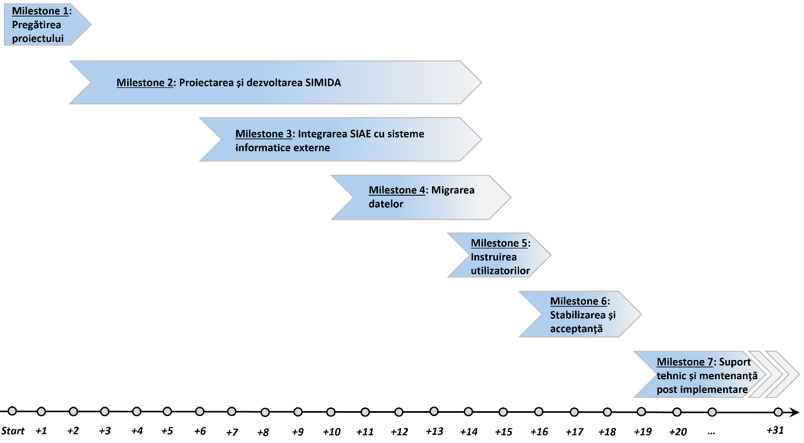
Figure 7. 1. IT system implementation schedule.

Information system implementation project management requirements
During the implementation of SIMIDA , project management activities will produce a series of deliverables that will be coordinated and agreed with the project stakeholders to ensure the smooth running of the project. The relevant requirements for organizing the SIMIDA implementation project are reflected in Table 7.2.
Table 7. 2. SIMIDA project management requirements.
ID | compulsoriness | Requirement description
PM 01 | M | The Supplier is responsible for managing the project according to the Project Management Plan and practices mutually agreed upon with ANSA and the Purchaser.
PM 02 | M | SIMIDA must be implemented based on a hybrid project management approach ( Agile will be used as the management approach, but the implementation of SIMIDA's IT components will begin with a preliminary business analysis stage ).
PM 03 | M | The Supplier is responsible for identifying and mobilizing the resources necessary to carry out the assigned activities contained in the Project Management Plan while ensuring the agreed quality level.
PM 04 | M | ANSA is responsible for all procedures and administrative aspects related to the project launch, the organization of the internal project team, and the preparation of the ICT environment necessary for the implementation and operation of SIMIDA .
PM 05 | M | The provider must coordinate with ANSA the SIMIDA Implementation Plan . This document must include at least the following aspects:  - Project organization chart, including: Project Manager, Project Committee, roles of project team members from the Supplier, roles of project team members from ANSA;  - Key responsibilities of each role within the project;  - Practices applied for project interaction and collaboration, including: Project Plan management; Detailed planning of project activities; Resource management; Communication plan; Change management; Risk management; Deliverable quality management; Progress monitoring and reporting; Project plan deviation management; Project library management.
PM 06 | M | ANSA and the Supplier must each designate a Project Manager to lead the corresponding project teams.
PM 07 | M | The supplier must carry out at least the following specific project management activities for the implementation of SIMIDA :  - Develop and coordinate with stakeholders the Project Initiation Document. Make necessary adjustments as necessary;  - Developing and coordinating with stakeholders the Project Plan. Making necessary adjustments as necessary throughout the project implementation period;  - Elaboration of Detailed Work Plans;  - Coordination of activities according to the Work Plan;  - Implementation of the Communication Plan;  - Preparing weekly reports on project progress;  - Keeping records of the project management process throughout the project implementation period ( at least: Deliverables Register, Risk Register, Change Register, Correspondence Register, Event Register );  - Organizing project management meetings according to the agreed Communication Plan;  - Sending final reports for each project phase and making presentations during project management meetings at the end of each project stage;  - Finalizing the main phases of the project and submitting acceptance documents to project stakeholders;  - Uploading project management deliverables to the Project Library.
PM 08 | M | All communications and deliverables related to project management activities must be completed in Romanian. An English version of the given documents may be requested on a case-by-case basis.
PM 09 | M | The supplier must prepare at least the following project management deliverables:  - The project implementation plan and its amendments;  - Detailed project activity plans (Product Backlog, development iterations);  - Presentations for periodic project management meetings;  - Weekly project progress reports and project records maintained and updated as per requirements specified in the Project Implementation Plan.  - Project phase completion reports that will contain at least the following information: Overview of the completed phase, Project plan for the next stage; Risk analysis; Identification of project problems; Recorded project quality level.  - Project deviation reports that will contain at least: a description of the reasons for deviations from project plans; the impact produced, the proposed solutions and their overall impact on the project, the recommended options.

Requirements for the IT system implementation team
The supplier will present in the technical offer summary data regarding the following key personnel to be involved in the project activities and their qualifications (the CVs of the key personnel must be included in the offer):
Table 7. 3. Requirements for the SIMIDA implementation team.
No. | Specialty | Experience and qualification
1. | Project Manager / Scrum Master | The Project Manager/Scrum Master must have a master's degree in ICT and the following experience and qualifications:  - at least 7 years of project management experience in the ICT field;  - at least 4 years of demonstrated experience in team/project management (preferably in the government field) applying Agile and/or Waterfall methodology;  - at least 2 reference projects for the implementation of information systems with similar application or complexity;  - strong analytical, leadership and staff motivation skills and relevant experience in business process analysis;  - recognized certification in the field of project management ( for example: PMP, Prince 2, Professional Scrum Master, etc. );  - Fluent knowledge of Romanian and English.
2. | Business Analyst / System Architect | The Business Analyst/System Architect must be licensed in the ICT field and have the following qualifications and experience:  - at least 5 years of work experience as a System Architect/Business Analyst demonstrated by involvement in the implementation of projects in a similar position for the design/development/implementation of information systems with similar use or complexity;  - demonstrated experience in using modern methodologies and approaches to designing information systems and applying ICT standards and initiatives specific to the government sector of the Republic of Moldova;  - demonstrated participation in the position of System Architect/Business Analyst in at least 2 projects of similar complexity over the last 3 years;  - experience in modular testing, continuous integration, DevOps;  - certification in the field of information systems design ( for example : TOGAF 9, CTA, etc. ) will be an advantage;  - Fluent knowledge of Romanian and English.
3. | Team Leader / Senior software developer | The Team Leader/Senior software developer must have a master's degree in ICT and have the following qualifications and experience:  - at least 7 years of experience in developing IT systems of similar complexity using the proposed technology stack;  - demonstrated involvement in a similar role in at least 2 similar projects or of similar complexity over the last 3 years;  - demonstrated experience in modular software testing (unit testing), continuous integration, DevOps;  - Demonstrated experience in integrating information systems, designing and implementing data exchange interfaces (APIs) using SOAP/REST;  - Recognized certification in the technologies proposed as a technology stack will be an advantage.
4. | Database Developer / Administrator | The Database Developer/Administrator must be licensed in the ICT field and have the following qualifications and experience:  - at least 5 years of experience in software development as a Database Developer/Administrator using the proposed technology stack;  - demonstrated involvement in a similar role in at least 2 similar projects or of similar complexity over the last 3 years;  - demonstrated experience in database design, development and optimization;  - experience and skills in modular testing (unit testing), continuous integration;  - Recognized certification in the field of databases and technologies proposed as a technology stack will be an advantage.
5. | Developer / DevOps Specialist | The DevOps Developer/Specialist must be licensed in the ICT field and have the following qualifications and experience:  - at least 5 years of experience in software development using the proposed technology stack;  - demonstrated involvement in a similar role in at least 2 similar projects or of similar complexity over the last 3 years;  - experience and skills in Continuous Integration/Continuous Delivery of IT systems of similar complexity;  - experience and skills in unit testing and DevOps;  - Recognized certification in the field of Continuous Integration / Continuous Delivery of IT solutions and the technologies proposed as a technology stack will be an advantage.
6. | Developer / Integration Expert | The Developer/Integration Expert must be licensed in the ICT field and have the following qualifications and experience:  - at least 5 years of experience in software development using the proposed technology stack;  - demonstrated involvement in a similar role in at least 2 similar projects or of similar complexity over the last 3 years;  - experience and skills in modular testing (unit testing);  - Demonstrated experience in integrating information systems, designing and implementing data exchange interfaces (APIs) using SOAP/REST;  - Recognized certification in the use of the technologies proposed as a technology stack will be an advantage.
7. | User Interface Developer / UI/UX Specialist | User Interface Developer / UI/UX Specialist must be licensed in ICT or other relevant fields and have the following qualifications and experience:  - at least 3 years of experience in software development using the proposed technology stack;  - experience in building interfaces that work flawlessly on any device;  - experience in optimizing user interfaces for performance, reducing loading times, optimizing resources, accessibility best practices;  - experience in using prototyping and wireframing systems, designing and implementing user interfaces using Figma, Sketch, Adobe XD or another similar tool;  - Recognized certification in the use of the technologies proposed as a technology stack will be an advantage.
8 . | Quality Assurance Engineer | The Quality Assurance Engineer must be licensed in ICT or other relevant fields and have the following qualifications and experience:  - at least 5 years of experience in testing IT systems of similar complexity;  - demonstrated involvement in a similar role in at least 2 similar projects or of similar complexity over the last 3 years;  - demonstrated skills and experience in functional testing of IT systems;  - familiarity with national standards in the Republic of Moldova in the field of ICT security, cybersecurity and GDPR compliance requirements;  - demonstrated skills and experience in applying automated testing of information systems;  - demonstrated skills and experience in performance testing (load and stress testing), security testing ( at least OWASP top 10 vulnerabilities );  - Recognized certification in the field of software testing ( for example: ISTQB ) and recognized certification in the field of offensive security assurance ( for example: OSCP, CEH ) and the use of the proposed technologies as a technology stack will be an advantage.
9. | formed | The trainer must be licensed in ICT or other relevant fields and have the following qualifications and experience:  - communication and user training skills;  - demonstrated skills and experience in conducting training for IT system users in at least 2 projects implemented in the last 3 years;  - Demonstrated skills and experience in developing documentation and instructional materials for end users;  - experience in developing and delivering online training;  - fluent knowledge of Romanian and Russian.
The other members of the project team (non-key personnel) must have skills in the following areas:
- development/implementation of Web IT solutions;
- database design and administration;
- user interface developer, UI/UX specialist;
- design/development/integration of interfaces for data exchange with external IT systems;
- quality assurance including experience in testing process automation;
- ensuring information security ( for example: CISSP, CISM, CISA );
- user training skills.

Requirements for the information system development process
SIMIDA will be developed based on an iterative and incremental approach using Continuous Integration/Continuous Delivery practices. Agile is to be used as a project management approach, but before starting software development activities the Supplier will perform a preliminary business analysis phase specific to the Waterfall approach (a hybrid Agile and Waterfall approach is being opted for).
The specific requirements for the design and development phase of SIMIDA are set out in Table 7.4.
Table 7. 4. Requirements for the SIMIDA development process.
ID | compulsoriness | Requirement description
DEV 01 | M | SIMIDA is to be designed and developed based on a hybrid project management approach. In this context, the Supplier will perform a business analysis (specific to the Waterfall approach) before starting the SIMIDA design and development phase . Based on the results of the business analysis, the Project Backlog will be developed, which will subsequently be used in the IT system development iterations.
DEV 02 | M | The design and development of SIMIDA must be carried out using the Agile project management approach (the information system will be designed and developed in an iterative and incremental manner using CI/CD (continuous integration/continuous delivery) practices).
DEV 03 | M | The duration of the iteration (project sprints) for the SIMIDA development phase will be 2 weeks. Depending on the development progress, if necessary, the duration can be increased to 3 weeks.
DEV 04 | M | During each sprint, the Supplier must perform the following activities:  - selecting relevant tasks from the Project Backlog to be implemented within the sprint (or transferring unfinished tasks to the previous sprint);  - performing the business analysis related to the Project Backlog tasks to be implemented within the sprint;  - developing user stories related to the Project Backlog tasks to be implemented within the sprint;  - development of the planned functionalities within the sprint;  - internal testing of the functionalities implemented during the sprint;  - developing/updating technical documentation related to the functionalities implemented within the sprint ( example: Technical Project (SDD), guides, specific procedures, etc. );  - updating the Project Backlog (if necessary).
DEV 05 | M | The Supplier must prepare periodic weekly/bi-weekly project management reports to succinctly inform project stakeholders about:  - finished tasks;  - tasks to be completed in the next period;  - tasks planned for the next period;  - problems/questions related to current activities;  - current risks and actions to mitigate them.
DEV 06 | M | The provider will periodically perform demo presentations of the implemented functionalities and collect comments and suggestions from project stakeholders to be taken into account in the SIMIDA development process .
DEV 07 | M | The supplier must be able to deliver specific SIMIDA functionalities into production, if necessary (the project stakeholders may decide on the functional modules of SIMIDA to be put into production earlier than the full completion of the SIMIDA development phase ).

IT system deployment requirements
The Provider must take into account the current requirements in the Republic of Moldova for the deployment of government IT systems within the common government platform MCloud and load balancing SIMIDA . Table 7.5 presents deployment requirements that must be considered for the SIMIDA deployment and load balancing process .
Table 7. 5. Requirements for the deployment of the information system.
ID | compulsoriness | Requirement description
DEP 01 | M | SIMIDA must be able to be installed in virtualized environments.
DEP 02 | M | SIMIDA must be able to provide a containerized infrastructure intended for deployment on relevant environments ( example: Docker Engine, Kubernetes ).
DEP 03 | M | Kubernetes should be used as the SIMIDA deployment and load balancing technology.
DEP 04 | M | SIMIDA must be able to initiate deployment on multiple environments simultaneously ( e.g. development, test/training, production ) initiated from scratch.
DEP 05 | M | The implementation of SIMIDA must be carried out using specialized instrumentation.
DEP 06 | M | SIMIDA deployment mechanism must be able to define the container component to be updated ( example: new version of platform software, updated functional module, etc. ).
DEP 07 | M | SIMIDA deployment mechanism must be able to manage the contents of the container.
DEP 08 | M | SIMIDA deployment mechanism must be able to add new components to the container content.
DEP 09 | M | To deploy SIMIDA, it is necessary that the deployment mechanism can specify in which cluster (dedicated server or Cloud) the deployment must be performed.
DEP 10 | M | SIMIDA deployment, it is necessary for the deployment mechanism to provide workflow for compiling the code or registers.
DEP 11 | M | SIMIDA deployment mechanism must provide functionalities for delivering the IT solution and performing third-party actions ( e.g. installing additional packages, configuring notifications, etc. ) using existing instrumentation.
DEP 12 | M | SIMIDA production environment must be able to be updated automatically with possibilities for manual intervention ( example: manual build approval ).
DEP 13 | M | SIMIDA deployment mechanism must be able to transfer specific records created in the SIMIDA test/training environment to the production environment ( example: configuration parameters, classifier/nomenclature values, user interface labels/messages/texts, etc. ).
DEP 14 | M | The developer will deliver to ANSA and STISC all the tools and scripts necessary for the automated deployment of SIMIDA .

Requirements for migration and data population of the IT system
Table 7.6 contains the requirements for the migration and data population process of SIMIDA necessary for the optimal start of SIMIDA exploitation . It should be emphasized that user training and acceptance of SIMIDA will be carried out only after SIMIDA has been populated with the relevant initial data made available to the Provider by ANSA.
Table 7. 6. Requirements for migration and data population of SIMIDA.
ID | compulsoriness | Requirement description
MIG 01 | M | ANSA will prepare and deliver the data and metadata sets necessary for the primary data population of the components within the SIMIDA perimeter . The format of the migrated data will be mutually agreed with the Supplier.
MIG 02 | M | The provider will need to convert specific metadata values related to external datasets according to the ANSA metadata system.
MIG 03 | M | The supplier will include in the technical offer its approach regarding the migration procedure and initial data population of SIMIDA .
MIG 04 | M | SIMIDA database with relevant metadata ( nomenclatures, classifiers, variables of different nature, etc. ) and primary data sets received from external sources in order to consolidate the initial SIMIDA data stock .
MIG 05 | M | During the implementation of the data migration and population procedure, the Provider is responsible for:  - defining the methodology used in the data migration and population process;  - developing detailed data migration and population plans;  - providing software mechanisms for data migration and population;  - defining quality requirements for data sets intended for migration/population and processing them through the developed migration and population mechanisms;  - mapping the value of metadata received from external sources (in case of divergences);  - defining criteria for reconciling migrated and populated data;  - participation in the data cleaning and enrichment process;  - verifying and validating the quality of the data sets to be migrated and populated;  - SIMIDA database based on the data sets provided by ANSA;  - identifying and resolving exceptions/errors during the data migration and population process.
MIG 06 | M | The provider must propose to ANSA the methodology for data migration and population. The methodology for data migration and population must contain the following elements:  - the methodology for preparing the data to be migrated and populated;  - methodology for mapping migrated and populated data;  - methodology for cleaning and enriching migrated/populated data and ensuring their quality;  - the methodology for completing the value of data required by SIMIDA but missing from the data sets provided;  - automated data migration and population procedure;  - principles of reconciliation of migrated and populated data;  - the disaster recovery plan (for each stage of the data migration and population process);  - the delivery plan for the data migration and population mechanism.
MIG 07 | M | The supplier must prepare and deliver a detailed plan for the migration and initial data population of SIMIDA (data migration and conversion strategy). This plan must be aligned with the SIMIDA implementation plan .
MIG 08 | M | The supplier must deliver to ANSA a software solution designed to automate the migration and initial data population processes of SIMIDA .
MIG 09 | M | All migration and initial data population activities of SIMIDA must be performed in the operating environment controlled by ANSA. The data will never leave ANSA's ICT infrastructure.
MIG 10 | M | SIMIDA with data, the Supplier will confirm to the ANSA security policy.
MIG-11 | M | The Supplier will demonstrate the correctness of the migration and initial data population tool of SIMIDA to ANSA specialists ( an act of acceptance of the migration and initial data population of SIMIDA is to be signed between the Supplier and ANSA ).

Requirements for training computer system users
Table 7. 7. SIMIDA user training requirements.
ID | compulsoriness | Requirement description
UTD 01 | M | The Supplier will provide all the necessary facilities to organize training for the relevant categories of authorized SIMIDA users :  - space for training;  - network-connected workstations;  - technical equipment intended for user training.
UTD 02 | M | The supplier must ensure:  - preparing the environment for user training;  - support materials for training;  - training efficiency evaluation tests.
UTD 03 | M | The supplier must develop and deliver training programs for all categories of authorized users of SIMIDA .
UTD 04 | M | The provider, jointly with ANSA, must develop the SIMIDA user training plan .
UTD 05 | M | The Supplier must train SIMIDA users according to the Training Plan and Programs agreed with ANSA.
UTD 06 | M | SIMIDA user training involves performing the following activities and making the following deliverables available to ANSA:  - training on the operation of SIMIDA 's key functionalities (intended for non-administrator users);  - training on SIMIDA configuration and administration (intended for users with administrator role);  - training of SIMIDA trainers who in the future will provide support and training to users after SIMIDA is put into production ;  - guides and support instructions for all categories of users SIMIDA involved in the administration or operation of SIMIDA .
UTD 07 | M | The supplier must train at least 2 users with the role of System Administrator of SIMIDA on behalf of ANSA. The System Administrators training program will be designed for at least 40 hours .
UTD 08 | M | The supplier must train at least 2 trainers who will then train SIMIDA users . The training of trainers program is to be designed for at least 40 hours .
UTD 09 | M | SIMIDA authorized user training program should be designed for at least 64 hours . Up to 60 users with different roles within SIMIDA are to be trained. The training for authorized users will consist of the following sessions and it is expected that the training agenda will be refined during the SIMIDA implementation :  - training sessions to familiarize users with SIMIDA functionalities and features ;  - practical exercise sessions;  - question-and-answer sessions.
UTD 10 | M | The supplier must prepare and deliver the following support documents for the SIMIDA user training process :  - SIMIDA architecture document ;  - SIMIDA administration guide ;  - user guides for each IT component of SIMIDA ( SSI " Register of food chain operators" , SSI " Monitoring and control at import", SSI "Registration and dissemination of alerts", SSI "Administration and system functionalities");  - Support materials for training sessions for administrator and non-administrator users ( example: video instructions, textual instructions, Power Point presentations, etc. ).
UTD 11 | M | User guides for each IT component of SIMIDA must be completed in Romanian. If necessary, some technical instructions can also be requested in English.
UTD 12 | M | SIMIDA user guides in electronic format ( including online tutorials/multimedia presentations ). The guides must be easy to access and navigate, and the information presented must be easy to identify.
UTD 13 | M | The supplier must prepare and deliver the following operational guides for the components within the SIMIDA perimeter :  - guide to eliminating defects detected during SIMIDA operation ;  - SIMIDA installation/deployment/configuration guide ;  - SIMIDA maintenance guide ;  - SIMIDA developer guide ( provides useful information to future SIMIDA developers );  - guide to data archiving and data restoration processes;  - SIMIDA information security management system .
UTD 14 | M | The supplier must deliver the complete source code and libraries necessary to compile the SIMIDA source code. The source code must contain sufficient comments to be easily understood by ANSA's ICT staff. The supplier must provide access to the version control system repository where the SIMIDA source code is stored, updated and assembled .
UTD 01 5 | M | All support materials intended for user training and training efficiency evaluation tests (at least those intended for system administrators and other users who have advanced qualified electronic signature) must be available on the Government Distance Learning Platform "MLearn".

Requirements for IT system acceptance testing
SIMIDA acceptance testing process . Table 7.8 contains the requirements related to the SIMIDA acceptance testing procedure .
Table 7. 8. Requirements for SIMIDA acceptance testing.
ID | compulsoriness | Requirement description
UAT 01 | M | Before starting acceptance tests, all SIMIDA components must be implemented and configured according to functional and non-functional specifications.
UAT 02 | M | The Supplier must organize the acceptance testing of SIMIDA . In this regard, the Supplier must perform the following activities:  - defining the testing strategy and procedures;  - development of the Detailed Test Plan (The Supplier must deliver the Acceptance Test Plan to the project stakeholders for coordination and acceptance);  - preparation of test scenarios (The Supplier must develop test scenarios for all test categories (modular testing, integration testing, performance testing, functional testing, etc.) to the project stakeholders for coordination and acceptance;  - documenting errors/deficiencies detected during the verification of test scenarios and their removal;  - developing a Report with the final results of the SIMIDA testing , including the status of all errors/deficiencies (the Supplier will deliver this report to the project stakeholders for coordination and acceptance).
UAT 03 | M | Before deploying SIMIDA in the production environment to be exploited by ANSA, the Supplier must develop test scenarios in collaboration with the project stakeholders and complete 5 types of testing as follows:  - Unit Testing : The Supplier will perform unit testing to ensure that each functional component/module of SIMIDA operates as designed.  - Integration Testing : After each SIMIDA module is developed, integration tests will be performed to ensure that SIMIDA modules work as expected when interacting with each other;  - Performance Testing (Load and Stress Testing) : Since SIMIDA is to be exploited by multiple authorized users, performance testing must be performed to verify how SIMIDA performs under different workloads. This may require optimizing the web server, application software and/or database server configurations or network configurations;  - Recovery Testing : An important aspect of SIMIDA is the possibility of recovering operation in case of failure, unavailability of the server infrastructure or services exposed by the information system . In this regard, tests must be performed to see how well SIMIDA recovers in case of hardware crashes and failures;  - Security Testing : It is necessary to perform detailed security tests of SIMIDA in accordance with the requirements for ensuring information security. Security testing will verify the existence of SIMIDA vulnerability to attacks such as: SQL injection attack, DDoS attacks, etc. Security testing will make use of software means to detect SIMIDA security threats and vulnerabilities .
UAT 04 | M | The following three types of additional tests must be performed by ANSA jointly with the Supplier:  - Usability Testing : It consists of verifying the ease of use of SIMIDA . The computer application is tested and verified to see if users easily understand the principles of using the user interface. The navigation mechanism of the SIMIDA user interface is also verified during these tests. The user interface can be redesigned/modified during this testing phase based on the feedback provided by ANSA;  - Functional Testing : During functional testing, all real processes and key services provided by ANSA are simulated end-to-end to verify that SIMIDA stores data and generates reports appropriately;  - Acceptance Testing : This type of testing is done to verify that SIMIDA meets the requirements of the terms of reference in accordance with the test scenarios that will be prepared by the Supplier. The Purchaser may request additional test scenarios for the acceptance testing of SIMIDA . ANSA will perform this type of testing to determine whether or not it accepts the delivered information system.
UAT 05 | M | The coverage of SIMIDA functionalities with tests must be at least 90%.
UAT 06 | M | SIMIDA stakeholders, must perform all tests included in the Test Plan. The final test results and the IT system will be accepted if there were no critical (blocking) errors and less than 3 major errors/deficiencies.
UAT 07 | M | SIMIDA acceptance will be dated on the day on which all errors/deficiencies detected during the testing sessions were remedied.

Requirements for putting the IT system into production
This section contains the requirements related to the production of SIMIDA . Table 7.9 contains the requirements related to the production procedure of SIMIDA .
Table 7. 9. Requirements for putting SIMIDA into production.
ID | compulsoriness | Requirement description
COM 01 | M | The supplier must propose and justify the optimal strategy for putting SIMIDA into production ( example: phased, big-bang, parallel operation, pilot launch ).
COM 02 | M | The Supplier must take part in all stages of putting SIMIDA into production . To this end, the Supplier must perform at least the following actions:  - SIMIDA Production Plan ;  - developing a roll-back plan if applicable;  - updating the data sets generated/modified in the current ANSA IT systems after carrying out the procedures aimed at populating SIMIDA with initial data ;  - SIMIDA Production Plan ;  - rapid elimination of errors and deficiencies detected during the operation of SIMIDA .
COM 03 | M | The supplier must develop and coordinate with ANSA the plan for putting SIMIDA into production .
COM 04 | M | ANSA, with the support of the Supplier, prior to the launch of SIMIDA in production, is to upload all the reference documents necessary for the entire life cycle of the project to the Register of State Information Resources and Systems.
COM 05 | M | SIMIDA can be put into production if it is available and operational for all authorized users, and the SIMIDA Acceptance Protocol has been signed by the Supplier and ANSA.

Requirements for stabilizing the IT system
This section contains the requirements related to the operation of SIMIDA during the stabilization period. Table 7.10 contains the requirements related to the stabilization and final acceptance of SIMIDA .
Table 7. 10. Requirements for stabilization and final acceptance SIMIDA.
ID | compulsoriness | Requirement description
STAB 01 | M | The 3-month stabilization period of SIMIDA will begin immediately after the IT system is put into production.
STAB 02 | M | During the SIMIDA stabilization period , the Supplier must provide ANSA with on-site support in order to resolve errors and deficiencies detected during the operation of SIMIDA .
STAB 03 | M | During the SIMIDA stabilization period , the Supplier must carry out development activities to eliminate errors and deficiencies, analyze logging records to prevent potential problems, and make adjustments to the user interface and critical modules of SIMIDA .
STAB 04 | M | The final acceptance of SIMIDA must be certified based on the Final Acceptance Report signed by the Supplier and ANSA, provided that the following conditions are met:  - the stabilization period has expired;  - all major Level 1 errors and deficiencies have been eliminated;  - there are less than 10 Level 2 errors and deficiencies to be resolved;  - none of the test scenarios attested to data integrity and consistency issues.
STAB 05 | and | An error or deficiency related to SIMIDA is considered Level 1 if it blocks or makes it difficult to use key functionalities of the information system.
STAB 06 | and | An error or deficiency related to SIMIDA is considered Level 2 if it blocks or makes it difficult to use the functionalities of the information system for which there are alternative options (workarounds).

Requirements for IT system project deliverables
SIMIDA deliverables are specified in Table 7.11.
Table 7. 11. Key deliverables of SIMIDA.
ID | compulsoriness | Description of deliverables
LED 01 | M | Deliverables related to the project management process:  - Project management plan;  - Weekly project management reports;  - Report on implemented modification requirements and improvements applied to SIMIDA based on suggestions and requirements received from project stakeholders;  - Project phase completion reports;  - Reports on project deviations.
LED 02 | M | Technical documentation and key artifacts related to SIMIDA :  - Product Backlog;  - Technical architecture document;  - Technical project (SRS+SDD);  - SIMIDA technical infrastructure requirements (development environment, test/training environment, production environment).  - SIMIDA Integration Plan with external computer systems.  - Documentation for the integration of components within the SIMIDA perimeter with shared government services, State Registers, the information systems of the PA of the Republic of Moldova and the information systems of the ANSA;  - Documentation of APIs exposed by SIMIDA ;  - The complete source code of SIMIDA (developed during the project);  - Data migration plan and methodology;  - Production plan;  - Access to the version control system repository where source code is stored, updated, and assembled.  - Data migration/data populating scripts.  - Scripts and deployment mechanisms.
LED 03 | M | Guides for using the IT subsystems within the SIMIDA perimeter :  - SIMIDA administration guide ;  - SIMIDA components installation/deployment/configuration guide ;  - SIMIDA components routine maintenance guide ;  - Guide to eliminating the most common defects that may occur during the operation of SIMIDA components ;  - SIMIDA User Guide (for each of its applications);  - SIMIDA Developer's Guide ;  - Video instructions describing the key business processes implemented by the IT subsystems within the SIMIDA perimeter.
LED 04 | M | Deliverables intended for training SIMIDA users :  - Training plan and training schedule;  - Support materials for training all categories of users (guides, presentations, video instructions);  - List of qualifications and skills required for ANSA System Administrators to maintain and operate SIMIDA components .  - Final report on the trainings conducted, including suggestions/requirements for improving SIMIDA functionalities received during the training period.
LED 05 | M | SIMIDA acceptance testing process :  - Testing strategy and procedure;  - Test plan and test scenarios;  - Minutes of acceptance of the SIMIDA interoperability and data exchange mechanism .  - Minutes regarding migration/population of SIMIDA with data;  - Minutes regarding the results of testing (functional, integration, performance, security, etc.);  - Minutes on the final acceptance of SIMIDA;  - Minutes regarding the handover of SIMIDA to ANSA and the associated technical documentation.
LED 06 | M | SLA agreement for the warranty period, maintenance and technical support of SIMIDA signed between the Supplier and ANSA.
LED 07 | M | During the review period of the deliverable sent for acceptance, the Supplier will submit additional documents/justifications (if requested) or sign the acceptance of the deliverable and will respond to all comments/suggestions/deficiencies sent by the Approvers regarding the analyzed deliverable.
LED 08 | M | The Supplier shall review and resolve the deliverable deficiencies reported by the Approvers within 5 business days of the date of rejection of the deliverable by the Approvers. The Supplier shall resubmit the adjusted deliverable to the Approvers for review and approval.
LED 09 | M | Approvers either accept or reject the resubmitted deliverable within 5 business days. The deliverable can be considered accepted when it is signed by the Approvers.
LED 10 | M | All documentation to be delivered as part of the Contract will be in Microsoft Office format (2018 or later).
LED 11 | M | For any software developed under the Project, fully documented source code will be provided to ANSA in HTML format and/or reference manual ( e.g. documentation generated via Doxygen, NDoc, Enterprise Architect or similar tools ) and in a format that will allow ANSA to compile the software.
LED 12 | M | SIMIDA deliverables are to be transmitted digitally ( for example: USB Stick ).

Requirements for IT system maintenance and technical support services
SIMIDA post-implementation support and maintenance services is to ensure the following objectives for ANSA:
- the functionalities offered by the IT components within the SIMIDA perimeter will be aligned over time to the changing business needs of ANSA;
- SIMIDA operation process will be addressed and resolved in a timely manner, with minimal impact on ANSA's activity;
- difficulties in operating SIMIDA will be able to be overcome correctly and in a timely manner, without affecting the functioning of the IT system.
To achieve these objectives, post-implementation support and maintenance services are to be provided by the Supplier according to the requirements set out in this document.
Table 7.12 contains the support service requirements that the Supplier must provide during the warranty, maintenance and technical support period.
Table ‎7. 12. SIMIDA technical support service requirements during the warranty period.
ID | compulsoriness | Requirement description
MST 01 | M | The Supplier must provide maintenance services and technical support for SIMIDA for the entire warranty period specified in the terms of reference after the end of the SIMIDA stabilization period .
MST 02 | M | The warranty and technical support will correspond to the national standard SM ISO/IEC/IEEE 14764:2022 - Software engineering. Software life cycle processes. Maintenance.
MST 03 | M | SIMIDA operating errors detected during the warranty period will be remedied at the Supplier's expense (these activities will not be considered additional development activities outside of the SDD objectives).
MST 04 | M | The supplier must include in the offer an effort of 50 man/days for unplanned development services that will be consumed during the warranty period.
MST 05 | M | The provider must provide technical support to authorized users of SIMIDA in the event of reporting incidents related to the operation of the information system regardless of the causes that led to the incident ( for example: errors, deficiencies, problems generated by external applications, etc. ).  To this end, depending on the particularity of each incident, the Supplier will take the following actions:  - to receive information from authorized users about the incident that occurred and its context;  - locate the incident and identify immediate actions that need to be taken to mitigate the impact of the incident;  - identify the causes of the incident and define the actions that must be taken to eliminate the incident;  - to assist ANSA in taking the necessary actions to mitigate the impact of the incident and resolve it within the established deadline;  - to provide ANSA with detailed information on the causes of the incident, the rationale for the actions taken and the actions planned to prevent the recurrence of similar incidents;  - to consider the need to register any new issue related to the operation of SIMIDA (if the issue has been reported and registered, the Provider must manage it according to the SLA contract signed with ANSA).
MST 06 | M | SIMIDA application layer . To this end, depending on the particularities of each case, the Supplier may undertake the following actions:  - to receive and collect information related to the problem, symptoms, effects, specific conditions;  - to analyze, locate the problem at the level of the functional components of the SIMIDA and identify the interdependencies that contribute to the problem or are affected by it;  - to identify temporary solutions to mitigate the effects of the problem and to guide ANSA to apply them;  - to identify solutions for the reported problem and ensure regular communication with ANSA regarding the progress made in identifying solutions;  - if the solutions are related to software configuration, ANSA must be assisted in performing the necessary configurations;  - if the solutions require changes to the program code level SIMIDA , these must be performed by the Supplier and implemented within the maintenance services within the established deadline.
MST 0 7 | M | The Supplier must provide consulting services to support the operation of SIMIDA to ANSA. To this end, depending on the specifics of ANSA's consulting needs, the Supplier must undertake the following actions:  - to receive and record requests for technical support from ANSA and information related to the context in which technical support is requested;  - identify and validate solutions in the test environment SIMIDA ;  - to provide complete and precise answers on how ANSA should react during exploitation SIMIDA according to the technical support request.
MST 08 | M | Upon signing the final acceptance documents of SIMIDA, the Supplier will sign an SLA agreement with ANSA that will specify in detail the mechanism for providing warranty services, technical support and maintenance for SIMIDA .
MST 09 | M | After providing warranty, maintenance and post-implementation support services, ANSA may request the extension of the provision of services for an additional payment.  The Supplier is obliged to accept the subsequent provision of services, for at least 1 year, under the conditions resulting from these Terms of Reference and the offer estimates ( example: service level, service price, etc. ).
MST 10 | M | For a period of 1 calendar year after the expiration of the support contract, the Supplier will be willing to cooperate with third parties authorized by ANSA, in order to provide ANSA with post-implementation support and maintenance services.  For this purpose, the Provider will at least ensure the provision of any information held that would help improve the services.

Annexes

Annex 1. Work processes related to public services provided by ANSA

A 1.1. Notification regarding the import of products subject to sanitary-veterinary, phytosanitary and food safety supervision and control
Work process |  | Code | Name
 |  | 1-A | Notification regarding the import of products subject to sanitary-veterinary, phytosanitary and food safety supervision and control.
General description |  | The notification regarding the import of products subject to sanitary-veterinary, phytosanitary and food safety supervision and control is the document through which ANSA is notified of the import of each batch of products intended for introduction onto the market of the Republic of Moldova.  The notification aims to supervise the import process of products subject to sanitary-veterinary, phytosanitary and food safety control, as well as to describe the stages that underlie the admission or refusal of import.  Import operations of live animals, germinal material of animal origin, products and by-products subject to sanitary-veterinary supervision and control may only be carried out if an import notification has been made at least 24 hours before the import operation.  Importers will complete and submit the import notification through the "Import Monitoring and Control" information system and inspectors at the Border Inspection Posts (BIP) will examine this notification and make a decision on the admission or rejection of the import.
Regulatory framework |  | - Law No. 221/2007 on veterinary health activity ( legis );  - Law No. 422/2023 on protective measures against organisms harmful to plants ( legis );  - Law No. 119/2004 on phytosanitary products and fertilizers ( legis );  - Law No. 50/2013 on official controls to verify compliance with feed and food law and animal health and welfare rules ( legis );  - Law No. 306/2018 on food safety ( legis );  - Decision No. 1045/2005 approving the Regulation on the import, storage, marketing and use of phytosanitary products and fertilizers ( legis );  - Decision No. 333/2018 on the approval of certain model documents ( legis );  - Government Decision No. 938/2018 approving the Regulation on the manner of crossing the state border of goods subject to control by the National Food Safety Agency ( legis );  - ANSA Order no. 132/2020;  - ANSA Order No. 41/2022 ( ansa.gov.md );  - Government Decision No. 14/2023 on the organization and functioning of the National Food Safety Agency ( legis ).  - GD 679/2024 for the approval of the Regulation on the application of protective measures against plant pests ( legis )
Actors involved |  | Importer – The economic agent importing live animals, germinal material of animal origin, products and by-products subject to sanitary-veterinary supervision and control.  PIF Inspector – ANSA employee, inspector at the border inspection post.  ANSA territorial inspector – ANSA employee, territorial inspector within ANSA subdivisions.  MCI – the "Import Monitoring and Control" information system.  SI "Frontiera" – information system for managing border crossing.
Delivery time |  | At least 24 hours before the date of import ( according to art. 34 par. 2 of Law no. 221/2007 and point 12 of Government Decision no. 591/2024 ).  5 working days until the date of import ( according to ANSA Order no. 41/2022 and point 17.1 of Government Decision no. 938/2018 ).
Business rules |  | - According to art.34 par.2 of Law no. 221/2007, import, export and transit operations of goods subject to veterinary and sanitary supervision and control may be carried out only if an import notification has been made through the "Import Monitoring and Control" information system at least 24 hours before the import, export or transit operation, or, as the case may be, within 5 working days until the date of import.  - To successfully promote documentary control, the PIF Inspector must ensure that:  - the importer holds (as applicable): sanitary-veterinary operating authorization, sanitary-veterinary registration, phytosanitary registration, food safety registration.  - the importer has an authorized warehouse for storing the products mentioned in the import notification.  - the transport unit used for import is sanitary-veterinary authorized.  - the importer has attached the necessary documents (as applicable): quality certificate, catch certificate.  - Importer authenticated in SSI " Import Monitoring and Control " will only be able to send import notifications on the domain in which it was registered in ROLA (if the importer is registered in ROLA).
Input/output data |  | Type |  | Name | Form
 |  | entry |  | Notification regarding the import of products subject to sanitary-veterinary , phytosanitary and food safety supervision and control. | Electronic document
 |  | entry |  | Document issued by the manufacturer/exporter for all food products of non-animal origin confirming quality and harmlessness ( for goods subject to food safety control ). | Attached document
 |  | entry |  | Document issued by the competent food safety authority of the exporting state, certifying that food products of non-animal origin are safe and comply with the provisions of the legislation, which is required only for food products of non-animal origin subject to consolidated control ( for goods subject to food safety control ). | Attached document
 |  | entry |  | Data on the sanitary and veterinary operating authorization ( for goods subject to sanitary and veterinary control ). | ROLL
 |  | entry |  | Data on the veterinary certificate ( for goods subject to veterinary control ) . | ROLL
 |  | entry |  | Data on the official registration of the operator in the field of food safety ( for goods subject to food safety control ) . | ROLL
 |  | entry |  | Data on the place of destination of the goods subject to control at the BIP (authorized/registered sanitary-veterinary warehouses, PUFF warehouses, etc.). | ROLL
 |  | entry |  | Catch certificate, for fish and fishery products from wild fishing (for goods in the veterinary health field). | Attached document
 |  | entry |  | Phytosanitary certificate issued by the exporting country (for goods subject to phytosanitary control). | Attached document
 |  | entry |  | Data on the official registration of the operator in the field of phytosanitary protection ( for goods subject to phytosanitary control ) . | ROLL
 |  | Exit |  | The decision to cross the border. | Electronic document
 |  | Exit |  | Transit closure decision. | Electronic document
 |  | Exit |  | Border detention decision. | Electronic document
Detailed description of the work process
Code | Actor | Activity name |  | Activity description | Result
1-A01 | Importer | Complete and submit the Notification and other attached documents |  | The importer authenticates via MPASS in SSI " Import Monitoring and Control " (MCI) at least 24 hours (or 5 working days, as the case may be) prior to the import of products subject to sanitary-veterinary, phytosanitary and food safety surveillance and control to complete the electronic form with the necessary data according to the standard notification model approved by ANSA.  The Importer will choose the type of import notification he intends to complete, and the system will provide the form with the fields provided for that type of notification. The following notification types will be available to the Importer for selection:  - DCIA – notification regarding the import of products subject to sanitary-veterinary supervision and control (live animals);  - DCIP – notification regarding the import of products subject to sanitary-veterinary supervision and control (products of animal origin);  - DCID – notification regarding the import of products subject to food safety surveillance and control;  - DCI F – notification regarding the import of products subject to phytosanitary surveillance and control.  By querying the ROLA database, the MCI system verifies the existence of the Importer's data based on the IDNO code. If the Importer is identified, the related information is automatically taken from ROLA and pre-filled in the import notification form, thus ensuring the accuracy of the data.  the Importer's data is not available in ROLA, the system will allow the notification to be registered by manually entering the necessary information. After submitting the notification, ANSA will manage the situation and clarify the reasons why the Importer is not listed in ROLA (outside the MCI).  The importer will be able to select the goods they intend to import from a pre-established list, which contains exclusively the products related to the activity permitted for import, according to the sanitary-veterinary authorization or registration held (if the Importer is registered in ROLA).  When choosing the transport unit used for the import or the destination of the goods (warehouse), the system will provide the importer with lists that include only transport units and authorized sanitary and veterinary units, the information being automatically taken from the ROLA registry (if the Importer is registered in ROLA).  While filling out the form, the Importer may receive warnings regarding the data indicated in the notification, if there are alerts transmitted through the SSI "Registration and dissemination of alerts" regarding a certain type of product, a country of origin with a risk level, etc. or other alerts configured in the MCI. However, the Importer will be able to complete the registration of the import notification even if there is an alert associated with this import.  The importer will attach all necessary documents, confirm the data on his own responsibility and send the notification for examination to the PIF Inspector of the inspection post specified in the import notification. | Notification sent together with the necessary documents to attach.
1-A02 | MCI | Send notification to the PIF inspector |  | The MCI information system will transmit the notification regarding the new import notification to all PIF Inspectors within the inspection post indicated in the notification, who are to be involved in the control of the said goods.  PIF inspectors will be informed, for each notification received, of the existence of associated alerts, the lack of registration of the Importer in ROLA and the fact that, consequently, a significant part of the automated validations have not been performed. These import notifications will be highlighted by a standardized visual mechanism ( e.g. color, graphic symbol or textual label ) so that inspectors can quickly identify critical notifications.  Also, based on alerts and selection criteria previously configured in the MCI, the PIF Inspectors will be notified by the system of the need to perform a physical check. | import notification sent to the appropriate PIF Inspectors.  Notification to PIF Inspectors about alerts and other risks associated with notification.
1 -A03 | AND "Border" | Queries data from the MCI about the transport unit arriving at the border and sends a response to the MCI |  | Based on the registration number of the transport unit that arrived at the border, SI "Frontiera" will initiate the query to the MCI to obtain data related to the import notifications sent by the Importer to ANSA.  If it identifies an active import notification, the "Border" SI will send a response to the MCI regarding the arrival of the transport unit at the border.  Also, SI "Frontiera" will verify whether the Importer who submitted the notification holds the AEO authorization and will provide this information to MCI. | Data regarding active import notifications received by SI "Frontiera" .  Data regarding the arrival of the transport unit at the border, as well as the Importer's AEO status transmitted to the MCI.
1-A04 | MCI | Records data in the "Frontiera" SI, notifies the PIF Inspectors |  | Based on the response received from SI "Frontiera", MCI will notify the appropriate PIF Inspectors regarding the need to carry out the control. This notification will also be sent in the case of repeated documentary control as a result of the completion of the necessary documents by the Importer .  MCI will record, at the import notification level, information regarding the Importer's status as an Authorized Economic Operator (AEO), this data will be used to prioritize control at the border inspection post. | Confirmation of the arrival of the transport unit at the border received by the PIF Inspectors .  Data on the status of AEO authorized economic operator registered in the MCI.
1-A05 | PIF Inspector | Check the notification and attached documents  Performs documentary control |  | PIF inspectors have the possibility to carry out documentary control of the import notification before the goods reach the border or directly when the means of transport is present at the inspection post.  The PIF inspectors examine the import notification data and the attached documents. Depending on whether the documentary control has been successfully passed or whether non-conformities, the lack of mandatory documents or the existence of critical risks related to the notified goods have been identified, they will decide on the applicable measures, as follows:  - permitted border crossing – the situation in which the documentary check is completed without non-conformities and, due to the coverage of the frequency level of checks, identity check/physical check is no longer necessary or these checks have been requested by the Importer to be carried out at the place of destination (go to 1- A12 ).  - promotion for identity check and physical check – when the documentary check, carried out remotely or at the inspection post, is in accordance with the requirements, respectively, the batch can be directly subjected to identity check and physical check upon arrival at the border (go to 1- A08 ).  - return the notification for completion , in the absence of the indispensable documents and the means of transport is not yet present at the inspection post (go to 1- A06 );  - rejection of the import notification , in situations where it is found that the problem cannot be remedied or there are critical alerts and the means of transport is not yet present at the inspection post (go to 1- A06 ).  - detention decision, in case of documentary non-conformities that can be remedied in a short time, the transport unit being already at the inspection post (go to 1- A06 ). | Notification received and verified for compliance with the provisions of the regulatory framework.
1-A06 | MCI | Notifies the Importer of the decision resulting from the documentary control |  | MCI notifies the Importer in the event of non-conformities being detected at the documentary control stage.  In the event that the notification is returned for completion, as a result of the preventive documentary control or the issuance of a retention act for the purpose of completing or rectifying the documents, the system will inform the Importer of the obligation to complete the notification by uploading the necessary additional documents (go to 1-A07 ).  Rejected import notifications do not imply continued communication with the Importer after the notification has been sent. | The decision resulting from the documentary control communicated to the Importer.
1 -A07 | Importer | Upload additional documents |  | The importer will upload the additional/corrected documents and send the corresponding import notification for verification to the PIF Inspectors (go to 1-A04 ). | Import notification completed and sent for repeated documentary control to the PIF Inspectors.
1-A08 | PIF Inspector | Document identity and physical checks |  | According to art. 18 of Government Decision no. 938/2018 , at the time of entry or transit of goods subject to the Agency's control, ANSA Inspectors within the inspection posts at the state border crossing points carry out, based on risk analysis, the following types of controls (documentary control covered in step 1-A05 ):  - control of the identity of the goods subject to control;  - physical control of the goods subject to control, with or without taking samples for investigation in an accredited laboratory.  The BIF inspector completes the import notification, recording the details of the physical check performed.  If samples have been taken for laboratory examination, when drafting the report in the Laboratory Information Management System (LIMS), the PIF Inspector will necessarily indicate the unique code of the import notification on the basis of which the samples were taken. The results of the laboratory investigations will be automatically transmitted to the MCI and will be correlated with the related import notification, through interoperability with the LIMS system. | Control carried out by the PIF Inspector.
1-A09 | PIF Inspector | Decides on the admission or rejection of the import |  | The PIF inspector , following the control procedures applied, makes the decision regarding:  - admission to cross the border – according to art.20 of Government Decision no. 938/2018 , if no non-conformities were detected following the control, the PIF inspector allows the entry/transit of the goods, with the issuance of the document related to the type of goods subject to control (go to 1-A12 );  - detention at the border – according to art. 21 of Government Decision no. 938/2018 , if the inspection found non-compliance with national requirements and the Importer can remove them (go to 1-A10 ).  - rejection at the border – if a direct or indirect risk to human health has been identified and the Importer chooses to return or destroy the batch (go to 1-A11 ). | Decision made regarding the admission or retention of the batch.
1-A10 | PIF Inspector | Records the detention decision and forwards it to the customs authorities |  | If the inspection reveals non-compliance with national requirements, the PIF Inspector detains the consignment to eliminate the non-compliances. The detention decision is drawn up using the tools implemented in the MCI. After eliminating the non-compliances, the Inspector carries out a repeated identity and physical check (go to 1-A08 ).  The border detention decision is automatically sent to the Importer and customs authorities through interoperability with the "ASYCUDA World" SI, without requiring manual intervention or paper confirmation from economic operators. | Detention document drawn up in electronic format and submitted to customs authorities.
1-A11 | PIF Inspector | Records the rejection decision and forwards it to the customs authorities |  | rejection decision is recorded in the MCI by the PIF Inspector , who subsequently transmits this decision to the national rapid alert network contact point ( national RASFF) , related to the border inspection post.  The border rejection decision is submitted to the Importer and customs authorities through interoperability with the "ASYCUDA World" SI, without requiring manual intervention or paper confirmation from economic operators. | Rejection act drawn up in electronic format and submitted to customs authorities.
1-A12 | PIF Inspector | Records the decision of free passage and submits it to the customs authorities/ANSA Inspector |  | The PIF inspector records the border crossing decision through the tools implemented in the MCI information system. The admission act will contain specific mentions for each case, as follows:  - permitted crossing and customs clearance – lack of non-conformities at primary identity and physical control;  - permitted crossing and customs clearance – lack of non-conformities during repeated identity and physical checks;  - permitted crossing and customs clearance – no need for identity and physical checks;  - permitted crossing – decision for physical control and customs clearance at the point of destination.  Through interoperability with the "ASYCUDA World" SI the "permitted crossing" decision will be automatically submitted to the customs authority, without requiring manual intervention or paper confirmation from economic operators.  If it is decided to carry out the physical check at the place of destination, the PIF Inspector will send, through the MCI, a notification to the ANSA Inspector from the corresponding territorial subdivision, regarding the obligation to carry out the check in the territory (go to 1-A13 ).  For import notifications for transit purposes , the PIF Inspector will transmit via MCI a notice to the inspection post located at the exit point from the Republic of Moldova, indicated in the notification, regarding the obligation to close the notification upon crossing that point (go to 1-A15 ). | Admission act drawn up and submitted to customs authorities.
1-A13 | ANSA territorial inspector | Performs identity and physical checks at the destination |  | The ANSA territorial inspector receives the notification regarding the need to carry out the control in the territory. He also receives access to all the data of the import notification.  The ANSA territorial inspector confirms the delivery of the goods at the point of destination and completes the import notification, recording the details of the identity and physical checks carried out.  When taking samples for laboratory examination, the ANSA Territorial Inspector will indicate in the LIMS report the unique code of the import notification. The results of the investigations will be automatically transmitted to the MCI and correlated with the respective notification through interoperability with the LIMS. | Identity and physical check data completed in the import notification.
1-A14 | ANSA territorial inspector | Decides on the admission or rejection of the import |  | The ANSA territorial inspector , following the control procedures applied, makes the decision regarding:  - customs clearance allowed – if no non-conformities were detected following the inspection (go to 1-A12 );  - customs clearance rejected – if a direct or indirect risk to human health has been identified and the Importer chooses return or destruction of the batch (go to 1-A11 ).  If customs clearance is rejected and a direct or indirect risk to human health is found, the ANSA Territorial Inspector notifies the contact point of the national rapid alert network in the respective territorial subdivision.  Both the permitted and rejected customs clearance decisions are automatically submitted to the Importer and customs authorities through interoperability with the "ASYCUDA World" SI, without requiring manual intervention or paper confirmation from economic operators. | Decision made regarding the admission or retention of the batch.
1-A15 | AND "Border" | Queries data from the MCI about the transport unit arriving at the border and sends a response to the MCI |  | Based on the registration number of the transport unit that arrived at the border, SI "Frontiera" will initiate the query to the MCI to obtain data related to the import notifications sent by the Importer to ANSA.  In the event of an unclosed import notification for transit purposes, SI "Frontiera" will send to the MCI confirmation of the arrival of the transport unit at the border, mentioning the need to close the notification.  Also, SI "Frontiera" will automatically check whether the Importer who submitted the notification holds the AEOS authorization and will provide this information to MCI . | Data regarding active import notifications received by SI "Frontiera".  Data regarding the arrival of the transport unit at the border, as well as the Importer's AEO status transmitted to the MCI .
1-A16 | PIF Inspector | Close transit import notification |  | In the case of an import notification for transit purposes, the PIF Inspector at the exit point from the Republic of Moldova enters notes on the import notification regarding the date of closure of the notification and completion of transit. | Transit import notification closed.
1-A17 | MCI | Check and notify about the expiration of the transit period |  | MCI automatically checks the transit period of import notifications intended for transit through the Republic of Moldova.  If the deadline for crossing the border at the specified exit point is exceeded, the system automatically sends notifications to all responsible parties: the border inspection post at the exit point specified in the notification and the ANSA central apparatus. | Notifications sent to all responsible parties regarding the expiration of the transit period.
1-A18 | MCI | Stores all notification data submitted by importers |  | The notification submitted by the importer together with the materials attached to it will be kept in electronic format in the importer's electronic file to be developed within the "Import Monitoring and Control" Information System. | The notification submitted by the importer together with the materials attached to it stored in the SI "Monitoring and control at import".
1-A19 | Importer | Consult import notification decisions |  | The importer can consult through the MCI facilities all decisions related to the submitted import notification. | Importer access to import notification decisions.

A 1.2. Notification regarding the import of phytosanitary products
Work process |  | Code | Name
 |  | 2 | Submission and examination of notification regarding import of plant protection products
General description |  | Notification about the import of a phytosanitary product is the document through which ANSA is notified about the import of each batch of phytosanitary products intended for placing on the market.  The notification regarding the import of phytosanitary products aims to supervise the import process of phytosanitary products as well as to describe the stages that underlie the admission of the import of phytosanitary products.  The import of phytosanitary products is carried out based on notification. The import of phytosanitary products is admitted free of charge by the DCUPPPUFF inspectors within the ANSA, based on the State Register of phytosanitary products permitted for use in the Republic of Moldova and the national regulatory acts in force.
Regulatory framework |  | - Law No. 119/2004 on phytosanitary products ( legis );  - Law 403/2023 on the placing on the market of phytosanitary products and amending certain normative acts ( legis );  - Decision No. 1045/2005 approving the Regulation on the import, storage, marketing and use of phytosanitary products and fertilizers ( legis );  - Government Decision No. 333/2018 on the approval of model acts ( legis );  - Government Decision No. 938/2018 approving regulations regarding the crossing of the state border of goods subject to control by the National Food Safety Agency ( legis ).  - Government Decision No. 14/2023 on the organization and functioning of the National Food Safety Agency ( legis );  - ANSA specific procedure for "Admission of import, manufacture, repackaging of phytosanitary products or fertilizers".
Actors involved |  | Importer – The economic agent importing phytosanitary products.  ANSA Inspector – employee of the central apparatus of ANSA within the Directorate for Control of the Use and Placement on the Market of Phytosanitary Products and Fertilizers .  PIF Inspector – ANSA employee, inspector at the border inspection post.  ANSA territorial inspector – ANSA employee, territorial inspector within ANSA subdivisions.  MCI – the "Import Monitoring and Control" information system.  SI "Frontiera" – information system for managing border crossing.
Delivery time |  | 3 working days until the date of import ( according to art.12 par.1 ³ letter (a) of Law no. 119/2004 ).
Validity |  | 14 calendar days from the date of signing.
Business rules |  | - According to art.17 of Government Decision no. 938/2018, the introduction into the country of batches of phytosanitary products and/or fertilizers in accordance with the provisions of Law no. 119/2004 on phytosanitary products is carried out based on the import notification, approved by Government Decision no. 333/2018 on the approval of certain model documents, which will be completed through the "Import Monitoring and Control" information system .  - According to art.12 par.1 ¹ letter (a) of Law no. 119/2004, the import and/or marketing of only phytosanitary products and/or fertilizers approved in the Republic of Moldova and included in the State Register of phytosanitary products is allowed .  - According to art.12 par.1 ¹ letter (d) of Law no. 119/2004, the import of phytosanitary products whose validity period expires earlier than one year from their introduction into the customs territory of the Republic of Moldova is not allowed.  - According to art.12 par.1 ³ of Law No. 119/2004, if the Agency does not officially respond to the notification within 3 working days, the principle of tacit approval occurs and the economic operator uses a copy of the notification (or confirmation of receipt by the Agency) to validate acceptance of the import of the notified batch.  - The importer authenticated in the "Import Monitoring and Control" information system will only be able to send import notifications in the domain in which he was registered in ROLA (validation possible if the importer is registered in ROLA).  - The importer holds an authorized warehouse for storing the products mentioned in the import notification, as well as a registered import right.
Input/output data |  | Type |  | Name | Form
 |  | entry |  | Notification regarding the import of phytosanitary products . | Electronic document
 |  | entry |  | Extract regarding the registration of the warehouse for storing phytosanitary products and fertilizers. | ROLL
 |  | entry |  | Data on phytosanitary products and fertilizers registered or approved in the Republic of Moldova. | State Register of Plant Protection Products and Fertilizers
 |  | entry |  | Quality certificate, issued by the manufacturer of the imported product . | Attached document
 |  | entry |  | Manufacturer confirmation for repackaging companies (for repackaging). | Attached document
 |  | entry |  | Sales contract / Import invoice. | Attached document
 |  | Exit |  | Import decision. | Electronic document
 |  | Exit |  | The decision to cross the border. | Electronic document
 |  | Exit |  | Border detention decision. | Electronic document
Detailed description of the work process
Code | Actor | Activity name |  | Activity description | Result
2-A01 | Importer | Complete and submit the Notification and other attached documents |  | The importer authenticates through MPASS in the SI "Monitoring and control at import" (MCI) at least 3 working days before the import of phytosanitary products to complete the electronic form with the necessary data according to the standard notification model approved by ANSA.  By querying the ROLA database, the MCI system verifies the existence of the Importer's data based on the IDNO code. If the Importer is identified, the related information is automatically taken from ROLA and pre-filled in the import notification form, thus ensuring the accuracy of the data.  the Importer's data is not available in ROLA, the system will allow the notification to be registered by manually entering the necessary information. After submitting the notification, ANSA will manage the situation and clarify the reasons why the Importer is not listed in ROLA (outside the MCI).  The importer will be able to select the goods they intend to import from a pre-established list, which contains exclusively phytosanitary products registered in the State Register of Phytosanitary Products and Fertilizers.  The importer will be required to fill in data about the transport unit that will cross the border with the products specified in the notification. The importer will update this data in case of changes before it reaches the border.  While filling out the form, the Importer may receive warnings regarding the data indicated in the notification, if there are alerts transmitted through the SSI "Registration and dissemination of alerts" regarding a certain type of product, a country of origin with a risk level, etc. or other alerts configured in the MCI. However, the Importer will be able to complete the registration of the import notification even if there is an alert associated with this import.  The importer will attach all necessary documents, confirm the data on his own responsibility and send it for examination to the responsible ANSA Inspector in the ANSA Central Office. | Notification sent together with the necessary documents to be attached.
2-A02 | MCI | Send notification to the ANSA Inspector |  | The "Import Monitoring and Control" information system will transmit the notification regarding the import notification available for documentary control to the ANSA Inspector responsible for processing this type of notification.  The ANSA inspector will be informed if the notification received has associated alerts, or the Importer is not registered in ROLA. These import notifications will be highlighted through a standardized visual mechanism ( e.g. color, graphic symbol or textual label ) so that inspectors can quickly identify critical notifications.  The validity of the import notification (14 calendar days) will be automatically entered by the system when the notification is registered by the Importer . | Notice about the import notification sent to the ANSA Inspector.  Notification to the ANSA Inspector about alerts and other risks associated with the notification.
2-A03 | ANSA Inspector | Check the notification, attached documents and add remarks |  | The ANSA inspector from the central office carries out the documentary control of the import notification before the goods reach the border.  According to the ANSA Specific Procedure and art.12 par.1 and par.1 ³ of Law no. 119/2004 , the ANSA Inspector , after verifying the correctness of the application, makes the decision on the admission or rejection of the import of phytosanitary products.  The ANSA inspector at the central office will complete the list of products specified by the Importer in the import notification with some additional data, such as the product category (herbicide, insecticide, etc.), the decision to admit/reject the import for each individual product.  The ANSA inspector will have the opportunity to change the registration number in the event that the car/trailer breaks down and the importer changes the transport unit.  Depending on the result of the documentary control, the ANSA Inspector will mark one of the alternatives in the MCI:  - import admission – when it is found that the mandatory conditions regarding the import of phytosanitary products are met for at least some of the products, those rejected will be marked accordingly;  - import refusal – when ANSA inspectors detect false or suspicious data in the information submitted by the importer, all products are rejected for import;  - returning the notification for completion , if the certified non-conformities can be remedied in a short time.  The ANSA inspector will complete the documentary check by adding details and the overall conclusion. | Notification received and verified for compliance with the provisions of the regulatory framework.  Mentions and conclusions added by the ANSA Inspector.
2-A04 | MCI | Sends notification regarding the ANSA Inspector's decision to the Importer and the PIF Inspector |  | For each of the decisions marked by the ANSA Inspector in the MCI, the system will send notifications to the Importer and the PIF Inspector at the inspection post specified in the notification, as follows:  - confirmation of import admission ( go to 2-A06 );  - refusal of import with specification of the reason;  - return the notification for completion with the specification of the non-conformities requested for correction/completion ( go to 2-A05 ). | The importer was informed of the ANSA Inspector's decision.
2-A05 | importer | Complete/correct the notification data |  | The Importer will receive through the MCI the ANSA Inspector's remarks regarding the certified documentary non-conformities and will upload new documents or make changes to the notification, as appropriate. As a result, the Importer sends the notification for repeated verification to the ANSA Inspector ( go to 2-A02 ) . | Import notification completed/corrected.
2-A06 | AND "Border" | Queries data from the MCI about the transport unit arriving at the border and sends a response to the MCI |  | Upon arrival of the transport unit at the border, based on the registration number of the transport unit, SI "Frontiera" will initiate the query to the MCI to obtain data related to import notifications submitted by the Importer to ANSA.  If it identifies a valid import notification (14 calendar days from signing), SI "Frontiera" will send a response to MCI regarding the arrival of the transport unit at the border.  Also, SI "Frontiera" will automatically check whether the Importer who submitted the notification holds the AEO authorization and will provide this information to the MCI. | Data regarding active import notifications received by SI "Frontiera".  Data regarding the arrival of the transport unit at the border, as well as the Importer's AEO status transmitted to the MCI .
2 -A07 | MCI | Records data in the "Frontiera" SI , notifies the PIF Inspector |  | Based on the response received from SI "Frontiera", MCI will automatically change the notification status to "awaiting PIF control" and will notify the appropriate PIF Inspector of the need to perform identity and physical checks.  MCI will record, at the import notification level, information regarding the Importer's status as an Authorized Economic Operator (AEO), this data will be used to prioritize control at the border inspection post. | Confirmation of the arrival of the transport unit at the border received by the PIF Inspector .  Data on the status of AEO authorized economic operator registered in the MCI .
2-A08 | PIF Inspector | Document identity and physical checks |  | According to art. 18 of Government Decision no. 938/2018 , at the time of entry or transit of goods subject to the Agency's control, ANSA Inspectors within the inspection posts at the state border crossing points carry out, based on risk analysis, the following types of controls (documentary control covered in step 2-A03 ):  - control of the identity of the goods subject to control;  - physical control of the goods subject to control.  The BIF inspector completes the import notification, recording the details of the physical check performed. | Identity and physical check carried out by the PIF Inspector.
2-A09 | PIF Inspector | Decides on the admission or rejection of the import |  | The PIF inspector , following the control procedures applied, makes the decision regarding:  - admission to cross the border – according to art.20 of Government Decision no. 938/2018 , if no non-conformities were detected following the control, the PIF inspector allows the entry/transit of the goods, with the issuance of the document related to the type of goods subject to control (go to 2-A12 );  - detention at the border – according to art. 21 of Government Decision no. 938/2018 , if the inspection found non- compliance with national requirements and the Importer can remove them (go to 2-A10 ).  - rejection at the border – if a direct or indirect risk to human health has been identified and the Importer chooses to return or destroy the batch (go to 2-A11 ). | Decision made regarding the admission or retention of the batch.
2-A10 | PIF Inspector | Prepares the detention document and submits it to the customs authorities |  | If the inspection reveals non-compliance with national requirements, the PIF Inspector detains the consignment to eliminate the non-compliances. The detention decision is drawn up using the tools implemented in the SSI "Import Monitoring and Control". After eliminating the non-compliances, the Inspector carries out a repeated identity and physical check (go to 2-A08 ).  The border detention decision is automatically sent to the Importer and customs authorities through interoperability with the "ASYCUDA World" SI, without requiring manual intervention or paper confirmation from economic operators. | Detention document drawn up in electronic format and submitted to customs authorities.
2-A11 | PIF Inspector | Records the rejection decision and forwards it to the customs authorities |  | rejection decision is recorded in the MCI by the PIF Inspector , who subsequently transmits this decision to the national rapid alert network contact point ( national RASFF) , related to the border inspection post.  The border rejection decision is automatically sent to the Importer and customs authorities through interoperability with the "ASYCUDA World" SI, without requiring manual intervention or paper confirmation from economic operators. | Rejection act drawn up in electronic format and submitted to customs authorities.
2-A12 | PIF Inspector | Records the decision of free passage and submits it to the customs authorities/ANSA Inspector |  | The PIF inspector records the border crossing decision through the tools implemented in the MCI information system. The admission decision will contain specific mentions for each case, as follows:  - permitted crossing and customs clearance – lack of non-conformities at primary identity and physical control;  - permitted crossing and customs clearance – lack of non-conformities during repeated identity and physical checks;  - permitted crossing and customs clearance – no need to perform identity and physical checks.  Through interoperability with the "ASYCUDA World" SI the decision to admit the passage will be automatically submitted to the customs authority, without requiring manual intervention or paper confirmation from economic operators. | Admission act drawn up and submitted to customs authorities.
2-A13 | MCI | Stores all notification data submitted by importers |  | The notification submitted by the importer together with the materials attached to it will be kept in electronic format in the importer's electronic file to be developed within the "Import Monitoring and Control" Information System.  The import deadline date will be automatically entered when the ANSA Inspector signs the notification in accordance with the regulatory framework. | All import notification data is stored in the MCI.
2-A14 | Importer | Consult import notification decisions |  | The importer can consult through the MCI facilities all decisions related to the submitted import notification. | Importer access to import notification decisions.

A 1.3. Notification regarding the import of fertilizer products
Work process |  | Code | Name
 |  | 3-A | Submission and examination of notification regarding the import of fertilizer products
General description |  | Notification about the import of a fertilizer product is the document through which ANSA is notified about the import of each batch of fertilizer products intended for placing on the market.  The notification regarding the import of fertilizer products aims to supervise the import process of fertilizer products, as well as to describe the stages that underlie the admission of the import of fertilizer products.  The import of fertilizer products is carried out based on notification. The admission of PUFF import is carried out free of charge by ANSA Inspectors, based on the State Register of phytosanitary products and fertilizers permitted for use in the Republic of Moldova, as well as fertilizers marked with the mention "CE Fertilizer" and national regulatory acts in force.
Regulatory framework |  | - Law 21/2025 on the making available on the market of fertilizer products ( legis );  - Decision No. 1045/2005 approving the Regulation on the import, storage, marketing and use of phytosanitary products and fertilizers ( legis );  - Government Decision No. 14/2023 on the organization and functioning of the National Food Safety Agency ( legis );  - ANSA Order No. 387/2025 on the approval of the notification form for the import of fertilizer products;  - ANSA specific procedure for "Admission of import, manufacture, repackaging of phytosanitary products or fertilizers".  - MAFI Order No. 207/2025 Regarding the approval of the guide regarding the visual appearance of the label for EU fertilizer products and/or MD fertilizer products.
Actors involved |  | Importer – The economic agent importing phytosanitary products or fertilizers.  ANSA Inspector – employee of the central apparatus of ANSA within the Directorate for Control of the Use and Placement on the Market of Phytosanitary Products and Fertilizers .  PIF Inspector – ANSA employee, inspector at the border inspection post.  ANSA territorial inspector – ANSA employee, territorial inspector within ANSA subdivisions.  MCI – the "Import Monitoring and Control" information system.  SI "Frontiera" – information system for managing border crossing.
Delivery time |  | 1 working day until the date of import ( according to art.10 par.15 of Law no. 21/2025 ).  5 working days until the date of import for inorganic fertilizers ( according to art.10 par.15 of Law no. 21/2025 ).
Validity |  | 14 calendar days from the date of shipment.
Business rules |  | - According to art. 10 par. 15 of Law 21/2025 on the making available on the market of fertilizer products, importers shall notify the market surveillance authority, according to the notification model established by it, at least one working day before the introduction of the fertilizer product into the Republic of Moldova, with the exception of the simple or compound solid inorganic fertilizer product with macroelements based on ammonium nitrate with an increased nitrogen concentration (greater than 28% by mass) - situation in which importers shall notify the authority in question at least 5 working days before the introduction of the fertilizer product into the Republic of Moldova.  - Import and/or marketing only of fertilizer products approved in the Republic of Moldova and included in the State Register of Phytosanitary Products and Fertilizers, as well as fertilizers marked with the mention "CE Fertilizer".  - According to art.4 of law no. 21/2025, an MD fertilizer product must be:  - included in the MD fertilizer product identification list;  - packaged and labelled in accordance with the requirements established by the competent policy-making authority; and  - introduced/made available on the market together with the safety data sheets, as required by Law No. 277/2018 on chemical substances, and with the instructions for use, with testing protocols of the chemical composition of the fertilizer product issued by an accredited laboratory, as well as with the specification of the main and secondary nutrients, water-soluble substances, harmful impurities, microorganisms intended for application to plants.  - According to Law no. 21/2025, art. 4, if an MD fertilizer product does not meet at least one of the requirements set out in the identification list, the economic operator submits to the authorizing authority an application for inclusion of the respective product in the identification list, as well as the supporting documents regarding the conformity of the product in question.  - The importer authenticated in the "Import Monitoring and Control" information system will only be able to send import notifications in the domain in which he was registered in ROLA (validation possible if the importer is registered in ROLA).  - The import of fertilizer products is not allowed if they do not meet the conditions of art. 4 paragraph 1 and paragraph 2, Law 21/2025 on the making available on the market of fertilizer products .  - Importers shall notify the market surveillance authority, according to the notification model established by it, at least one working day before the introduction of the fertilizer product into the Republic of Moldova, with the exception of the simple or compound solid inorganic fertilizer product with macroelements based on ammonium nitrate with an increased nitrogen concentration (greater than 28% by mass) - situation in which importers shall notify the authority in question at least 5 working days before the introduction of the fertilizer product into the Republic of Moldova.  - According to art. 8 para. 6, 7,8 Law no. 21/2025, and Ord. MAIA no. 207 of 16.12.2025, the manufacturer has the following obligations regarding the labeling conditions of the goods:  - of fertilising products which they have placed on the market bears the type number , serial number and / or other element allowing identification of those products or, where fertilising products are supplied without packaging , that the required information is indicated . in a leaflet accompanying each EU fertilizer product or MD fertilizer product.  - Manufacturers shall indicate their name, registered trade name or trade mark, postal address and contact details on the packaging of the EU fertilising product or the MD fertilising product or, where the fertilising product is supplied without packaging, in a leaflet accompanying the EU fertilising product or the MD fertilising product. The postal address shall contain a single point of contact for the manufacturer. That information shall be presented in language which can be easily understood by end-users and the competent authorities.  - Manufacturers shall ensure that EU fertilising products and MD fertilising products are accompanied by the necessary information, in accordance with the labelling requirements for fertilising products established by the competent policy-making authority. Where a fertilising product is supplied in packaging, the information shall be indicated on the label applied to it. Where the packaging is too small to contain all the data, the information not indicated on the label shall be communicated in a leaflet accompanying the packaging and the leaflet shall be considered to be part of the label. Where the fertilising product is supplied without packaging, all the information shall be indicated in a leaflet. The label and the leaflet shall be accessible for inspection from the moment the fertilising product is made available on the market. The information shall be presented in Romanian, in a language easily understood by end-users, as established by the competent policy-making authority, and shall be clear and intelligible .
Input/output data |  | Type |  | Name | Form
 |  | entry |  | Notification regarding the import of fertilizer products. | Electronic document
 |  | entry |  | Importer data, based on the IDNO code. | ROLL
 |  | entry |  | Validity of approval. | Attached document or RSPUFF
 |  | entry |  | CRM international consignment note. | Attached document
 |  | entry |  | Safety data sheet (from the manufacturer). | Attached document
 |  | entry |  | Manufacturer confirmation for repackaging companies (for repackaging). | Attached document
 |  | entry |  | Declaration of conformity (Confirmation of registration as a product "EC Fertilizer"). | Attached document
 |  | entry |  | EU Declaration of Conformity (for EU fertilizer products). | Attached document
 |  | entry |  | The quality certificate or test report, issued by an accredited conformity assessment body for MD fertilizer products from another country. | Attached document
 |  | entry |  | Detonation resistance test for ammonium nitrate with increased nitrogen content. | Attached document
 |  | entry |  | Label. | Attached document
 |  | Exit |  | Import decision (central ANSA). | Electronic document
 |  | Exit |  | The decision to cross the border. | Electronic document
 |  | Exit |  | The decision to reject at the border. | Electronic document
Detailed description of the work process
Code | Actor | Activity name |  | Activity description | Result
3-A01 | Importer | Complete and submit the Notification and other attached documents |  | The importer authenticates via MPASS in the SI " Monitoring and control at import " (MCI) at least 1 working day before the import of fertilizer products (exception for inorganic fertilizers - 5 working days) to complete the electronic form with the necessary data according to the standard notification model approved by ANSA.  By querying the ROLA database, the MCI system verifies the existence of the Importer's data based on the IDNO code. If the Importer is identified, the related information is automatically taken from ROLA and pre-filled in the import notification form, thus ensuring the accuracy of the data.  the Importer's data is not available in ROLA, the system will allow the notification to be registered by manually entering the necessary information. After submitting the notification, ANSA will manage the situation and clarify the reasons why the Importer is not listed in ROLA (outside the MCI).  The importer will be able to select the goods they intend to import from a pre-established list, which contains exclusively fertilizer products registered in the State Register of Phytosanitary Products and Fertilizers, as well as fertilizers with the "CE Fertilizer" mark.  The importer will be required to fill in data about the transport unit that will cross the border with the products specified in the notification. The importer will update this data in case of changes before it reaches the border.  While filling out the form, the Importer may receive warnings regarding the data indicated in the notification, if there are alerts transmitted through the SSI "Registration and dissemination of alerts" regarding a certain type of product, a country of origin with a risk level, etc. or other alerts configured in the MCI. However, the Importer will be able to complete the registration of the import notification even if there is an alert associated with this import.  The importer will attach all necessary documents, confirm the data on his own responsibility and send it for examination to the responsible ANSA Inspector in the ANSA Central Office. | Notification sent together with the necessary documents to attach.
3-A02 | MCI | Send notification to the ANSA Inspector |  | The "Import Monitoring and Control" information system will transmit the notification regarding the import notification available for documentary control to the ANSA Inspector responsible for processing this type of notification.  The ANSA inspector will be informed if the notification received has associated alerts, or the Importer is not registered in ROLA. These import notifications will be highlighted through a standardized visual mechanism ( e.g. color, graphic symbol or textual label ) so that inspectors can quickly identify critical notifications.  The validity of the import notification (14 calendar days) will be automatically entered by the system when the notification is registered by the Importer . | Notice about import notification sent to ANSA Inspector.  Notification to the ANSA Inspector about alerts and other risks associated with the notification.
3-A03 | ANSA Inspector | Check the notification, attached documents and add remarks |  | The ANSA inspector from the central office carries out the documentary control of the import notification before the goods reach the border.  The ANSA inspector , after verifying the correctness of the application, makes the decision on the admission or rejection of the import of fertilizer products.  The ANSA inspector from the central office will complete the list of products specified by the Importer in the import notification with some additional data, such as: the decision to pass/reject the import for each batch of products.  The ANSA inspector will have the opportunity to change the registration number in the event that the car/trailer breaks down and the importer changes the transport unit.  Depending on the result of the documentary control, the ANSA Inspector will mark one of the alternatives in the MCI:  - import rejection – when it is found that the mandatory conditions regarding the import of fertilizer products are met for at least some of the products, the rejected ones will be marked accordingly;  - import refusal – when ANSA inspectors detect false or suspicious data in the information submitted by the importer, all products are rejected for import;  - returning the notification for completion , if the certified non-conformities can be remedied in a short time.  The ANSA inspector will complete the documentary check by adding details and the overall conclusion. | Notification received and verified for compliance with the provisions of the regulatory framework.  Mentions and conclusions added by the ANSA Inspector.
3-A04 | MCI | Sends notification regarding the ANSA Inspector's decision to the Importer and the PIF Inspector |  | For each of the decisions marked by the ANSA Inspector in the MCI, the system will send notifications to the Importer and the PIF Inspector at the inspection post specified in the notification, as follows:  - confirmation of import admission ( go to 3-A06 );  - refusal of import with specification of the reason;  - return the notification for completion with the specification of the non-conformities requested for correction/completion ( go to 3-A05 ). | The importer was informed of the ANSA Inspector's decision.
3-A05 | importer | Complete/correct notification data |  | The Importer will receive through the MCI the ANSA Inspector's remarks regarding the documented non-conformities and will upload new documents or make changes to the notification, as appropriate. As a result, the Importer sends the notification for repeated verification to the ANSA Inspector ( go to 3-A02 ) . | Import notification completed/corrected.
3-A06 | AND "Border" | Queries data from the MCI about the transport unit arriving at the border and sends a response to the MCI |  | Upon arrival of the transport unit at the border, based on the registration number of the transport unit, SI "Frontiera" will initiate the query to the MCI to obtain data related to the import notifications sent by the Importer to ANSA.  If it identifies a valid import notification (14 calendar days from shipment), SI "Frontiera" will send a response to MCI regarding the arrival of the transport unit at the border.  Also, SI "Frontiera" will automatically check whether the Importer who submitted the notification holds the AEO authorization and will provide this information to the MCI. | Data regarding active import notifications received by SI "Frontiera" .  Data regarding the arrival of the transport unit at the border, as well as the Importer's AEO status transmitted to the MCI .
3-A07 | MCI | Records data in the "Frontiera" SI, notifies the PIF Inspector |  | Based on the response received from SI "Frontiera", MCI will automatically change the notification status to "awaiting PIF control" and will notify the appropriate PIF Inspector of the need to perform the identity and physical check.  MCI will record, at the import notification level, information regarding the Importer's status as an Authorized Economic Operator (AEO), this data will be used to prioritize control at the border inspection post. | Confirmation of the arrival of the transport unit at the border received by the PIF Inspector .  Data on the status of AEO authorized economic operator registered in the MCI .
3-A08 | PIF Inspector | Document identity and physical checks |  | According to art. 18 of Government Decision no. 938/2018 , at the time of introduction or transit of goods subject to Agency control , ANSA Inspectors within the inspection posts at state border crossing points carry out, based on risk analysis, the following types of controls (documentary control covered in step 3-A03 ):  - control of the identity of the goods subject to control;  - physical control of the goods subject to control.  The BIF inspector completes the import notification, recording the details of the physical check performed. | Identity and physical check carried out by the PIF Inspector.
3-A09 | PIF Inspector | Decides on the admission or rejection of the import |  | The PIF inspector , following the control procedures applied, makes the decision regarding:  - admission to cross the border – according to art.20 of Government Decision no. 938/2018 , if no non-conformities were detected following the control, the PIF inspector allows the entry/transit of the goods, with the issuance of the document related to the type of goods subject to control (go to 3-A12 );  - detention at the border – according to art. 21 of Government Decision no. 938/2018 , if the inspection found non-compliance with national requirements and the Importer can remove them (go to 3-A10 );  - rejection at the border – if a direct or indirect risk to human health has been identified and the Importer chooses to return or destroy the batch (go to 3-A11 ). | Decision made regarding the admission or retention of the batch.
3-A10 | PIF Inspector | Records the detention decision and forwards it to the customs authorities |  | If the inspection reveals non-compliance with national requirements, the PIF Inspector detains the consignment to eliminate the non-compliances. The detention decision is drawn up using the tools implemented in the SSI "Import Monitoring and Control". After eliminating the non-compliances, the Inspector carries out a repeated identity and physical check (go to 3-A08 ).  The border detention decision is automatically sent to the Importer and customs authorities through interoperability with the "ASYCUDA World" SI, without requiring manual intervention or paper confirmation from economic operators. | Detention document drawn up in electronic format and submitted to customs authorities.
3-A11 | PIF Inspector | Records the rejection decision and forwards it to the customs authorities |  | border rejection decision is recorded in the MCI by the PIF Inspector , who subsequently transmits this decision to the national rapid alert network contact point ( national RASFF) , related to the border inspection post.  The border rejection decision is automatically sent to the Importer and customs authorities through interoperability with the "ASYCUDA World" SI, without requiring manual intervention or paper confirmation from economic operators. | Rejection act drawn up in electronic format and submitted to customs authorities.
3-A12 | PIF Inspector | Records the decision of free passage and submits it to the customs authorities/ANSA Inspector |  | The PIF inspector records the decision to pass through the tools implemented in the MCI. The admission act will contain specific mentions for each of the cases, as follows:  - permitted crossing and customs clearance – lack of non-conformities at primary identity and physical control;  - permitted crossing and customs clearance – lack of non-conformities during repeated identity and physical checks;  - permitted crossing and customs clearance – no need to perform identity and physical checks.  Through interoperability with the "ASYCUDA World" SI the border crossing decision will be automatically submitted to the customs authority, without requiring manual intervention or paper confirmation from economic operators. | Admission act drawn up and submitted to customs authorities.
3 -A13 | MCI | Stores all notification data submitted by importers |  | The notification submitted by the importer together with the materials attached to it will be kept in electronic format in the importer's electronic file to be developed within the SSI. "Import monitoring and control".  The import deadline date will be automatically entered when the ANSA Inspector signs the notification in accordance with the regulatory framework. | All import notification data is stored in the MCI.
3-A14 | Importer | Consult import notification decisions |  | The importer can consult through the MCI facilities all decisions related to the submitted import notification.  The importer may cancel the notification at any time if he is certain that the import cannot be carried out within the validity period of the import notification. | Importer access to import notification decisions.

A 1.4. Recording and reviewing non-compliance/alert notification
Work processes | Code | Name
Work processes | 4-A | Non-conformity reporting and review
 | 4-B | Transmission and examination of the notification
Regulatory framework | - Law 221/2007 on sanitary and veterinary activity ( legis );  - Law 306/2018 on food safety ( legis );  - Decision No. 59/2017 on the approval of the measures for the implementation of the rapid alert system for food and feed at national level ( legis );  - Decision No. 790/2023 on the approval of the General Crisis Management Plan in the field of food and feed safety ( legis );  - The procedure specified by ANSA "Rapid alert system for food and feed at national level".

A. Submission and examination of non-compliance
General description |  | Non-conformities in the field of food and feed are deviations from legal requirements, safety standards or technical specifications applicable to products intended for human or animal consumption. These deviations may generate direct or indirect risks to public health.  ANSA is notified of non-conformities identified based on the results of test reports taken from ANSA laboratories (LIMS), directly from food chain operators, consumer complaints, notifications received through the EU RASFF, etc.  These non-conformities are recorded automatically from the LIMS or manually by members of the National Contact Point (NCP). After the NCP examines the non-conformity, it is classified as either a simple non-conformity or a notification.
Actors involved |  | National Contact Point (NCP) – employee from the central apparatus of ANSA within the Planning, Risk Assessment and Quality Management Directorate.  Point of contact – employee from the ANSA, AAPC technical departments, ANSA territorial subdivisions/border inspection posts.  IDA – the "Alert Recording and Dissemination" information system.  LIMS – laboratory management information system.
Delivery time |  | -
Validity |  | -
Business rules |  | -
Input/output data |  | Type | Name | Form
 |  | entry | Non-compliance registration form. | Electronic document
 |  | entry | Data on non-conformities. | Lim
 |  | Exit | Decision to classify non-conformity. | Electronic document
Detailed description of the work process
Code | Actor | Activity name | Activity description | Result
4 -A01 | PNC | Record non-compliance | The National Contact Point (NCP) authenticates via Mpass in the IDA system and accesses the Register of Non-conformities from where it launches the form for registering a new non-conformity, received from sources such as the media, consumer complaints, European notifications, etc. At least the following data categories will be completed when registering a non-conformity:  - description of non-conformity;  - risk classification;  - date of discovery;  - source of origin (EU RASFF, media, other sources);  - product name;  - product type (animal feed/food);  - product category (meat, milk, etc.);  - batch/series code;  - the quantity affected;  - packaging and labeling;  - country of origin;  - the food chain operator;  - laboratory results;  - attached documents;  - other relevant data.  After saving the data, it will be saved in the Non-conformity Register. | Non-conformity registered
4-A02 | Lim | Send data about non-conformities | LIMS will automatically periodically send non-conformities highlighted with a red mark to the LIMS platform. | Non-conformance data received from LIMS.
4-A03 | IDA | Save data about non-conformities in the Non-conformity Register, Notify PNC | IDA saves data about non-conformities in the Non-conformity Register.  IDA will notify the PNC of new recorded non-conformities available for review. | Non-conformity register populated with data.  PNC notified of new non-conformities.
4 -A04 | PNC | Review unclassified nonconformities | The PNC will analyze the unclassified non-conformities in the Non-conformity Register and, depending on the clarity of the situation, will decide:  - classify the non-compliance – if the existing information is sufficient to assess the direct or indirect risk to human health ( go to 4-A08 );  - requests additional expertise – if the existing information is NOT sufficient to assess the direct or indirect risk to human health. PNC distributes the non-compliance to the competent contact points ( go to 4-A05 ). | Non-conformity distributed to other contact points.
4-A05 | IDA | Notify the contact point regarding the request for expertise | IDA will send notice regarding the request for expertise for the respective non-compliance to all contact points indicated by the PNC as competent for intervention. | Notification regarding the request for expertise sent to the contact point.
4-A06 | Point of contact | Fill in the non-compliance with data | The contact point receives the notification of the request for expertise and, following the profile analysis performed, completes the non-compliance in the IDA with the relevant additional information. | Additional data about non-compliance recorded.
4-A07 | IDA | Informs PNC about newly registered non-compliance activity | IDA will send a notification to the PNC regarding the additions made to the non-compliance by the contact points. (go to 4-A04 ). | Notification of additions to non-compliance.
4-A08 | PNC | Decides the classification of the non-conformity | The PNC decides on the classification assigned to the non-conformity , as follows:  - promoting non-compliance in the initial notification – if a major risk to human health is found;  - maintaining the status of simple non-compliance – in situations where no additional intervention is required.  The PNC updates the classification of the respective non-conformity and the status of revised/classified non-conformity in the Non-conformity Register .  In the event of non-compliance being transferred to the initial notification, the PNC will assign the Contact Point responsible for initiating and subsequently completing the notification ( go to 4-B01 ). | Decision on classification of non-compliance.

B. Transmission and examination of the notification
General description |  | Any transmission of information posing a direct or indirect risk to public health, deriving from food, food contact materials or feed and requiring or likely to require rapid action by another member of the RASFF network, is recorded in the "Alert Recording and Dissemination" information system.  Notifications are registered by members of the national rapid alert network (RASFF) and are subsequently validated and coded by the National Contact Point.  Any subsequent additions regarding the measures taken or other additional information related to a notification will be transmitted in the form of follow - up notifications.
Actors involved |  | National Contact Point (NCP) – employee from the central apparatus of ANSA within the Planning, Risk Assessment and Quality Management Directorate.  Point of contact – employee from the ANSA, AAPC technical departments, ANSA territorial subdivisions, border inspection points.  IDA – the "Alert Registration and Dissemination" information system.  RSC – the information system "State Register of Controls".
Delivery time |  | -
Validity |  | -
Business rules |  | - The RASFF members at national level are:  - The National Food Safety Agency, which represents the national contact point;  - Territorial Subdivisions for Food Safety;  - Border Inspection Points;  - The Ministry of Health, through the National Agency for Public Health;  - The Ministry of Internal Affairs at the central level, respectively the institutions subordinate to it at the local level;  - The Ministry of Agriculture and Food Industry at the central level, respectively the institutions subordinate to it at the local level;  - The Customs Service, respectively the subordinate institutions at the local level.
Input/output data |  | Type | Name | Form
 |  | entry | Initial notification registration form. | Electronic document
 |  | entry | Data on state controls. | CSR
Detailed description of the work process
Code | Actor | Activity name | Activity description | Result
4-B01 | Point of contact | Register/fill out notification | The designated member of the contact point authenticates via Mpass in the IDA system and accesses the form for registering a new notification.  Depending on the classification assigned to the notification, the system will display a specific set of mandatory fields to fill in. The following data categories will be filled in, as appropriate, when registering a notification:  - notification type (food, feed, feed, etc.);  - notification classification (information, alert, border rejection);  - the basis for the notification (official control, border rejection, consumer complaint, etc.);  - date of notification;  - data about PC members for intervention/information;  - product data;  - batch traceability data;  - hazard data;  - risk data;  - border control data ;  - fraud data;  - attached documents (test report, distribution list, etc.);  - other relevant data.  For notifications to be created following the decision to classify a simple non-compliance, the initiating Contact Point , designated by the PNC , will access the notification form from the list of available notifications or directly from the notification sent by the IDA. In this case, some of the fields will be automatically pre-filled with information taken from the content of the non-compliance that was the basis for the notification.  After saving the data of an initial notification, it will be sent to the PNC for validation. | Registered notification.
4-B02 | IDA | Send notification to PNC | IDA will notify the PNC of the notifications available for validation and coding. | PNC notified of new notifications.
4-B03 | PNC | Validate initial notification | The PNC will analyze the initial notifications and, depending on the clarity of the situation, will decide:  - classify and code the notification – if the existing information is sufficient to assess the direct or indirect risk to human health ( go to 4-B07 );  - requests additional expertise – if the existing information is NOT sufficient to assess the direct or indirect risk to human health. PNC distributes the notification to the competent contact points ( go to 4-B04 );  - reject notification – if it is found that the specified risk is not adequately substantiated. | Notification validated and distributed to other contact points.
4-B04 | IDA | Notify the contact point regarding the request for expertise | IDA will send notice regarding the request for expertise for the respective notification to all contact points indicated by the PNC as competent for intervention. | Notification regarding the request for expertise sent to the contact point.
4 -B05 | Point of contact | Fill out the notification with data | The contact point receives the notification requesting the expertise and, following the profile analysis performed, completes the notification in IDA with the relevant additional information. | Additional notification data recorded.
4-B06 | IDA | Informs PNC about newly registered activity for notification | IDA will send the PNC a notification regarding the additions made to the notification by the responsible contact points (go to 4-B03 ). | Notice regarding additions to the notification.
4-B07 | PNC | Decides the classification and codes the notification | The PNC decides on the classification assigned to the initial notification , as follows:  - accepts the classification proposed by the initiating PC;  - modify the classification – based on additional expertise from the relevant departments.  After approval of the classification of the initial notification by the PNC, IDA will automatically generate and record a unique code ( for example: year, number ) for each initial notification accepted.  If necessary, the PNC may add additional contact points for which the notification should be distributed. | Coded notification.
4-B08 | IDA | Notify the contact points responsible for the intervention | IDA will send notice of approval of the notification or/and request for intervention to all contact points involved. | Notice of approval of notification and/or request for intervention.
4-B09 | Point of contact | Fill out the notification with data | Each contact point concerned will be able to access the notification and add additional information, measures taken, requests for information or intervention addressed to other members of the network under its subordination, as well as requests to withdraw or modify the notification.  Requests that involve modifying the notification — such as changing the classification, withdrawing or closing the notification — will be submitted to the PNC for approval. | Notification completed with data.
4-B10 | IDA | Notify PNC of change requests | IDA will send a notification to the PNC regarding the need to adopt a decision regarding the modification requests generated following the additions submitted by the contact points involved. | Notification of change request sent to PNC.
4 -B11 | PNC | Decides on the application of the change | For each request to modify the notification, the PNC will decide as follows:  - approve the amendment – if there are no objections (go to 4-B12 );  - reject the change – if additional information is required or the change is not admissible.  The PNC will include the appropriate reasoning for the refusal of the modification. In the event that the refusal is determined by incomplete data ( for example, in the case of refusal to close the notification ), the PNC will submit requests for adjustment or completion (go to 4-B08 ). | Decision on approval/rejection of the change.
4-B12 | IDA | Notifies the point of contact regarding the approval of the change request | IDA will send notification regarding the approval of the notification change to the contact point that requested the change and to the one who initiated the notification (in case they are different members of the alert network). | Notification of change approval sent to relevant network members.
4-B13 | Point of contact | Apply adjustments approved by PNC | The Initiating Contact Point of a notification is the one who will apply the changes approved by the PNC. | Adjustments applied to notification.
4-B14 | CSR | Transmits data on state controls to IDA | If, based on a notification, an official control has been initiated, its results will be automatically recorded in the IDA, being associated with the notification by its unique code, which will be indicated in the RSC at the time of registration of the control. The results of the official state control will be recorded in the form of follow-up. | Data on registered state controls.
4-B15 | PNC | Close notification | The final closure of a notification is carried out by the PNC.  The Initiating contact point requests the closure of the notification and after its approval, the PNC completes the closure of the notification in the system. | Notification closed.

Annex 2. Reports

Reports related to SSI "Import monitoring and control"

A2.1. Records of notifications for the import of phytosanitary products.
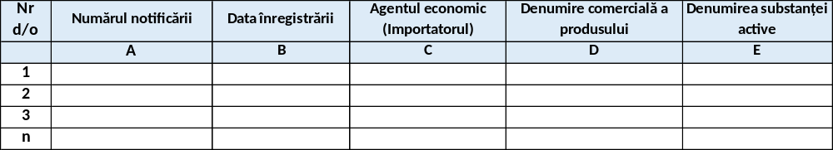
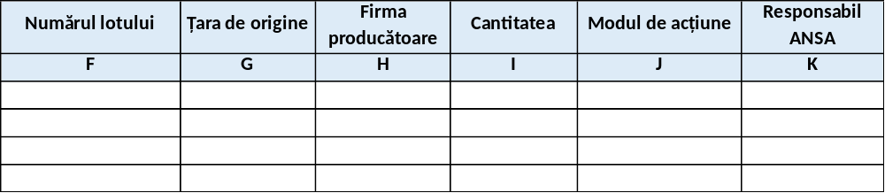

A2.2. Records of notifications for the import of fertilizer products.
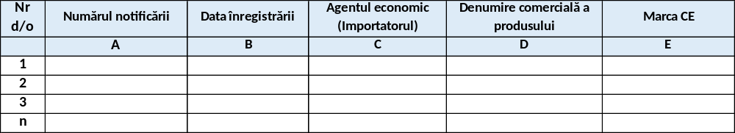
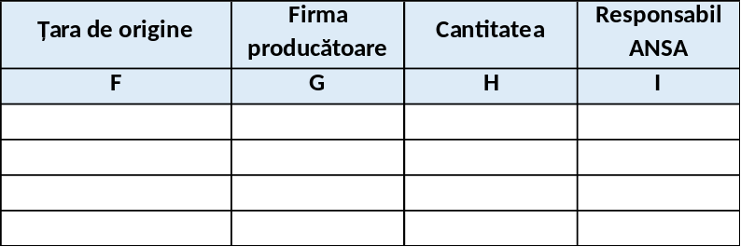

A2.3. List of import notifications received.
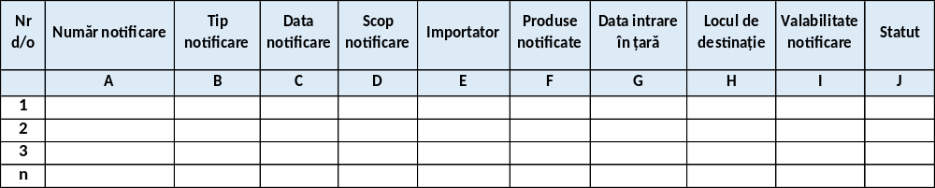

A2.4. List of imported goods that were subject to sanitary-veterinary control in the last calendar year by origin of the goods.
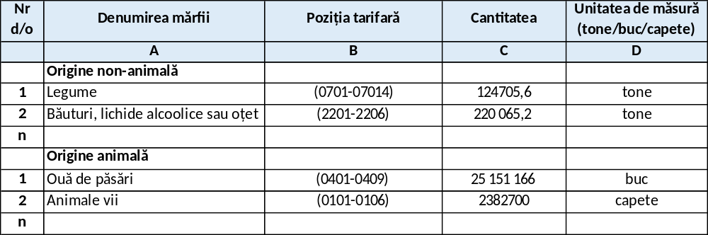

A2. 5. List of imported goods that were subject to phytosanitary control in the last calendar year by product type.
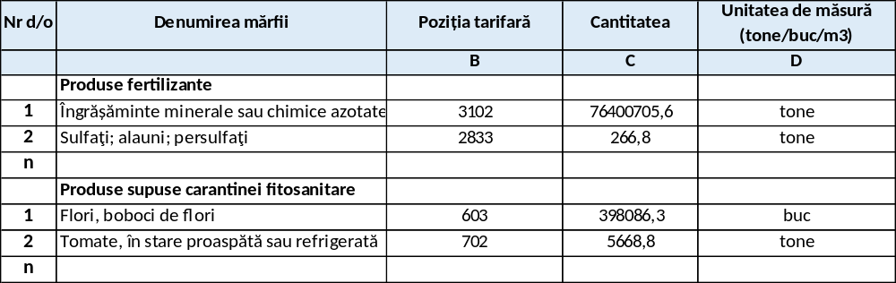

A2.6. List of returned goods that were subject to PIF control in the last calendar year.
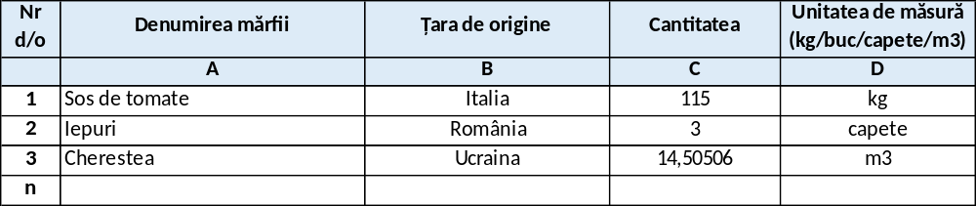

A2.7. Number of import notifications grouped by border inspection posts and calendar years.
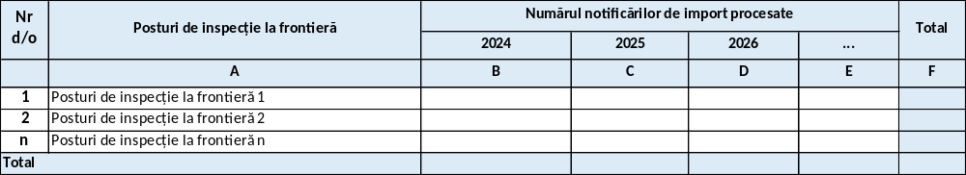

A2.8. Number of import notifications grouped by import notification type and calendar months.
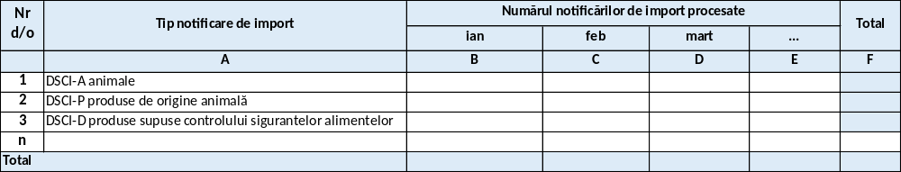

Reports related to SSI "Alert Registration and Dissemination"

A2.9. Centralized list (quarterly/semi-annual/annual) regarding RASFF Notifications
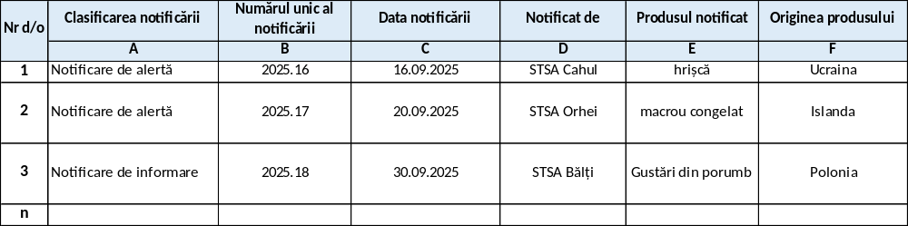
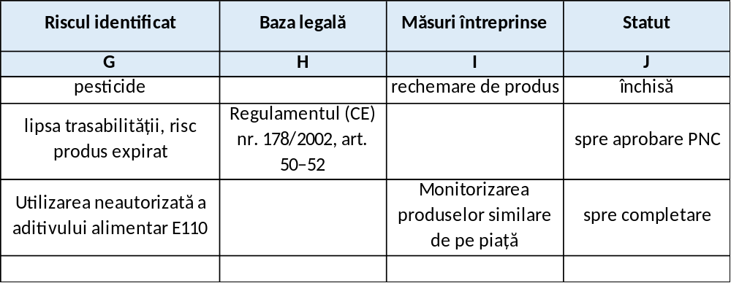

A2.10. Alert list for civil society
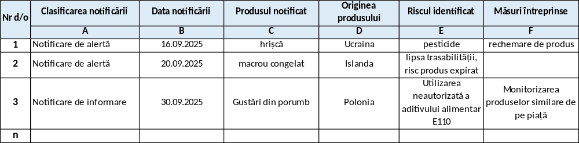

A2.1 1. Number of notifications received by notification classification, by calendar year.
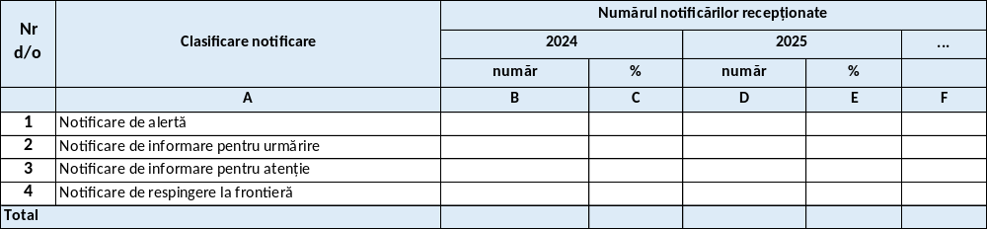

A2.12. Number of notifications received by product group concerned, by calendar year.
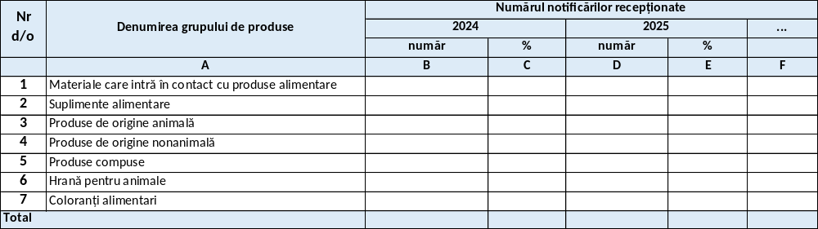

Reports related to the SSI "Register of food chain operators"

A2.13. List of operators registered in ROLA.
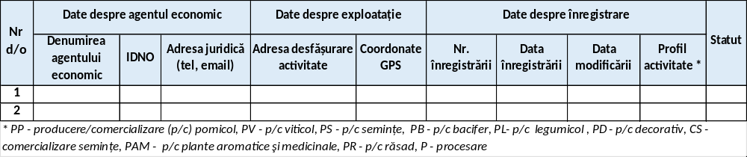

A2.14. List of authorized veterinary operators grouped by type of holding
Example: wholesale feed warehouse, veterinary hospital, pig farm, according to Annex No. 6 of LP 221/2007 and the territorial administrative unit
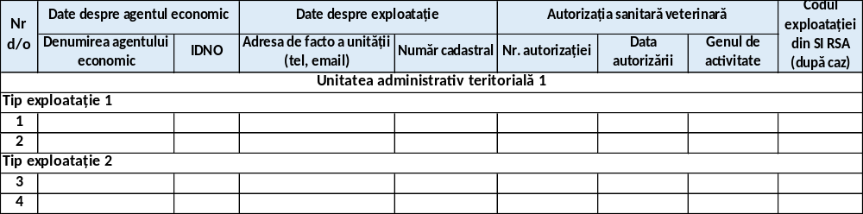

A2.1 5. List of means of transport authorized by the sanitary and veterinary authorities.
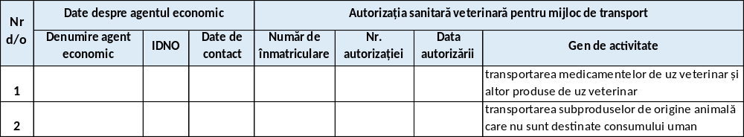

A2.16. List of approved veterinary holdings
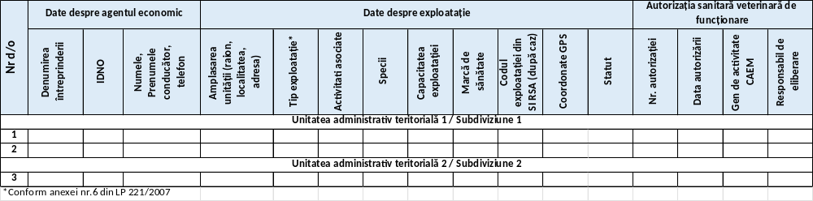

A2. 17. List of holdings authorized for a type of activity (according to CAEM) grouped by administrative-territorial unit
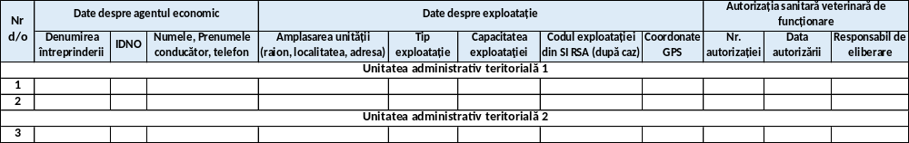

A2.18. List of registered veterinary units.
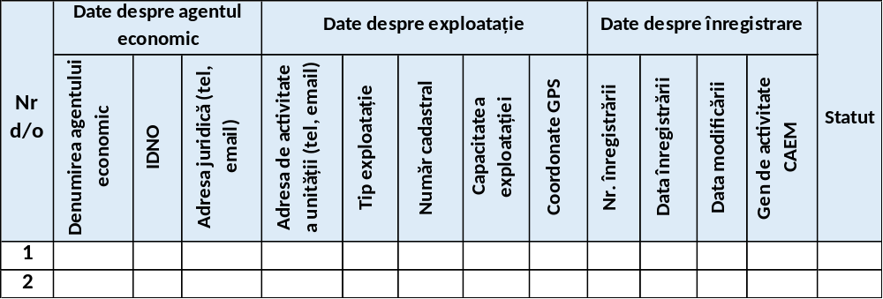

A2.1 9. Registration register of the main technological equipment.
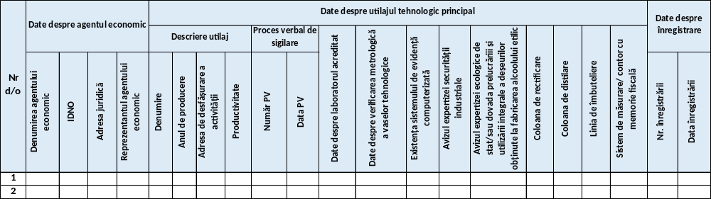

A2.20. List of operators registered in the field of food safety of non-animal origin
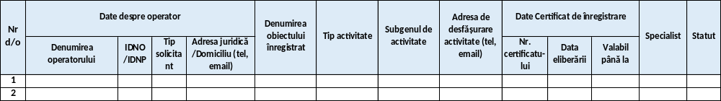

A2. 21. List of registered operators in the field of food safety by type of activity/territorial administrative unit
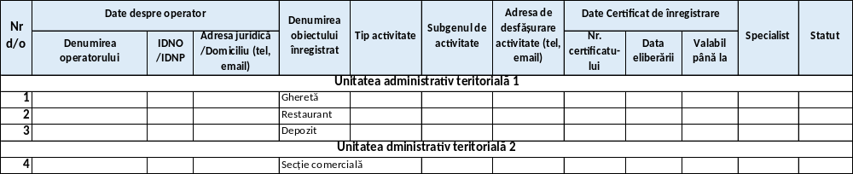

A2.22. List of operators/holdings registered in the field of phytosanitary products
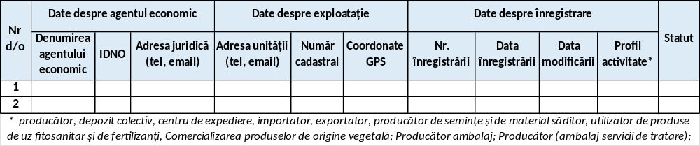

A2.23. List of registered producers in the field of phytosanitary products
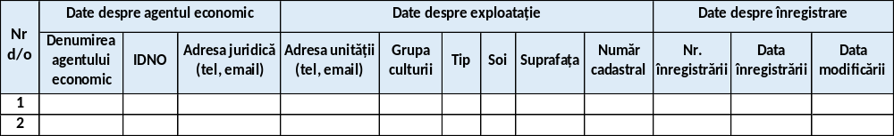

A2. 24. List of operators registered for the production and/or processing, and/or marketing of seeds and planting material

A2.25. List of operators registered for the production of seeds and planting material
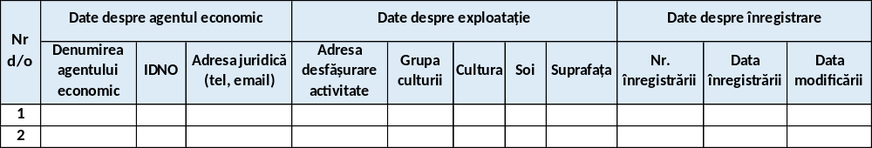

A2. 26. Register of specialized warehouses for the storage of phytosanitary products and fertilizers
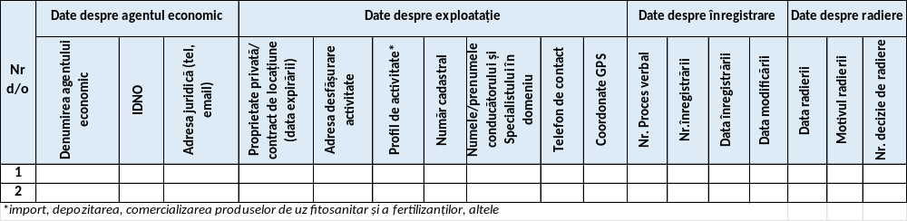

A2.27. List of authorized/registered repositories.
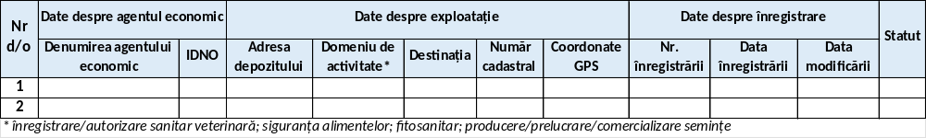

A2. 28. Total number of operators/holdings registered by field of activity and/or subdivision
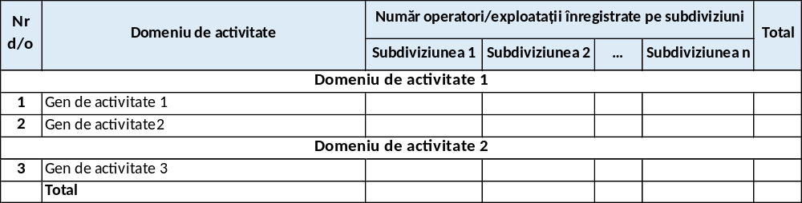

A2.29. List of registered operators by current status (active, suspended, deregistered)
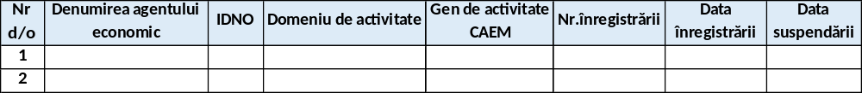

A2. 30. List of issued permissive acts (variant 1)
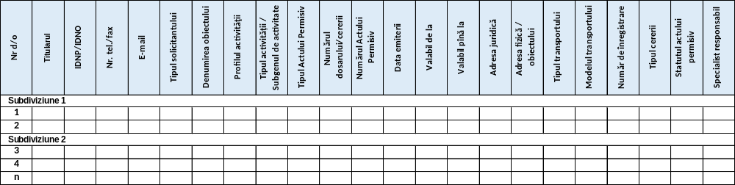

A2.31. List of issued permissive documents (variant 2)
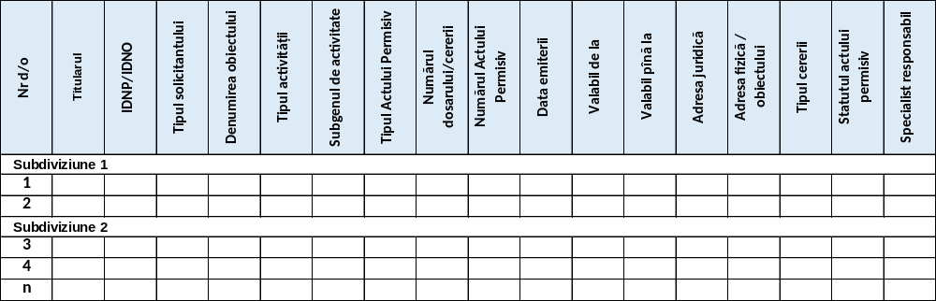

Annex 3. Information objects of the information system
1. Food chain operator . This information object is composed of the following data categories:
- state identification number IDNO/IDNP;
- VAT code (for VAT payers);
- name / surname and first name;
- organizational-legal form;
- property type;
- legal address;
- billing address;
- Email address;
- contact details;
- bank details;
- current status;
- other categories of data, as appropriate.
2. Agri-food holding . This complex information object is composed of the following data categories:
- holding identifier;
- cadastral number;
- the state identification number (IDNP/IDNO) of the food chain operator;
- address of the holding (locality according to CUATM, street, number);
- geospatial coordinates;
- the name of the holding;
- type of holding;
- the area of land managed;
- geospatial data of the holding;
- activity profile;
- the activities practiced;
- data on the species of animals/crops on the holding;
- the number of animals of that species on the holding;
- annual production capacity/volume;
- data on the epizootic status of the holding;
- contact details;
- the status of the holding.
Depending on the type of farm, it will be described by specific attributes, as follows:
2.1. Warehouse. The warehouse operation will also include the following data categories:
- type of deposit or destination;
- private property/lease contract;
- the expiration date of the lease agreement.
2.2. Land. The land type exploitation will also include the following data categories:
- agricultural area ;
- arable land;
- parcel.
2.3. Technological equipment. The technological equipment type operation will also include the following data categories:
- year of production;
- productivity;
- data about the sealing report (number, date);
- data about the accredited laboratory;
- data on metrological verification of technological vessels;
- data on the existence of the computerized records system;
- industrial security expert opinion;
- the opinion of the state ecological expertise or proof of complete waste processing;
- rectification column;
- distillation column;
- measurement system/meter with fiscal memory.
2.4. Transport unit. The transport unit type operation will also include the following data categories:
- registration number;
- type of means of transport;
- other relevant data.
3. ROLA Registration . This information object is composed of the following data categories:
- the record identifier;
- authorized user identifier (ANSA official responsible for registration);
- registration type (operator, agri-food holding);
- food chain operator identifier;
- agri-food holding identifier;
- data on official control;
- registration traceability data;
- attached documents;
- other categories of data, as appropriate.
4. Electronic document . This complex information object is composed of the following data categories:
- document identifier;
- document type;
- document format;
- document issuer;
- document content;
- document status.
5. Permission . This information object is composed of the following data categories:
- permission identifier;
- agri-food holding identifier;
- activity identifier;
- date of registration;
- date of modification;
- status.
6. Activity . This information object is composed of the following data categories:
- activity identifier;
- activity profile identifier;
- field of activity identifier;
- agricultural crop identifier;
- name of the activity;
- other categories of data, as appropriate.
7. Field of activity . This information object is composed of the following data categories:
- field of activity identifier;
- name of the field of activity.
8. Activity profile . This information object is composed of the following data categories:
- activity profile identifier;
- name of the activity profile.
9. Agricultural culture . This information object is composed of the following data categories:
- agricultural crop identifier;
- the name of the agricultural crop;
- culture group;
- the variety.
10. Authorized user
It represents the authorized user profile with access to the user interface of the information system. The following categories of data will be stored in the authorized user profile:
- the user's IDNP code;
- name;
- first name;
- access data to the computer system;
- mailing address;
- email address;
- contact phone number;
- the roles assigned within the information system;
- data access rights;
- current profile status (active/inactive);
- other relevant data.
11. Task
This information object will contain the following categories of data:
- task identifier;
- task executor;
- task execution deadline;
- task details (in the context of workflows implemented in the IT system);
- pregnancy status.
12. Importer . This information object is composed of the following data categories:
- Importer identifier;
- state identification number IDNO/IDNP;
- VAT code (for VAT payers);
- name / surname and first name;
- organizational-legal form;
- property type;
- legal address;
- billing address;
- Email address;
- contact details;
- current status;
- other categories of data, as appropriate.
13. Import notification . This information object is composed of the following data categories:
- import notification identifier;
- importer identifier;
- notification type (DSCI-A, DSCI-P, DSCI-D, DCIF, DCIPP, DCIPUF);
- product batch data;
- data on agri-food holdings;
- notification date;
- notification purpose (internal market, transit);
- data about the place of destination;
- data on temporary storage;
- data about the operator responsible for transport;
- description of the transport;
- the place of physical control (at the border, at the place of destination);
- the point of entry into the country;
- estimated date of entry into the country;
- exact date of entry into the country;
- point of exit from the country (for transit);
- country of destination (for transit);
- transit validity (14 days from entry into the country);
- notification closing date (for transit);
- notification validity (14 days from notification dispatch);
- mentions;
- notification status (active/cancelled/to be completed/refused at the border/closed etc.)
14. Notified batch . This information object is composed of the following data categories:
- notified batch identifier;
- product identifier;
- batch number;
- batch description;
- health certificate data;
- product quantity;
- product packaging;
- Are there any alerts?
- other relevant data.
15. Imported batch . This information object is composed of the following data categories:
- imported batch identifier;
- product identifier;
- batch number;
- batch description;
- health certificate data;
- product quantity;
- product packaging;
- import allowed/rejected;
- mentions;
- other relevant data.
16. Product . This information object is composed of the following data categories:
- product identifier;
- product trade name;
- active substance name;
- mode of action;
- product registration number in the state register (phytosanitary and fertilizers);
- product category;
- NCM code;
- country of origin;
- CE mark;
- producer;
- validity dates.
17. Control . This information object is composed of the following data categories:
- control identifier;
- import notification identifier;
- authorized user identifier (PIF inspector);
- type of control (documentary/identity/physical);
- date;
- control decision (passage allowed/customs clearance allowed/detention at the border);
- control description;
- other relevant data.
17. Notification . This information object is composed of the following data categories:
- notification identifier;
- authorized user identifier (point of contact);
- non-conformity identifier;
- notification type (food, animal feed, feed, etc.);
- notification classification (information, alert, border rejection);
- the basis for the notification (official control, border rejection, consumer complaint, etc.);
- associated unique code;
- date of notification;
- the subject of the notification;
- legal basis;
- data on PC members for intervention;
- data on PC members for information;
- data about product batches;
- distribution list;
- Hazard data:
  - hazard category;
  - identified hazard;
  - test results data;
  - laboratory investigations;
  - data on data collection (number of samples, method, location, etc.);
  - laboratory analyses;
  - matrix/analysis method.
- risk data:
  - major risk (confirmation, evaluation);
  - number of people affected;
  - type of disease/symptoms;
  - legislation;
  - maximum allowed level.
- border control data:
  - starting point;
  - entry point;
  - checkpoint;
  - inspection reason;
  - destination country;
  - recipient(name, address);
  - container/seal number;
  - vehicle registration number.
- public information data;
- organization/ministry;
- fraud?
- fraud description;
- other categories of data, as appropriate.
18. Product batch . This complex information object is composed of the following data categories:
- product batch identifier;
- batch number;
- batch expiration dates;
- batch description (number of units, mass/volume);
- health certificate data (number/numbers, date, CVED/CED number);
- data on the operators involved (registration/authorization number, country/district, name, address);
- product category (fruit, sweets, milk, etc.);
- product name;
- NCM code;
- brand;
- trade name;
- product aspect (temperature, others);
- barcode;
- data on the label;
- unit mass/volume;
- country of origin;
- distribution list?
- other relevant data.
19. Non-conformity . This complex information object is composed of the following data categories:
- non-conformity identifier;
- description of non-conformity;
- risk classification;
- date of discovery;
- source of origin (LIMS, EU RASFF, media, other sources);
- type of control;
- product name;
- product type (animal feed/food);
- product category (meat, milk, etc.);
- batch/series code;
- the quantity affected;
- packaging and labeling;
- country of origin;
- the reporting country;
- the economic operator;
- data taken from LIMS:
  - Minutes No.;
  - test report number;
  - quantity of sample taken;
  - laboratory results;
- attached documents;
- processing date;
- status (project, simple non-compliance, notification);
20. Electronic file . This complex information object is composed of the following data categories:
- file identifier;
- notification identifier;
- the non-compliance identifier;
- file traceability data;
- data on the tasks necessary to be performed for the examination of the file;
- data about the contact points involved in the file examination process;
- data on correspondence between contact points related to the examination of the file;
- data on measures taken;
- documents in electronic format attached to the file;
- other categories of data, as appropriate.
21. Measure taken . This complex information object is composed of the following data categories:
- the identifier of the measure taken;
- notification identifier;
- product batch identifier;
- type of measure (voluntary, imposed);
- name of action (recall, destruction, consumer information, etc.);
- description of the measure taken;
- date of entry into force;
- duration;
- the responsible contact point;
- other relevant data.

Annex 4. Abbreviations, acronyms and concepts used in the document
Table 10. 1. Abbreviations and acronyms used in the document.
No. | Abbreviation/Acronym | Description
1. | AGE | Electronic Government Agency
2. | loop | National Food Safety Agency
3. | A? | Public authority
4. | API | Application programming interface
5. | ASP | Public Services Agency
6. | BD | Database
7. | BPML | Business process modeling language
8. | CAEM | Classifier of activities in the economy of Moldova
9. | CFOJ | Classifier of organizational and legal forms of economic agents in the Republic of Moldova
10. | CFP | Classifier of forms of ownership
11. | COTS | Commercial off-the-shelf
12. | CUATM | Classifier of administrative-territorial units
13. | DCIA | Notification regarding the import of products subject to sanitary-veterinary supervision and control (live animals)
14. | DCIP | Notification regarding the import of products subject to sanitary-veterinary supervision and control (products of animal origin)
15. | DCID | Notification regarding the import of products subject to food safety supervision and control
16. | DCIPP | Notification regarding the import of products subject to phytosanitary surveillance and control
17. | DCIPUF | Notification regarding the import of products subject to the supervision and control of phytosanitary products
18. | IFCD | Notification on the import of products subject to fertilizer supervision and control
19. | IDA | Information subsystem "Alert registration and dissemination"
20. | KPIs | Key performance indicators
21. | Lim | "Laboratory Management" information subsystem
22. | MCabinet | Government portal of the citizen and entrepreneur
23. | MCI | Information subsystem "Import monitoring and control"
24. | MCloud | Common Government Technology Platform
25. | MPass | Government electronic authentication and access control service
26. | MPower | Automated information system "Register of powers of representation based on electronic signature"
27. | MNotify | Government electronic notification service
28. | MLog | Government electronic journaling service
29. | NCM | Combined Nomenclature of Goods
30. | QBE | Query by example
31. | ESDP | Electronic services development platform
32. | PIF | Border inspection post
33. | PUFF | Phytosanitary products and fertilizers
34. | RBI | Real estate register
35. | ROLL | Information subsystem "Register of food chain operators"
36. | RSA | Information subsystem "State Register of Animals"
37. | CSR | State register of controls
38. | RSF | Information subsystem "State Phytosanitary Register"
39. | RSP | State Population Register
40. | SDUS | State Register of Legal Entities
41. | SDS | Document design software
42. | DBMS | Database management system
43. | AND | Information system
44. | SIA | Automated information system
45. | GEAP SIA | Automated information system "Management and issuance of permissive documents"
46. | Simidi | The integrated information system "e-ANSA Import Control and Alert Dissemination"
47. | ALS | Service level agreement
48. | SOA | Service-oriented architecture
49. | SPOF | Single point of failure
50. | SRS | Software requirements specification
51. | Si | Computer subsystem
52. | IT | Information technology
53. | TIC | Information and communication technology
54. | TLS/SSL | Transport layer security/Secure sockets layer

Table 10. 2. Definitions and concepts used in the document.
No. | Abbreviation/Acronym | Description
1. | Database | A set of data organized according to a conceptual structure that describes the basic characteristics and relationships between entities.
2. | Credentials | Set of attributes that establish the identity and authenticity of users and systems within information systems.
3. | data | Elementary information units about persons, subjects, facts, events, phenomena, processes, objects, situations, etc. presented in a form that allows their notification, commenting and processing.
4. | Personal data | Any information relating to an identified or identifiable natural person (personal data subject). In this sense, an identifiable person is one who can be identified, directly or indirectly, in particular by reference to an identification number or to one or more factors specific to his or her physical, physiological, mental, economic, cultural or social identity.
5. | Agri-food farm | The unit/object in the agri-food sector within which food chain operators carry out their activity.
6. | Workflow | Administrative process of an organization during which tasks, procedures and information are processed or executed in a certain sequence dictated by pre-established rules (procedural norms) for the purpose of producing a product or providing a service.
7. | Data integrity | State of data, when it retains its content and is interpreted unambiguously in cases of random actions. Integrity is considered preserved if the data has not been altered or damaged (deleted).
8. | Journaling | Event information recording function. Within information systems, event records include details about the date and time, the user, and the action taken.
9. | METADATA | Method of assigning semantic value to data stored in the database (data about data).
10. | Information object | Virtual representation of existing material and immaterial entities.
11. | Food chain operator | Natural or legal person, who practices entrepreneurial activity in the agricultural sector (plant production activities and activities auxiliary to plant production; activities in the field of phytosanitary products and fertilizers), the animal production field [animal production activities (animal breeding and reproduction activities) and activities auxiliary to animal breeding], the food field (activities of production and processing of food of animal and non-animal origin), falling under the competence of the National Food Safety Agency.
12. | Query by Example | Database query method using native text syntax. The main advantage is the lack of specific requirements for the structure of the information request.
13. | Information resource | Set of information documented in the IT system, maintained in accordance with the requirements and legislation in force
14. | Information system | Set of programs and equipment that ensure automatic data processing (automated component of the information system).
15. | Information system | Information processing system, together with associated organizational resources, such as human and technical resources, that provide and distribute information.
16. | Document Design Software | Director document of the information system which includes the detailed description of the following visions: data structures and their constraints, information system architecture which provides all the conceptual sections of the information system, information system interface which includes the conceptualization of all the components of the information system user interface, information system functionalities which include the detailed description of all the implementation scenarios of the information system.
17. | Software Requirements Specification | Document containing a detailed description of all interaction scenarios between users and the computer application.
18. | Computer subsystem | Component part (with the possibility of functional decoupling) of a complex information system.
19. | Information and communication technology | A general term that includes all technologies used for the exchange and manipulation of information.
20. | Data accuracy | Level of correspondence of data, stored in computer memory or in documents, to the real state of objects in the respective domain of the system, reflected by this data.

Annex 5. References and legal aspects for the development of the information system
Analyzing the regulatory and legislative framework in force in the Republic of Moldova and international practice, a number of acts, standards and good practices can be highlighted, the provisions of which must be taken into account when designing, developing and implementing information subsystems within the SIMIDA perimeter .
In this regard, for the development, implementation and operation of SIMIDA, a set of legal and normative acts was identified, grouped according to the degree of applicability as follows:
- the national regulatory framework regulating the ANSA's field of activity;
- the national regulatory framework in the field of computerization and information technology;
- standards and good practices in the ICT field.
The normative acts related to the ANSA activity, the public services provided by ANSA, as well as the business processes of the SIMIDA components are the following:
- Law No. 1100/2000 on the manufacture and circulation of ethyl alcohol and alcoholic production.
- Law No. 119/2004 on phytosanitary products.
- Law No. 33/2006 on the storage of cereals and the regime of storage certificates for cereals.
- Law No. 231/2006 on the identification and registration of animals.
- Law No. 235/2006 on the basic principles of regulating entrepreneurial activity.
- Law No. 221/2007 on veterinary health activity.
- Law No. 231/2010 on internal trade.
- Law No. 160/2011 on the regulation of entrepreneurial activity by authorization.
- Law No. 131/2012 on state control.
- Law No. 50/2013 on official controls to verify compliance with feed and food law and animal health and welfare rules.
- Law No. 68/2013 on seeds.
- Law No. 172/2014 on the approval of the Combined Nomenclature of Goods.
- Law No. 185/2017 amending and supplementing certain legislative acts.
- Law No. 237/2018 on the control of compliance with quality requirements for fresh fruits and vegetables.
- Law No. 306/2018 on food safety.
- Law No. 333/2018 on the approval of certain model documents.
- Law No. 234/2021 on public services.
- Law No. 77/2022 amending certain normative acts.
- Law No. 237/2023 on organic production and labeling of organic products.
- Law No. 403/2023 on the placing on the market of phytosanitary products and amending certain regulatory acts.
- Law No. 422/2023 on protective measures against organisms harmful to plants.
- Law No. 21/2025 on the making available on the market of fertilizer products.
- Government Decision No. 360/2002 on the approval of the Regulation on the import and export of seeds and planting material.
- Decision No. 1045/2005 approving the Regulation on the import, storage, marketing and use of phytosanitary products and fertilizers.
- Government Decision No. 1408/2008 on the approval of certain sanitary and veterinary norms.
- Government Decision No. 1279/2008 on the approval of the Technical Regulation "Packaging, transportation and storage of fresh fruits, vegetables and mushrooms".
- Government Decision No. 929/2009 on the approval of the "Quality and marketing requirements for fresh fruits and vegetables".
- Government Decision No. 558/2011 on emergency phytosanitary measures to prevent the introduction and spread of harmful organisms in the Republic of Moldova.
- Government Decision No. 915/2011 approving the Requirements regarding the quality and marketing of oilseed and fiber plant seeds.
- Government Decision No. 598/2012 on the approval of the Requirements regarding the quality and placing on the market of propagating material for ornamental plants.
- Government Decision No. 713/2013 approving the Requirements for the production and marketing of vegetable seeds, seedlings and vegetable planting material.
- Government Decision No. 600/2014 approving the Requirements regarding the quality and marketing of seeds of grassy cereal crops.
- Government Decision No. 654/2015 on the approval of the Regulation on the single window for issuing permissive documents for the export of products and by-products of animal origin;
- Government Decision No. 59/2017 on the approval of measures for the implementation of the rapid alert system for food and feed at national level.
- Government Decision No. 333/2018 on the approval of certain model documents.
- Government Decision No. 938/2018 for the approval of regulations regarding the crossing of the state border of goods subject to control by the National Food Safety Agency.
- Government Decision No. 257/2019 approving the model documents regarding the import of seeds and repealing a Government Decision.
- Government Decision No. 82/2021 on some information systems and state registers of the National Food Safety Agency.
- Government Decision No. 791/2022 on the establishment and approval of the Concept of the Integrated Information System "e-ANSA".
- Government Decision No. 14/2023 on the organization and functioning of the National Food Safety Agency .
- Government Decision No. 790/2023 on the approval of the General Crisis Management Plan in the field of food and feed safety.
- Government Decision No. 591/2024 approving the Regulation on the import and export of organic products.
- Government Decision No. 679/2024 approving the Regulation on the application of protective measures against plant pests.
- Regulation of the National Food Safety Agency no. 231/2003 on the management of phytosanitary products and fertilizers in the national economy.
- Order of the National Food Safety Agency No. 15/2021 on the approval of the Regulation on sanitary and veterinary registration of the activities of economic agents.
- Order of the National Food Safety Agency No. 163/2023 on limiting the validity period of notifications on the import of phytosanitary products and fertilizers.
- Order of the National Food Safety Agency No. 387/2025 on the approval of the notification form for the import of fertilizer products.
- Order of the Ministry of Agriculture and Food Industry No. 207/2025 Regarding the approval of the guide regarding the visual appearance of the label for EU fertilizer products and/or MD fertilizer products.
The normative acts regulating information and communication technology in the Republic of Moldova applicable to information subsystems within the SIMIDA perimeter are the following:
- Law No. 142/2018 on data exchange and interoperability.
- Law No. 124/2022 on electronic identification and trust services.
- Government Decision No. 330/2012 on the creation and administration of the single government portal of public services.
- Government Decision No. 656/2012 on the approval of the Interoperability Framework Program.
- Government Decision No. 1090/2013 on the government electronic authentication and access control service (MPass).
- Government Decision No. 128/2014 on the common government technological platform (MCloud).
- Government Decision No. 405/2014 on the integrated government electronic signature service (MSign).
- Government Decision No. 701/2014 on the approval of the Methodology for the publication of open government data.
- Government Decision No. 708/2014 on the electronic government logging service (MLog).
- Government Decision No. 717/2014 on the electronic services development platform (PDSE).
- Government Decision No. 201/2017 on the approval of the Minimum Mandatory Cybersecurity Requirements;
- Government Decision No. 1141/2017 approving the Regulation on the method of applying electronic signatures to electronic documents by officials of legal entities under public law within the framework of their electronic circulation.
- Government Decision No. 414/2018 on measures to consolidate data centers in the public sector and to rationalize the administration of state information systems.
- Government Decision No. 211/2019 regarding the interoperability platform (MConnect).
- Government Decision No. 376/2020 approving the Concept of the government electronic notification service (MNotify) and the Regulation on the functioning and use of the government electronic notification service (MNotify).
- Government Decision No. 650/2023 on the approval of the Digital Transformation Strategy of the Republic of Moldova for 2023-2030.
- Government Decision No. 677/2025 on strengthening access to electronic public services within the EVO integrated government portal used for the provision of electronic public services and approving the necessary measures for the implementation of the unitary design model.
When implementing SIMIDA, the following normative acts must be complied with, which regulate the launch and operation of information systems:
- Law No. 1069/2000 on information technology.
- Law No. 467/2003 on informatization and state information resources.
- Law No. 71/2007 on registers.
- Electronic Communications Law No. 241/2007.
- Law No. 239/2008 on transparency in the decision-making process.
- Law No. 133/2011 on the protection of personal data.
- Law No. 148/2023 on access to information of public interest.
- Government Decision No. 153/2021 for the approval of the Concept of the Information System "Register of State Information Resources and Systems" and the Regulation on the method of keeping the Register of State Information Resources and Systems".
All The information subsystems within the SIMIDA perimeter must be designed, developed and implemented in accordance with the following national and international regulations and recommendations, methodologies and recommendations related to the ICT sector:
- Order of the Ministry of Information Development No. OMDI78/2006 on the approval of the technical regulation "Software Life Cycle Processes" RT 38370656 - 002:2006.
- SM Standard ISO/IEC/IEEE 14764:2022 - Software engineering. Software life cycle processes. Maintenance.
- Standard SM EN ISO/IEC 27001:2023 - Information technology, cybersecurity and privacy. Information security management systems. Requirements.
- Standard SM EN ISO/IEC 27002:2022 - Information security, cybersecurity and privacy. Information security controls.
- SM Standard ISO/IEC/IEEE 14764:2022 Software engineering. Software life cycle processes. Maintenance.
- Level AA user interface requirements of the Web Content Accessibility Guidelines 2.1, https://www.w3.org/TR/WCAG21/.
- World Wide Web Consortium (W3C) recommendations (http://www.w3c.org) regarding the quality of Web page content, the possibilities of correct visualization of information, using widely used Internet browsers, and compatibility with different computer platforms.
- W3C (http://validator.w3.org) recommendations for testing web pages. All web pages will be tested in accordance with these recommendations.

Annex 6. ANSA Organizational Chart
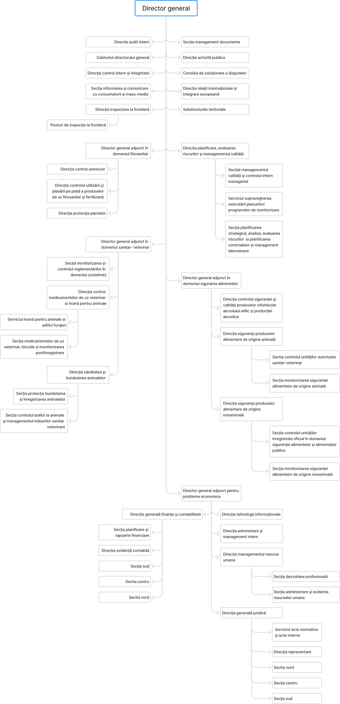
Figure 8. 1. ANSA organizational chart.

Annex 7. Technical annex regarding the exchange of data between SIMIDA and the Customs Service's IS
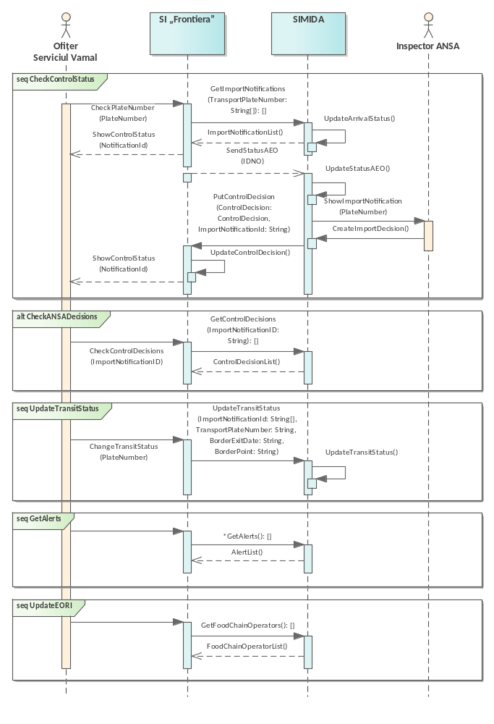
Figure 8. 2. ANSA organizational chart.

A 7.1. Interpellations
1. GetImportNotifications
Signature | GetImportNotifications(TransportPlateNumber: String[]) : ImportNotificationList
Description | SIMIDA provides SI "Frontiera" with data on prior import notifications that have been submitted to ANSA for the import of products subject to ANSA control and supervision.
HTTP or SOAP level input parameters
Property | Type | compulsory | Description
CallingUser | String(13) | Yes | The user IDNP or the system ID that processes the data
CallingEntity | String(13) | Yes | The IDNO of the legal entity processing the data
CallBasis | String(256) | Yes | Legal basis of the appeal
CallReason | String(512) | Yes | Purpose of the call
Input parameters
Property | Type | compulsory | Description
TransportPlateNumber | String[] | Yes | Registration number of the transport unit with which the goods are imported, previously notified to ANSA
2. GetControlDecisions
Signature | GetControlDecisions(ImportNotificationID: String) : ControlDecisionList
Description | SIMIDA provides SI "Frontiera" with data on decisions related to ANSA control on the import of products subject to ANSA control and supervision.
HTTP or SOAP level input parameters
Property | Type | compulsory | Description
CallingUser | String(13) | Yes | The user IDNP or the system ID that processes the data
CallingEntity | String(13) | Yes | The IDNO of the legal entity processing the data
CallBasis | String(256) | Yes | Legal basis of the appeal
CallReason | String(512) | Yes | Purpose of the call
Input parameters
Property | Type | compulsory | Description
ImportNotificationID | Thong | Yes | The unique identifier of the prior notification for the import of products subject to ANSA control and surveillance
3. PutControlDecision
Signature | PutControlDecision(ControlDecision: ControlDecision , ImportNotificationId: String)
Description | SIMIDA provides SI "Frontiera" with data on a decision related to ANSA control for prior notification of the import of products subject to ANSA control and surveillance.
HTTP or SOAP level input parameters
Property | Type | compulsory | Description
CallingUser | String(13) | Yes | The user IDNP or the system ID that processes the data
CallingEntity | String(13) | Yes | The IDNO of the legal entity processing the data
CallBasis | String(256) | Yes | Legal basis of the appeal
CallReason | String(512) | Yes | Purpose of the call
Input parameters
Property | Type | compulsory | Description
ControlDecision | ControlDecision | Yes | Data on the decision of inspectors at border inspection posts after carrying out the control of goods
ImportNotificationId | Thong | Yes | The unique identifier of the prior notification for the import of products subject to ANSA control and surveillance
4. UpdateTransitStatus
Signature | UpdateTransitStatus(ImportNotificationId: String[], TransportPlateNumber: String, BorderExitDate: String, BorderPoint: String)
Description | SIMIDA receives data from SI "Frontiera" data on the status of goods notified in advance and subject to control and supervision of ANSA
HTTP or SOAP level input parameters
Property | Type | compulsory | Description
CallingUser | String(13) | Yes | The user IDNP or the system ID that processes the data
CallingEntity | String(13) | Yes | The IDNO of the legal entity processing the data
CallBasis | String(256) | Yes | Legal basis of the appeal
CallReason | String(512) | Yes | Purpose of the call
Input parameters
Property | Type | compulsory | Description
ImportNotificationId | String[] | Yes | Unique identifier of the pre-import notification
TransportPlateNumber | Thong | Yes | Registration number of the transport unit with which the goods are transported
BorderExitDate | Thong | Yes | Date and time of departure of the transport unit from the country
BorderPoint | Thong | Yes | Contains values from the classifier of customs posts through which the goods in transit left the country
5. GetAlerts
Signature | GetAlerts : AlertList
Description | SIMIDA returns the list of alert notifications registered by the contact points of the national rapid alert system
HTTP or SOAP level input parameters
Property | Type | compulsory | Description
CallingUser | String(13) | Yes | The user IDNP or the system ID that processes the data
CallingEntity | String(13) | Yes | The IDNO of the legal entity processing the data
CallBasis | String(256) | Yes | Legal basis of the appeal
CallReason | String(512) | Yes | Purpose of the call
Input parameters
Property | Type | compulsory | Description
6. GetFoodChainOperators
Signature | GetFoodChainOperators(IDNO: String, DocumentNumber: String,): FoodChainOperatorList
Description | SIMIDA returns data about operators and their agri-food holdings that are registered in the Register of Food Chain Operators
HTTP or SOAP level input parameters
Property | Type | compulsory | Description
CallingUser | String(13) | Yes | The user IDNP or the system ID that processes the data
CallingEntity | String(13) | Yes | The IDNO of the legal entity processing the data
CallBasis | String(256) | Yes | Legal basis of the appeal
CallReason | String(512) | Yes | Purpose of the call
Input parameters
Property | Type | compulsory | Description
IDNO | Thong | Yes | Food chain operator IDNO code
DocumentNumber | Thong | Yes | Food chain operator permissive act code
7. UpdateStatusAEO
Signature | UpdateStatusAEO(LegalEntityId: String[], Status: String)
Description | The Customs Service's IS provides and SIMIDA updates data on the AEO status of economic agents when crossing the state border.
HTTP or SOAP level input parameters
Property | Type | compulsory | Description
CallingUser | String(13) | Yes | The user IDNP or the system ID that processes the data
CallingEntity | String(13) | Yes | The IDNO of the legal entity processing the data
CallBasis | String(256) | Yes | Legal basis of the appeal
CallReason | String(512) | Yes | Purpose of the call
Input parameters
Property | Type | compulsory | Description
LegalEntityId | String[] | Yes | Unique Business Identifier (UBI)
Status | Thong | Yes | AEO status of economic operators

A7. 2. Data structures
Property | Type | compulsory | Description
ImportNotification
ImportNotificationID | Thong | Yes | Import notification identifier
ImportGoods | ImportGood[] | Yes | Data of the consignment of goods to be notified for import or transit
AuthorizedTransport | AuthorizedTransport | Yes | Data of transport unit authorized for the transport of imported goods
Transporter | LegalEntity | Yes | Data of economic agent carrying out goods transport activities
Importer | FoodChainOperator | Yes | Data of an economic agent registered in the Register of Food Chain Operators that carries out import activities of goods subject to control and supervision by ANSA
ImportNotificationType | Thong | Yes | Contains values from the pre-import notification types classifier
NotificationDate | Thong | Yes | Date of dispatch of import notification
NotificationScope | Thong | Yes | This field contains values from the classifier for the purpose of notifying goods for which prior notification has been sent.
GoodsDestinationAddress | Thong | Yes | Data on the place of destination of the goods
GoodsStorageAddress | Thong | Yes | Data on the place of temporary storage of goods
GoodsControlPlace | Thong | Yes | This field contains values from the classifier with the place where the physical control of the goods for which prior notification has been sent will be carried out.
BorderEntrancePoint | Thong | Yes | Contains values from the classifier of border inspection points where ANSA performs identity control and physical control of goods
BorderExitPoint | Thong | Yes | Contains values from the customs post classifier where the goods in transit will exit the country
BorderEstimativeEntranceDate | Thong | Yes | Estimated date of entry into the country
BorderRealEntranceDate | Thong | Yes | Exact date of entry into the country
GoodsDestinationCountry | Thong | Yes | Country of destination of goods (for transit)
GoodsTransitValidity | Thong | Yes | Transit validity deadline
GoodsTransitClosed | Thong | Yes | Date of exit of goods from the country (for transit)
NotificationValidity | Thong | Yes | Notification validity deadline
Status | Thong | Yes | Status of prior import notification
ControlDecisions | ControlDecision[] | Yes | Data on decisions of inspectors at border inspection posts after carrying out control of goods
LegalEntity
wavering | Thong | Yes | State identification number IDNO/IDNP
Watt | Thong | Yes | VAT code (for VAT payers)
Name | Thong | Yes | Name / surname and first name
Address | Thong | Yes | Legal address
FoodChainOperator
OperatorCode | Thong | Yes | State identification number IDNO/IDNP
OperatorVat | Thong | Yes | VAT code (for VAT payers)
OperatorName | Thong | Yes | Name / surname and first name
OperatorLegalAddress | Thong | Yes | Legal address
OperatorContactData | Thong | Yes | Contact details
RegistrationStatus | Thong | Yes | Current status
LegalEntity | LegalEntity | Yes | Data of economic agent carrying out activities of importing goods
RegistrationProfile | Thong | Yes | The field of activity of the food chain operator that is subject to the control and supervision of ANSA ( veterinary health, plant protection, seed control, etc. )
RegistrationActivity | Thong | Yes | The specific activity practiced by the operator to ensure supervision and control in accordance with the regulatory framework
RegistrationUnit | Thong | Yes | Data on the establishment in which food chain operators carry out their activities (slaughterhouses, livestock farms, agricultural land intended for plant crops, storage centres and collective warehouses, food processing establishments of non-animal or animal origin, etc.)
RegistrationUnitAddress | Thong | Yes | Address of the agri-food holding where the economic agent registered with ANSA carries out its activity
RegistrationDocumentType | Thong | Yes | The type of permissive act based on which the activity is permitted to be carried out
RegistrationDocumentDate | Thong | Yes | Date of issuance of the permissive act on the basis of which the activity is permitted
RegistrationDocumentValidity | Thong | Yes | The validity period of the permissive act on the basis of which the activity is permitted to be carried out
ImportGood
Number | Thong | Yes | Notified batch number
Description | Thong | Yes | Lot description
ProductTradeName | Thong | Yes | Product trade name
Quantity | Thong | Yes | Quantity of products
Packaging Type | Thong | Yes | Packaging type
CertificationData | Thong | Yes | Data on the certification of the product batch from the exporting country
productively | productively | Yes | Product data to be notified for import or transit
productively
Product Code | Thong | Yes | NCM code
Product Name | Thong | Yes | Product name according to NCM
AuthorizedTransport
TransportCode | Thong | Yes | Unique registration number of the transport unit in the State Register of Vehicles
Type | Thong | Yes | Type of transport unit
Exemplary | Thong | Yes | Transport unit model
PlateNumber | Thong | Yes | Registration number of the transport unit
AuthorizationDocumentNumber | Thong | Yes | Number of the permissive act issued by ANSA
AuthorizationDocumentDate | Thong | Yes | Date of issuance of the permissive act
AuthorizationDocumentValidity | Thong | Yes | Validity date of the permissive act
Status | Thong | Yes | Status of the authorized transport unit in the Register of Food Chain Operators
ControlDecision
ControlStartData | Thong | Yes | Date of initiation of the ANSA control
ControlType | Thong | Yes | Type of control (documentary; identity; physical)
DecisionType | Thong | Yes | Contains values from the classifier of types of decisions taken by ANSA when controlling imported goods
DecisionDate | Thong | Yes | Decision date
Responsible | Thong | Yes | The ANSA inspector who made the decision
DecisionDescription | Thong | Yes | Data on the reasoning behind the decision
Alert
AlertCode | Thong | Yes | Unique alert notification code
ContactPointName | Thong | Yes | Name of the contact point in the national network of contact points
AlertCategory | Thong | Yes | Type of notification (food, feed, animal feed, etc.)
AlertType | AlertType | Yes | Contains a value from the alert type classifier
AlertBase | Thong | Yes | Basis of notification (official control, border rejection, consumer complaint, etc.)
Registration Date | Thong | Yes | Notification date
AlertSubject | Thong | Yes | Subject of the notification
LegalBase | Thong | Yes | Legal basis
InterventionContactPoints | String[] | Yes | Data on members of intervention contact points
InformationContactPoints | String[] | Yes | Data on members of information contact points
Hazards | String[] | Yes | Hazard data:  - hazard category;  - identified hazard;  - test results data;  - laboratory investigations;  - data on data collection (number of samples, method, location, etc.);  - laboratory analyses;  - matrix/analysis method.
Risks | String[] | Yes | Risk data:  - major risk (confirmation, evaluation);  - number of people affected;  - type of disease/symptoms;  - legislation;  - maximum allowed level.)
BorderControl | String[] | Yes | Border control data:  - starting point;  - entry point;  - checkpoint;  - inspection reason;  - destination country;  - recipient(name, address);  - container/seal number;  - vehicle registration number.
Goods | String[] | Yes | Product batch data:  - batch number;  - batch expiration dates;  - batch description (number of units, mass/volume);  - health certificate data (number/numbers, date, CVED/CED number);  - data on the operators involved (registration/authorization number, country/district, name, address);  - product category (fruit, sweets, milk, etc.);  - product name;  - NCM code;  - brand;  - trade name;  - product aspect (temperature, others);  - barcode;  - data on the label;  - unit mass/volume;  - country of origin;
ImportNotificationList
ImportNotification | ImportNotification[] | Yes | Prior notification data regarding the import of products subject to ANSA supervision and control
AlertList
Alert | Alert[] | Yes | Alert notification data recorded by the national rapid alert system contact points
ControlDecisionList
ControlDecision | ControlDecision[] | Yes | Data on the decision of inspectors at border inspection posts after carrying out the control of goods
FoodChainOperatorList
FoodChainOperator | FoodChainOperator[] | Yes | Operator and holding data registered in the Register of Food Chain Operators carrying out activities subject to control and supervision by ANSA

A7 . 3. Classifiers
Code | Description
NotificationType
NCLR1 | Types of prior import notifications for products subject to ANSA control and surveillance
DSCI-A | Importing animals
DSCI-P | Import of animal products
DSCI-D | Import of products subject to food safety control
IFCD | Import of products subject to phytosanitary control
DCIPUF | Import of phytosanitary products and fertilizers
NotificationScope
NCLR2 | Purpose of prior notification of goods
1 | Import
2 | Transit
GoodsControlPlace
NCLR3 | Place where physical control of the goods is requested to be carried out
1 | At the border
2 | At the place of destination of the goods
BorderCheckpoint
NCLR4 | List of border inspection points where ANSA carries out identity checks and physical checks of goods
DecisionType
NCLR5 | Types of decisions issued by ANSA in relation to the control of imported goods
1 | Crossing and customs clearance allowed - no non-compliances during documentary and physical identity checks
2 | Crossing allowed – if the decision related to the physical control will be issued at the place of destination
3 | Border detention - if the inspection found non-compliance with national requirements and the Importer can remove them
4 | Rejection at the border – if a direct or indirect risk to human health has been identified and the Importer chooses to return or destroy the batch
AlertType
NCLR6 | Alert notification types classifier
1 | Alert notification
2 | Border rejection notification
3 | Tracking information notification
4 | Information notice for attention

A7. 4. General service level agreement (SLA)
Features
Name | Feature/Period | Value
Number of calls | On average, 24h | 200 calls
Number of calls | Maximum, 24h | 1000 calls
Number of calls | competing | 10 calls
Response size | Estimated average | 30KB
Response size | Estimated maximum | 100KB
Performance | Average response time | 1 second
Performance | Maximum response time | 3 seconds
Availability | 8:00 AM – 5:00 PM, weekdays | 99%
Availability | 5:00 PM – 8:00 AM | 95%

Annex 8. Example of response with queried data from RSPUFF
{
"items": [
{
"id": 4,
"commercial_name": "FASTAC 100 EC",
"approval holder": "Nufarm Gmbh & Co KG", Austria",
"registration number": "25-04-15-03-1894",
"registration date": "15-04-2025",
"expiration date": "15-04-2032",
"active_active_substance": "alpha-cypermethrin, 100 g/l",
"consumption_rate": "0.1-0.15",
"cultures": [
{
"culture_id": 5,
"crop": "Wheat",
}],
"modul_period_use_limits": "By spraying during the growing season",
"interval_pauza_nr_tratamente": "15(2)",
"field_output_term_effect_of_manual_work_mechanized": "-(4)",
"categ_toxic": "II",
"parsite_id": "5;74;8;6;7",
"parasite_public_name": "lice;lice;fleas;lice;thrips",
"parasite_den_pupulara": "aphididae;aelia sp.;chrysomelidae;cicadellidae;haplothrips tritici",
"parasite_den_scientific": "aphididae; aelia sp.; chrysomelidae; cicadellidae; haplothrips tritici"
}
]
}

